

Football Field Booking System
Software Design Specification

– Can Tho, May 2026 –

Record of changeS
Date | A*  M, D | In charge | Change Description
*A - Added M - Modified D - Deleted

Table of Contents
I. Overview 4
1. Code Packages 4
2. Database Design 4
a. Database Schema 4
b. Table Description 4
II. Code Designs 5
1. Register account 5
a. Class Diagram 5
b. Class Specifications 5
c. Sequence Diagram(s) 5
d. Database queries 6
2. Login 6

I. Overview

1. Code Packages
Package diagram will be inserted here during the diagram phase.
Package descriptions
No | Package | Description
01 | com.swp391.backend | 1 Java file(s): BackendApplication. Count the Spring Boot entry point separately from feature packages.
02 | com.swp391.backend.config | 4 Java file(s): CorsConfig, DataSeeder, PostgresDdlSafetyEnvironmentPostProcessor, SecurityConfig. Authorization rules for many Admin/Staff endpoints live in SecurityConfig, not inside every service method.
03 | com.swp391.backend.controller | 8 Java file(s): AccountController, ApiExceptionHandler, BookingController, FieldOperationController, ImageUploadController, PaymentController, PromotionReportController, SystemController. UC-11 through UC-62 are concentrated in four domain controllers plus account support; there is no controller-per-UC structure.
04 | com.swp391.backend.dto | 1 Java file(s): ApiRequests. Request records are nested in one ApiRequests class rather than separate DTO files.
05 | com.swp391.backend.entity | 20 Java file(s): AppUser, AuditEntity, Booking, BookingPromotion, BookingServiceItem, CustomerMembership, ExtraService, FieldPrice, FieldType, FootballField, Invoice, Issue, MembershipLevel, Notification, Payment, Promotion, Refund, Role, Slot, SystemSetting. There are 19 table-backed entities plus the mapped superclass AuditEntity; do not count AuditEntity as a table.
06 | com.swp391.backend.enums | 13 Java file(s): AccountStatus, BookingSource, BookingStatus, CommonStatus, DiscountType, IssueStatus, NotificationType, PaymentMethod, PaymentOption, PaymentStatus, RefundStatus, ServiceType, SlotStatus. Status/value sets are Java enums persisted as strings; they are not lookup tables.
07 | com.swp391.backend.repository | 19 Java file(s): AppUserRepository, BookingPromotionRepository, BookingRepository, BookingServiceItemRepository, CustomerMembershipRepository, ExtraServiceRepository, FieldPriceRepository, FieldTypeRepository, FootballFieldRepository, InvoiceRepository, IssueRepository, MembershipLevelRepository, NotificationRepository, PaymentRepository, PromotionRepository, RefundRepository, RoleRepository, SlotRepository, SystemSettingRepository. Only BookingServiceItemRepository contains explicit JPQL; most queries are Spring Data derived or inherited CRUD.
08 | com.swp391.backend.security | 4 Java file(s): CustomUserDetailsService, JwtAuthenticationFilter, JwtService, SecurityUser. JWT identity and role authorization are cross-cutting implementation components, not persistence entities.
09 | com.swp391.backend.service | 13 Java file(s): AccountService, ApiException, BookingMaintenanceScheduler, BookingWorkflowService, DemoSupportService, FieldOperationService, ImageStorageService, PaymentWorkflowService, PayPalCheckoutService, PromotionReportService, SystemQueryService, VerificationEmailDelivery, VerificationEmailService. DemoSupportService is a shared domain helper/facade over repositories; PayPalCheckoutService is the provider adapter and BookingMaintenanceScheduler implements UC-43/UC-58 background work.

2. Database Design

a. Database Schema
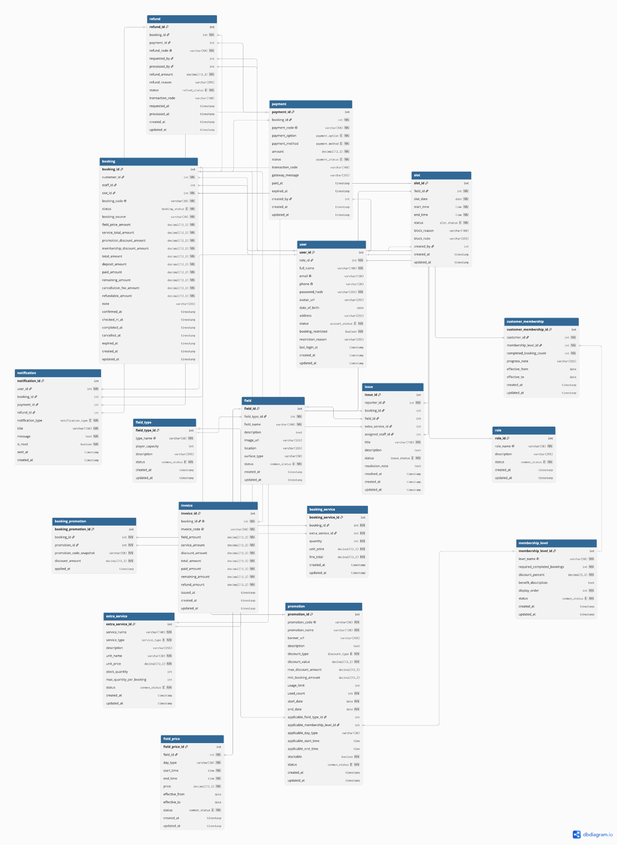

b. Table Description

No | Table | Description
01 | role | Primary key: role_id. Use role, not roles or user_role.
02 | app_user | Primary key: user_id. Use app_user, not user; auth_version is added by later Flyway migrations even though it is absent from the V1 create statement.
03 | membership_level | Primary key: membership_level_id. Stores lifetime/monthly/weekly completed-booking rules with consecutive-week requirements added by V10.
04 | customer_membership | Primary key: customer_membership_id. One row per customer is enforced by later integrity migration.
05 | field_type | Primary key: field_type_id. Football field type is a table; enum-like status remains a string.
06 | field | Primary key: field_id. Physical table is field although the entity is FootballField.
07 | field_price | Primary key: field_price_id. Pricing is scoped directly by field_id, day_type, and time/effective ranges.
08 | slot | Primary key: slot_id. Unavailable periods are represented by slot.status='blocked'; no unavailable_slot table exists.
09 | booking | Primary key: booking_id. Lifecycle, financial snapshots, and timestamps live together; there is no booking_status_history table.
10 | extra_service | Primary key: extra_service_id. Use extra_service, not service.
11 | booking_service | Primary key: booking_service_id. Physical table is booking_service although the entity/repository use BookingServiceItem naming.
12 | issue | Primary key: issue_id. Resolution fields are on issue; no issue_resolution table exists.
13 | promotion | Primary key: promotion_id. Applicability dimensions are nullable columns on promotion, not join tables.
14 | booking_promotion | Primary key: booking_promotion_id. Stores applied code/discount snapshots; ordinary product scope is one code per booking.
15 | payment | Primary key: payment_id. Provider order/capture/status/currency/idempotency fields are on payment and were repaired/added after V1.
16 | invoice | Primary key: invoice_id. booking_id is unique, so the relationship is one invoice per booking.
17 | refund | Primary key: refund_id. provider_status, idempotency_key, and gateway_message are added by V9; document the migrated schema, not only the V1 baseline.
18 | notification | Primary key: notification_id. Supports optional booking_id/payment_id/refund_id, but current shared notifyUser only supplies booking_id.
19 | system_setting | Primary key: setting_id. Deposit, refund, pending timeout, and reminder policy are key/value rows, not separate policy tables.

II. Code Designs

1. Register account

a. Class Diagram

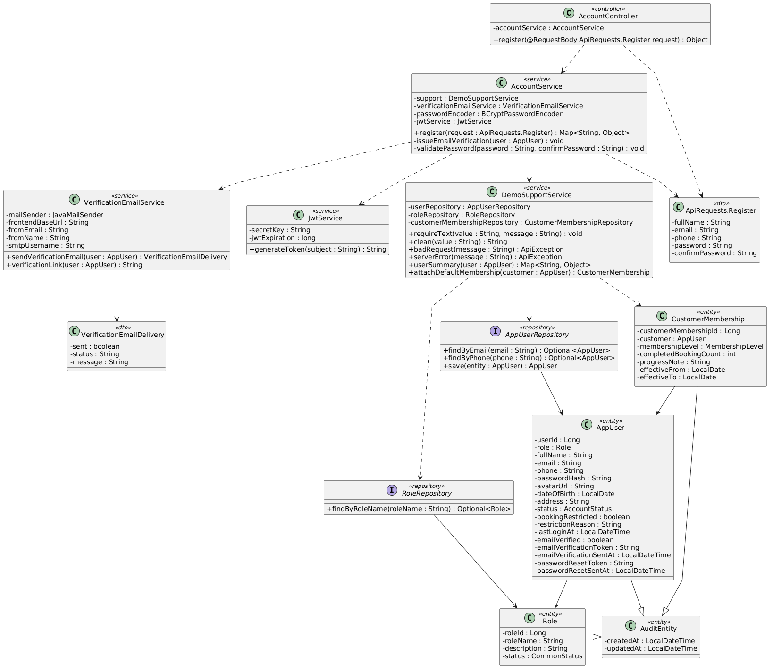

b. Class Specifications
AccountController
No | Method | Description
01 | register(request : ApiRequests.Register) : Object | Accepts a registration request and delegates the use case to AccountService.
02 | verifyEmail(request : ApiRequests.EmailVerification) : Object | Validates the email-verification link submitted by the client.
03 | resendEmailVerification(request : ApiRequests.EmailVerificationResend) : Object | Requests a new verification token and delivery attempt.

AccountService
No | Method | Description
01 | register(request : ApiRequests.Register) : Map<String, Object> | Validates unique identity and password policy, creates the Customer, attaches default membership, sends verification, and returns JWT/user data.
02 | verifyEmail(request : ApiRequests.EmailVerification) : Map<String, Object> | Validates a one-hour token and marks the account email as verified.
03 | resendEmailVerification(request : ApiRequests.EmailVerificationResend) : Map<String, Object> | Reissues a verification token for an unverified account.
04 | issueEmailVerification(user : AppUser) : void | Stores a new 16-character token and issue timestamp.
05 | validatePassword(password : String, confirmPassword : String) : void | Enforces length, character classes, no whitespace, and matching confirmation.

DemoSupportService
No | Method | Description
01 | requireText(value : String, message : String) : void | Rejects a missing required string.
02 | clean(value : String) : String | Trims optional input before validation and persistence.
03 | attachDefaultMembership(user : AppUser) : void | Creates the initial membership record for the new Customer.
04 | userSummary(user : AppUser) : Map<String, Object> | Builds the authenticated account response without exposing the password hash.

VerificationEmailService
No | Method | Description
01 | sendVerificationEmail(user : AppUser) : VerificationEmailDelivery | Sends the verification link and reports delivery status without rolling back account creation.
02 | verificationLink(user : AppUser) : String | Builds the frontend verification URL from user ID and token.

JwtService
No | Method | Description
01 | generateToken(user : SecurityUser) : String | Creates a signed JWT containing role and auth-version claims.

AppUserRepository
No | Method | Description
01 | findByEmail(email : String) : Optional<AppUser> | Loads an account and role by unique email.
02 | findByPhone(phone : String) : Optional<AppUser> | Loads an account and role by unique phone.
03 | save(user : AppUser) : AppUser | Persists the new account.

RoleRepository
No | Method | Description
01 | findByRoleName(roleName : String) : Optional<Role> | Loads the seeded Customer role.

c. Sequence Diagram
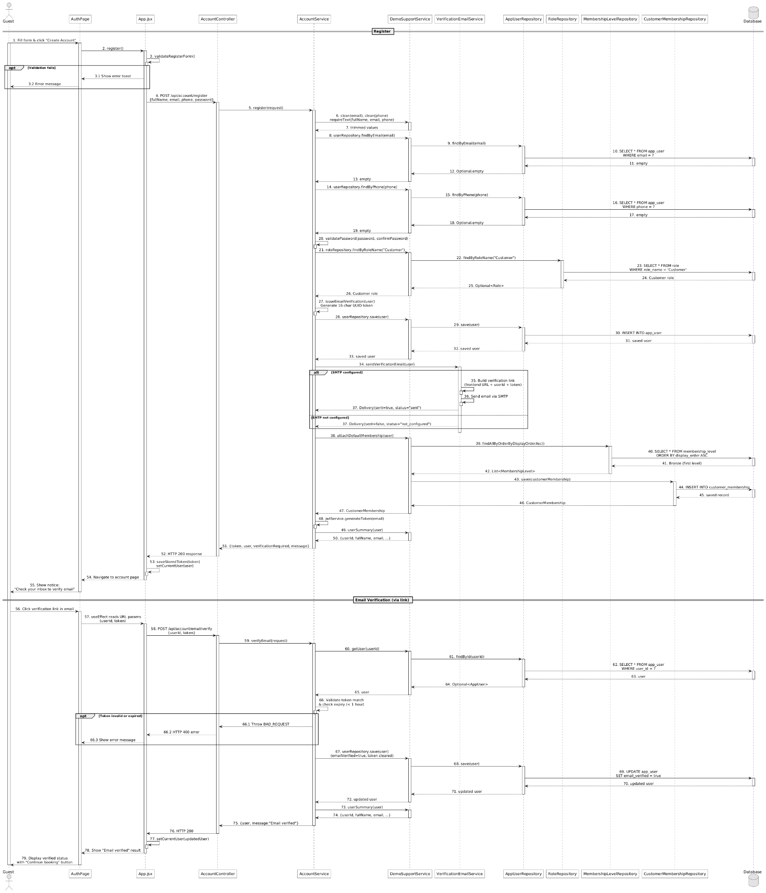

d. Database Queries
== Register account ==

1. 1. Check email uniqueness
SELECT u.*, r.* FROM app_user u
LEFT JOIN role r ON r.role_id = u.role_id
WHERE u.email = ?;

2. 2. Check phone uniqueness
SELECT u.*, r.* FROM app_user u
LEFT JOIN role r ON r.role_id = u.role_id
WHERE u.phone = ?;

3. 3. Load Customer role
SELECT * FROM role WHERE role_name = 'Customer';

4. 4. Insert Customer account
INSERT INTO app_user
(role_id, full_name, email, phone, password_hash, status, booking_restricted,
auth_version, email_verified, email_verification_token, email_verification_sent_at, created_at, updated_at)
VALUES (?, ?, ?, ?, ?, 'active', false, 0, false, ?, ?, ?, ?);

5. 5. Attach default membership
SELECT * FROM membership_level ORDER BY display_order ASC;
INSERT INTO customer_membership
(customer_id, membership_level_id, completed_booking_count, progress_note, effective_from, created_at, updated_at)
VALUES (?, ?, 0, 'Default membership', ?, ?, ?);

6. 6. Verify email
SELECT * FROM app_user WHERE user_id = ?;
UPDATE app_user SET email_verified = true, email_verification_token = NULL,
email_verification_sent_at = NULL, updated_at = ? WHERE user_id = ?;

2. Login

a. Class Diagram
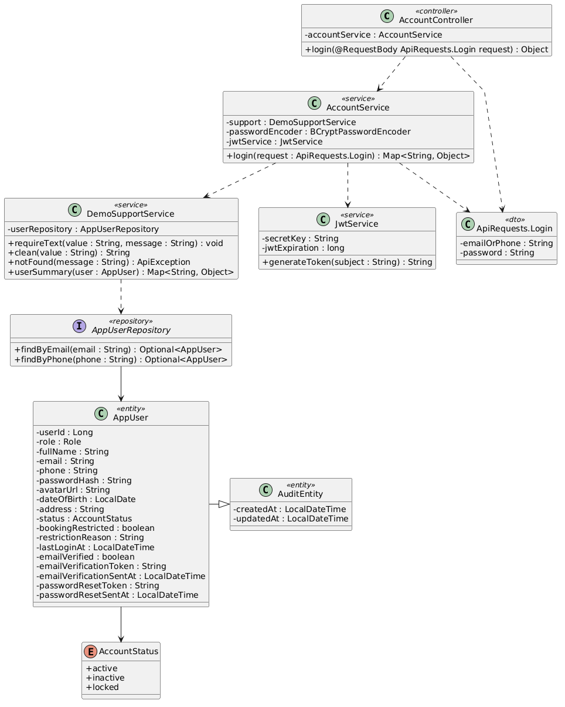

b. Class Specifications
AccountController
No | Method | Description
01 | login(request : ApiRequests.Login) : Object | Accepts email-or-phone credentials and returns the service response.

AccountService
No | Method | Description
01 | login(request : ApiRequests.Login) : Map<String, Object> | Loads the account, checks BCrypt credentials and active status, records login time, and returns JWT/user data.

BCryptPasswordEncoder
No | Method | Description
01 | matches(rawPassword : CharSequence, encodedPassword : String) : boolean | Compares the submitted password with the stored BCrypt hash.

JwtService
No | Method | Description
01 | generateToken(user : SecurityUser) : String | Issues a JWT with username, role, and current auth version.

AppUserRepository
No | Method | Description
01 | findByEmail(email : String) : Optional<AppUser> | Finds the account by email with role loaded.
02 | findByPhone(phone : String) : Optional<AppUser> | Finds the account by phone when email lookup fails.

c. Sequence Diagram
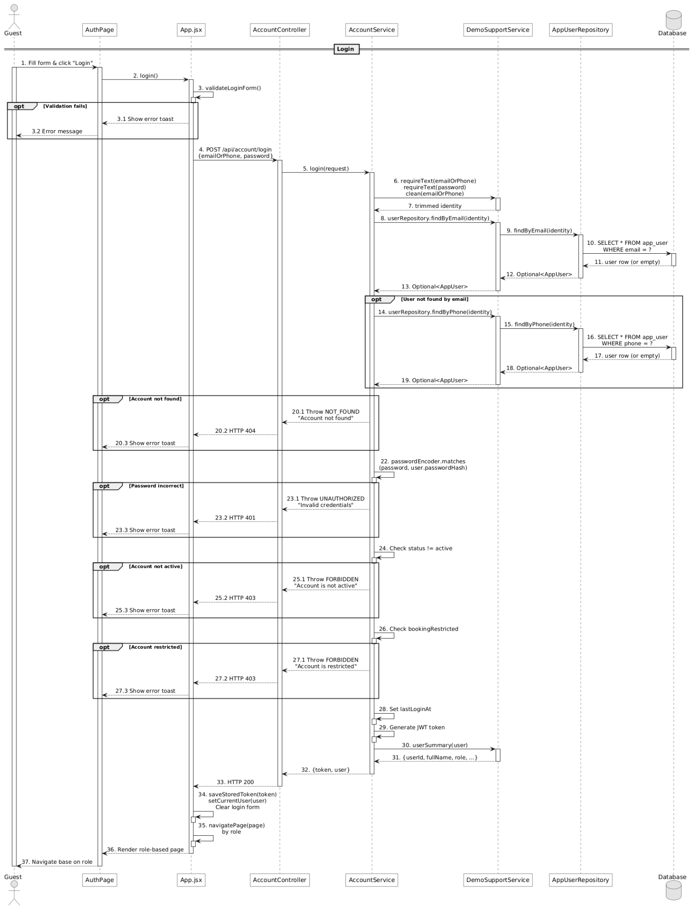

d. Database Queries
== Login ==

1. 1. Find account by email
SELECT u.*, r.* FROM app_user u LEFT JOIN role r ON r.role_id = u.role_id
WHERE u.email = ?;

2. 2. Find account by phone
SELECT u.*, r.* FROM app_user u LEFT JOIN role r ON r.role_id = u.role_id
WHERE u.phone = ?;

3. 3. Record successful login
UPDATE app_user SET last_login_at = ?, updated_at = ? WHERE user_id = ?;

3. Logout

a. Class Diagram
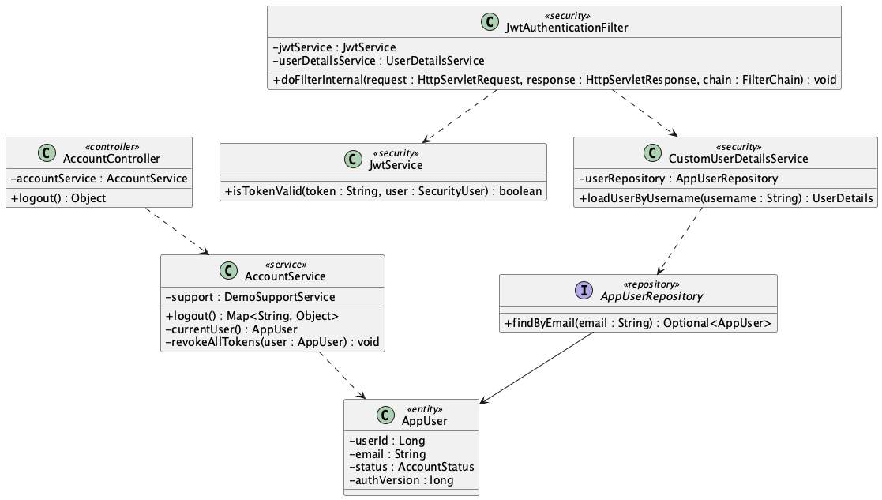

b. Class Specifications
AccountController
No | Method | Description
01 | logout() : Object | Requires authentication and delegates server-side token revocation.

AccountService
No | Method | Description
01 | logout() : Map<String, Object> | Resolves the current account, increments auth version, and returns sign-out confirmation.
02 | revokeAllTokens(user : AppUser) : void | Invalidates all JWTs issued with the previous auth-version value.

JwtAuthenticationFilter
No | Method | Description
01 | doFilterInternal(request, response, chain) : void | Rejects a later request when the token auth-version no longer matches the database account.

JwtService
No | Method | Description
01 | isTokenValid(token : String, user : SecurityUser) : boolean | Checks subject, expiration, and auth-version claim.

c. Sequence Diagram
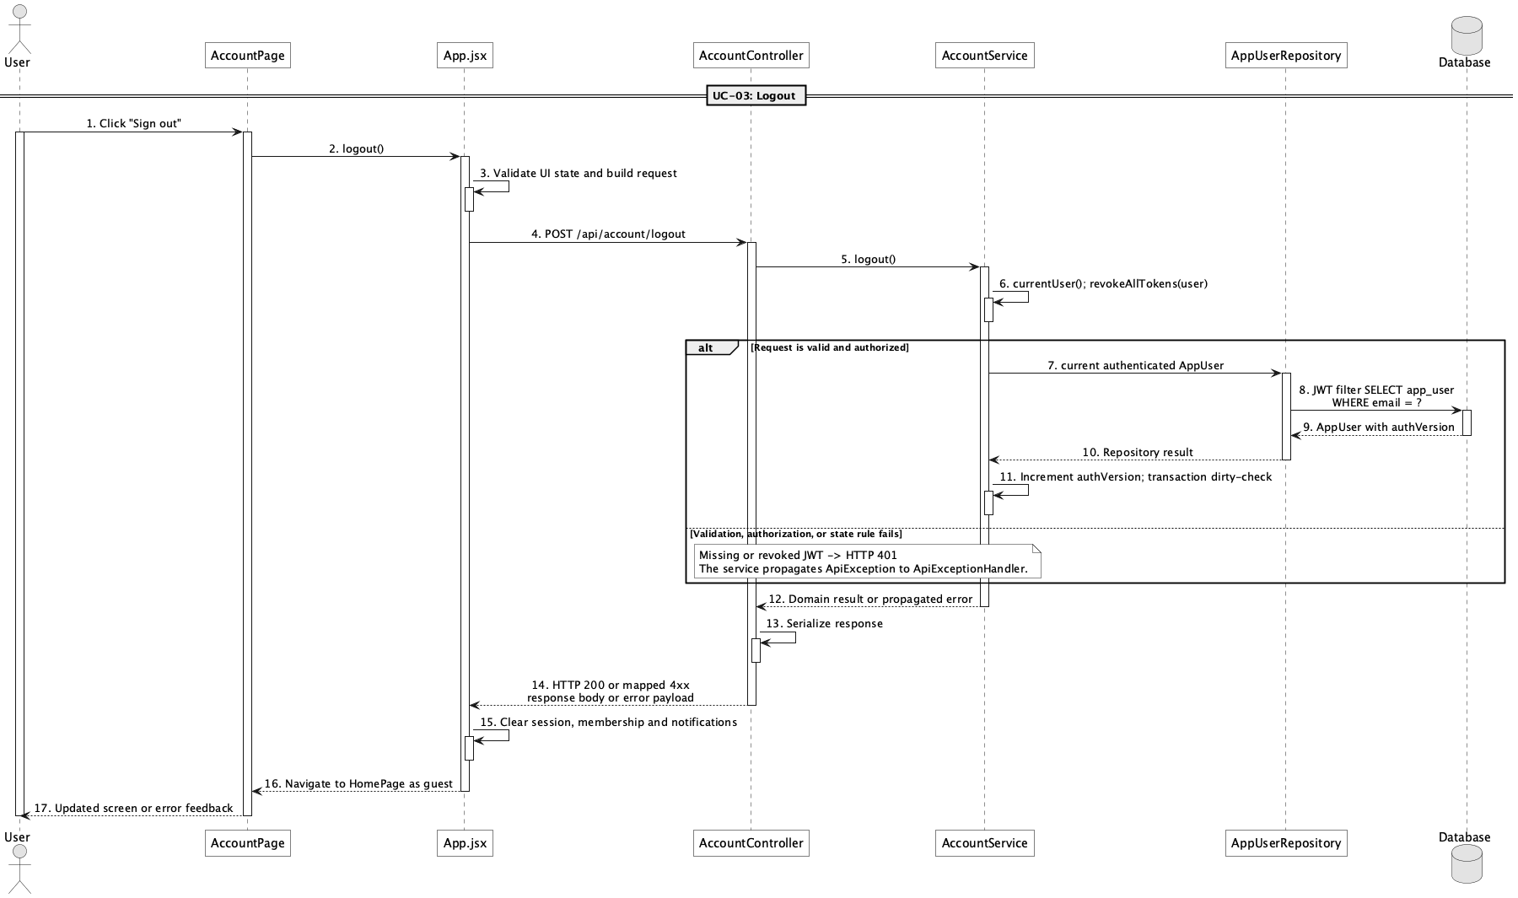

d. Database Queries
== Logout ==

1. 1. Load authenticated account
SELECT u.*, r.* FROM app_user u LEFT JOIN role r ON r.role_id = u.role_id
WHERE u.email = ?;

2. 2. Revoke issued JWTs
UPDATE app_user SET auth_version = auth_version + 1, updated_at = ?
WHERE user_id = ?;

4. Manage personal profile

a. Class Diagram
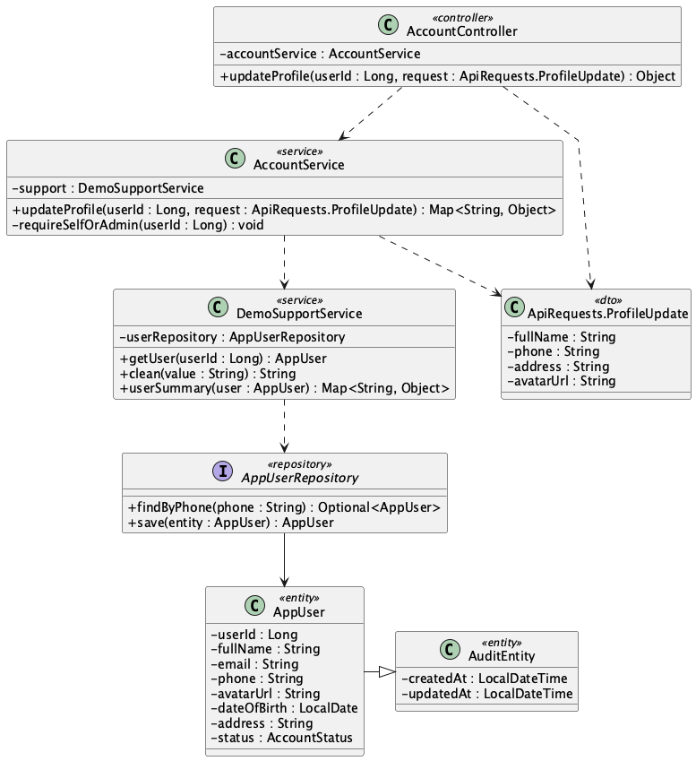

b. Class Specifications
AccountController
No | Method | Description
01 | updateProfile(userId : Long, request : ApiRequests.ProfileUpdate) : Object | Receives allowed profile changes for the selected account.

AccountService
No | Method | Description
01 | updateProfile(userId : Long, request : ApiRequests.ProfileUpdate) : Map<String, Object> | Checks self-or-Admin access, validates phone uniqueness, and updates name, phone, address, and avatar URL.
02 | requireSelfOrAdmin(userId : Long) : void | Prevents a non-Admin user from updating another account.

DemoSupportService
No | Method | Description
01 | getUser(userId : Long) : AppUser | Loads the target account or raises not-found.
02 | clean(value : String) : String | Normalizes optional profile input.
03 | userSummary(user : AppUser) : Map<String, Object> | Returns the updated safe profile representation.

AppUserRepository
No | Method | Description
01 | findByPhone(phone : String) : Optional<AppUser> | Checks that a replacement phone is not owned by another account.

c. Sequence Diagram
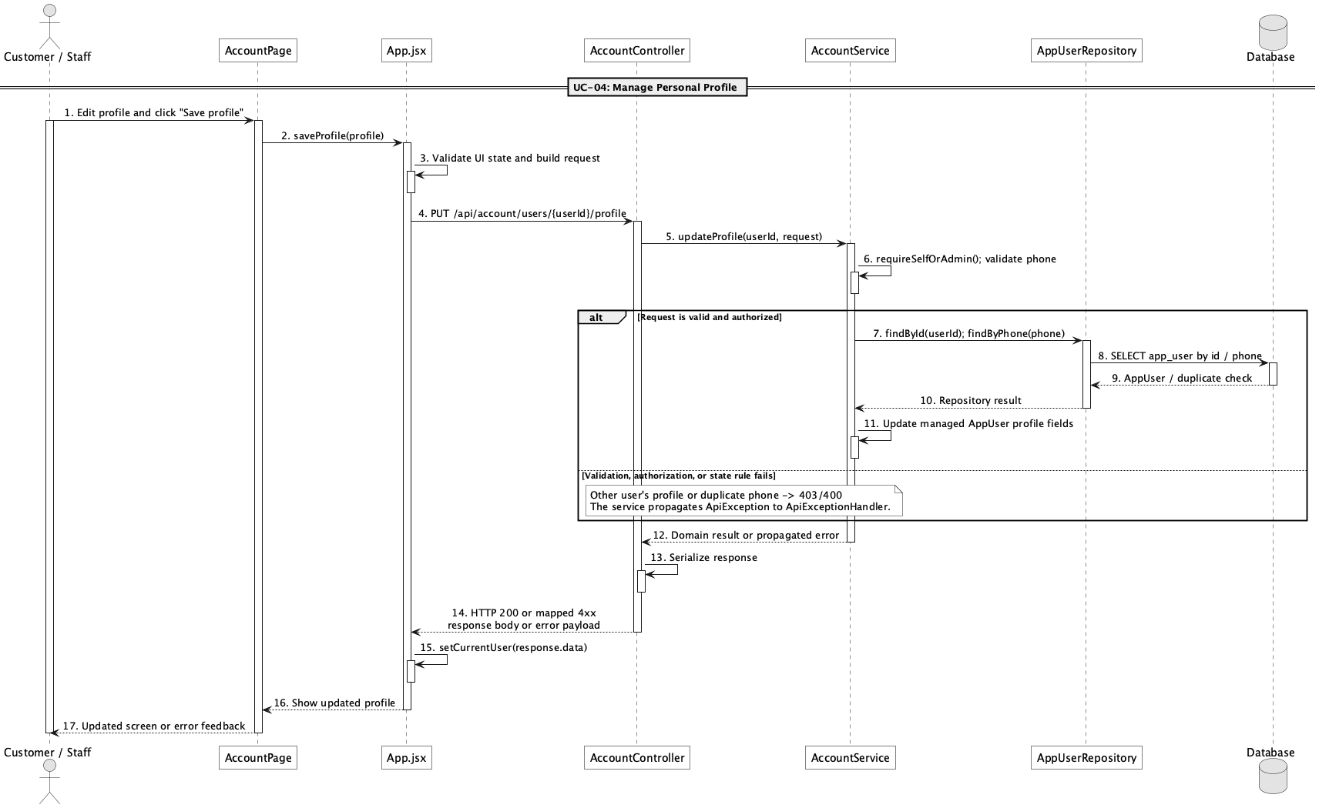

d. Database Queries
== Manage personal profile ==

1. 1. Load profile
SELECT u.*, r.* FROM app_user u LEFT JOIN role r ON r.role_id = u.role_id
WHERE u.user_id = ?;

2. 2. Check replacement phone
SELECT * FROM app_user WHERE phone = ? AND user_id <> ?;

3. 3. Update allowed profile fields
UPDATE app_user SET full_name = ?, phone = ?, address = ?, avatar_url = ?, updated_at = ?
WHERE user_id = ?;

5. Change password

a. Class Diagram
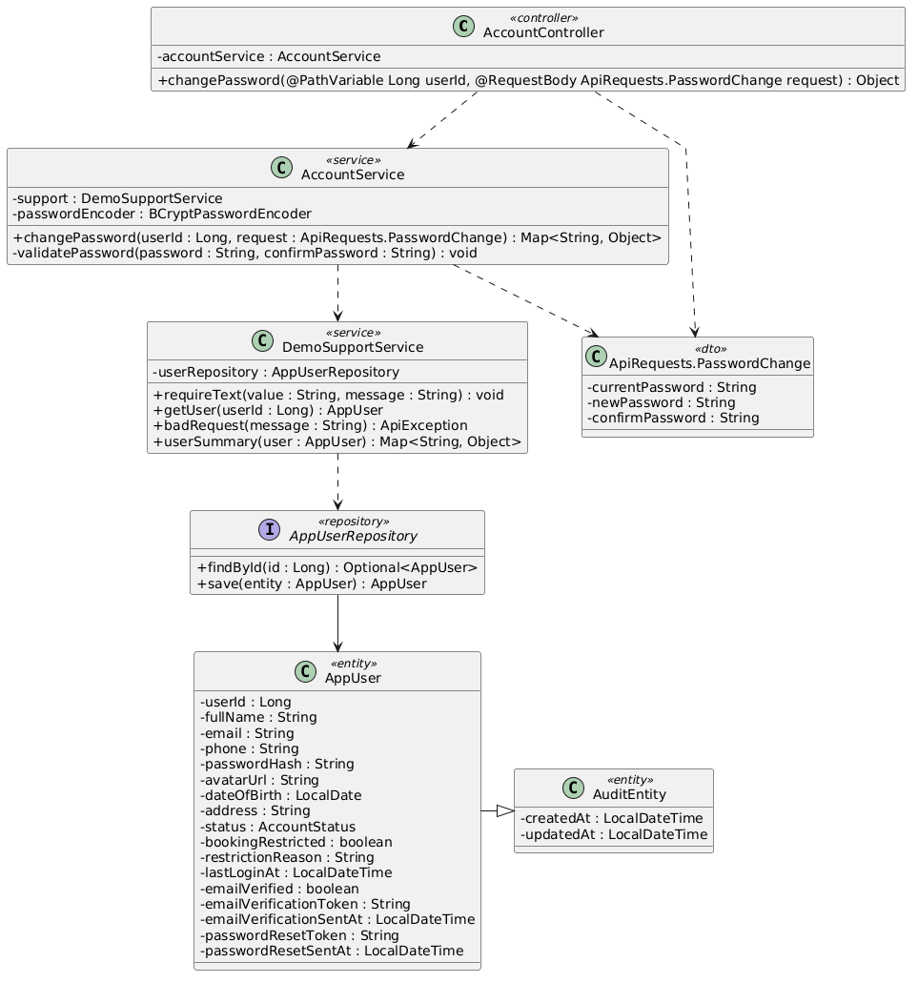

b. Class Specifications
AccountController
No | Method | Description
01 | changePassword(userId : Long, request : ApiRequests.PasswordChange) : Object | Accepts current and new password data for the authenticated account.

AccountService
No | Method | Description
01 | changePassword(userId : Long, request : ApiRequests.PasswordChange) : Map<String, Object> | Checks current password, validates a different new password, stores its hash, and revokes tokens.
02 | validatePassword(password : String, confirmPassword : String) : void | Enforces the shared password policy and confirmation.
03 | revokeAllTokens(user : AppUser) : void | Increments auth version after the password changes.

BCryptPasswordEncoder
No | Method | Description
01 | matches(rawPassword : CharSequence, encodedPassword : String) : boolean | Checks current/unchanged password conditions.
02 | encode(rawPassword : CharSequence) : String | Produces the replacement BCrypt hash.

c. Sequence Diagram
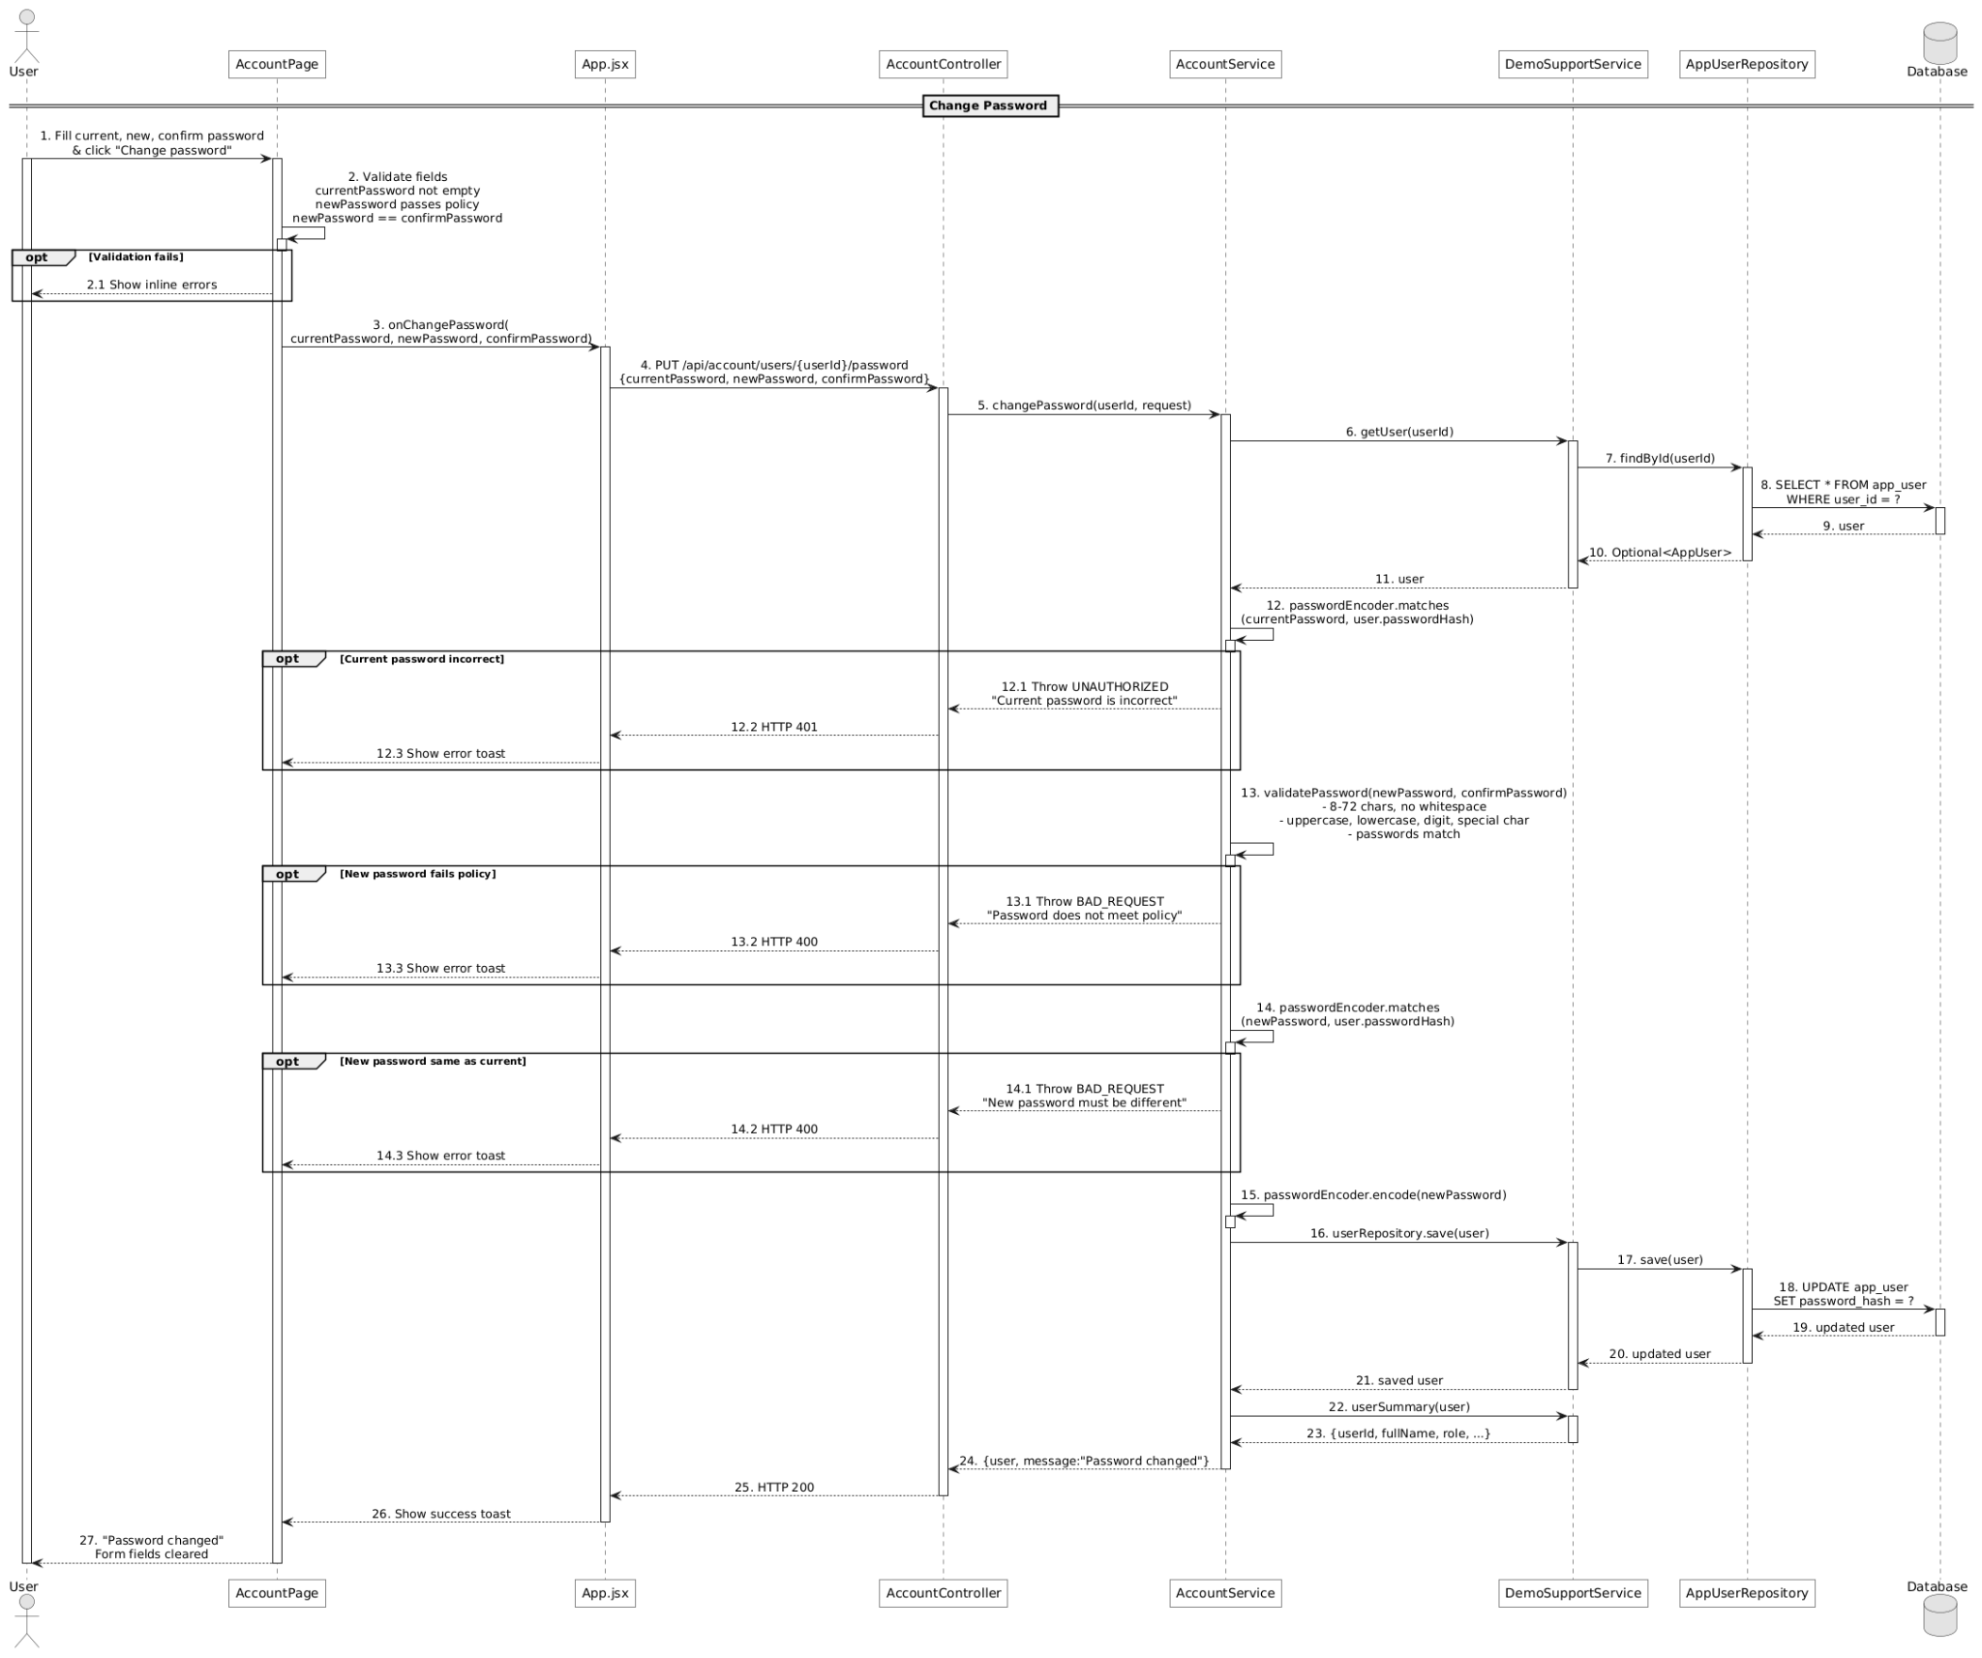

d. Database Queries
== Change password ==

1. 1. Load account for credential check
SELECT * FROM app_user WHERE user_id = ?;

2. 2. Store password and revoke tokens
UPDATE app_user SET password_hash = ?, auth_version = auth_version + 1, updated_at = ?
WHERE user_id = ?;

6. Forgot/reset password

a. Class Diagram
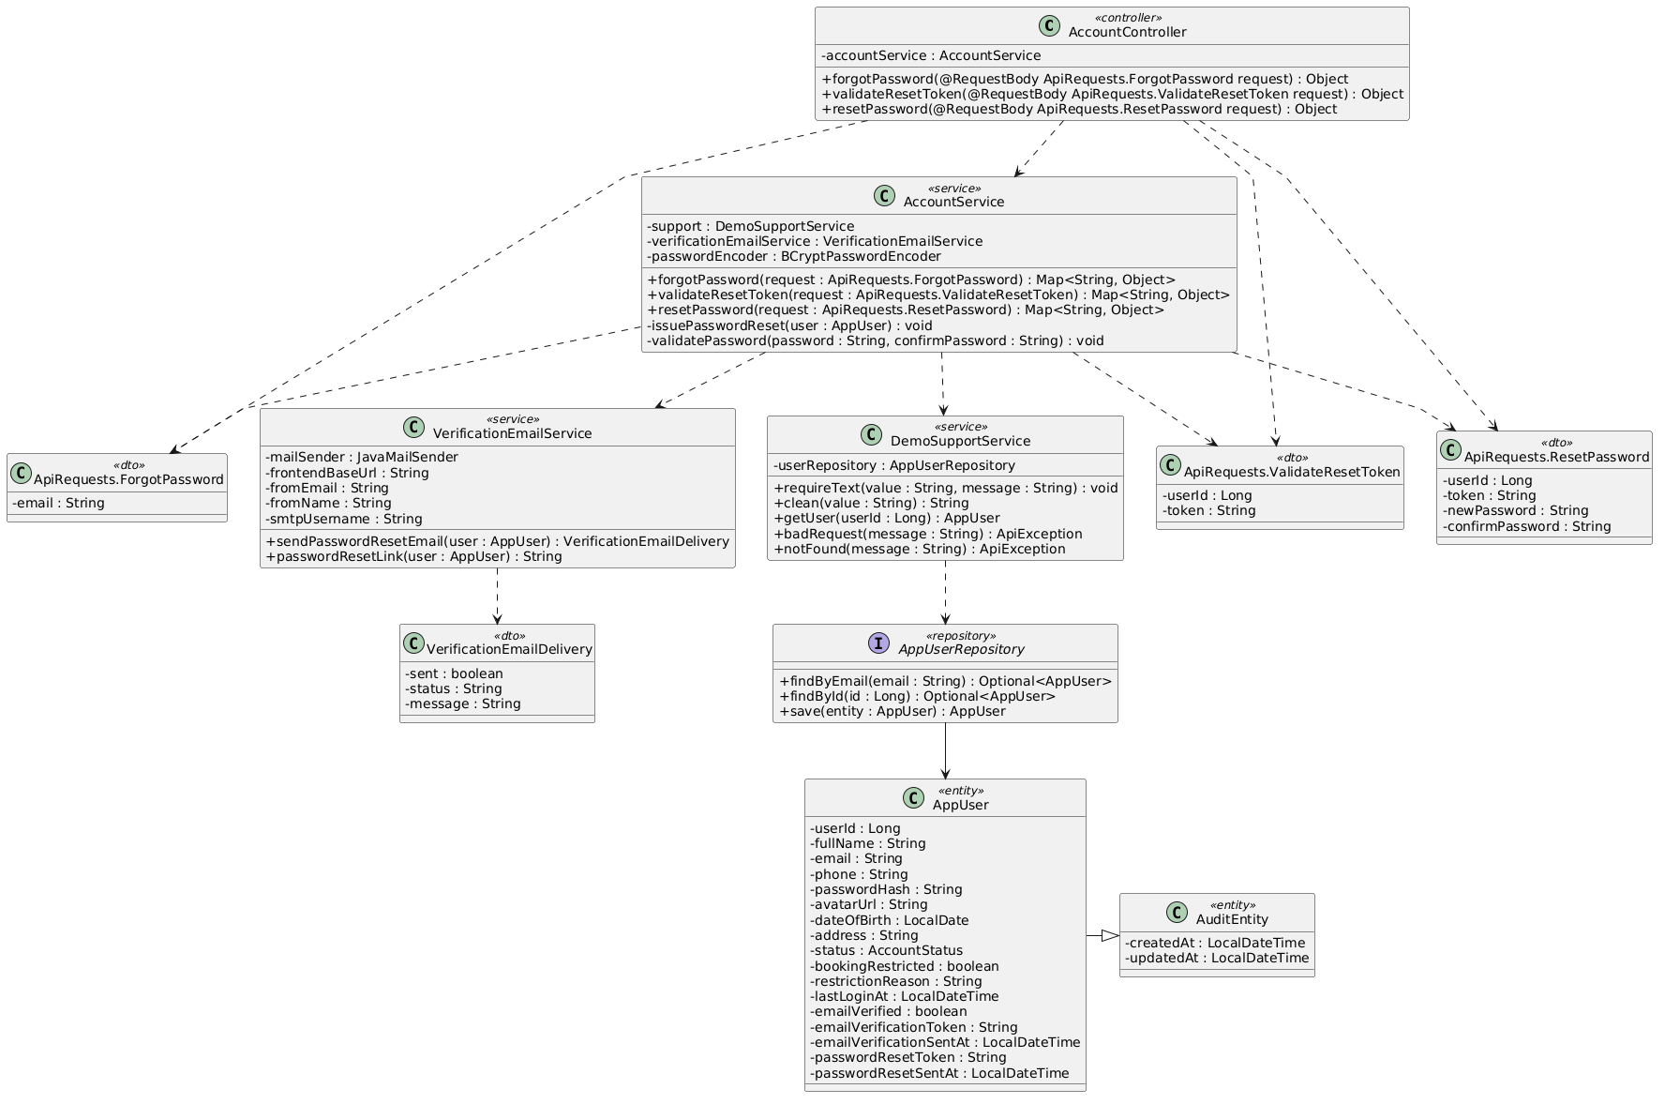

b. Class Specifications
AccountController
No | Method | Description
01 | forgotPassword(request : ApiRequests.ForgotPassword) : Object | Starts the neutral, anti-enumeration reset-request flow.
02 | validateResetToken(request : ApiRequests.ValidateResetToken) : Object | Validates user ID, token, and one-hour age.
03 | resetPassword(request : ApiRequests.ResetPassword) : Object | Applies a valid new password and completes the reset.

AccountService
No | Method | Description
01 | forgotPassword(request : ApiRequests.ForgotPassword) : Map<String, Object> | Issues and emails a token only for an active matching account while returning a neutral message in every case.
02 | validateResetToken(request : ApiRequests.ValidateResetToken) : Map<String, Object> | Rejects a mismatched or expired reset token.
03 | resetPassword(request : ApiRequests.ResetPassword) : Map<String, Object> | Validates the token/password, clears reset state, and revokes prior JWTs.
04 | issuePasswordReset(user : AppUser) : void | Stores a new 16-character token and issue time.

VerificationEmailService
No | Method | Description
01 | sendPasswordResetEmail(user : AppUser) : VerificationEmailDelivery | Sends the reset link to the registered email.
02 | passwordResetLink(user : AppUser) : String | Builds the frontend reset URL from user ID and token.

AppUserRepository
No | Method | Description
01 | findByEmail(email : String) : Optional<AppUser> | Finds an eligible reset account without changing the public response.
02 | save(user : AppUser) : AppUser | Persists issued reset data.

c. Sequence Diagram
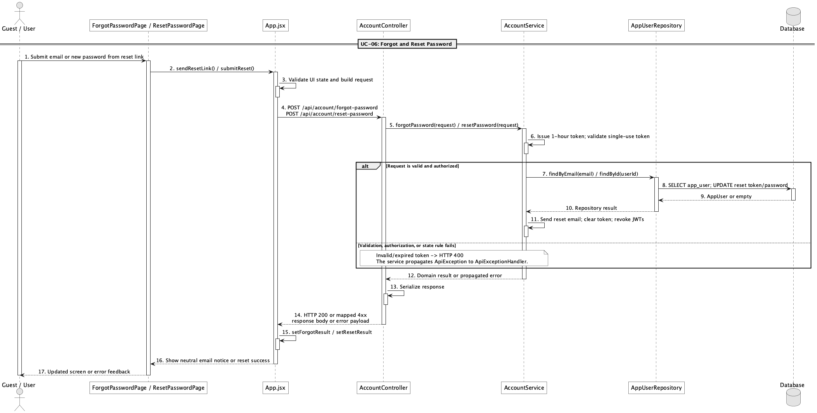

d. Database Queries
== Forgot/reset password ==

1. 1. Find reset account
SELECT u.*, r.* FROM app_user u LEFT JOIN role r ON r.role_id = u.role_id
WHERE u.email = ?;

2. 2. Issue reset token
UPDATE app_user SET password_reset_token = ?, password_reset_sent_at = ?, updated_at = ?
WHERE user_id = ? AND status = 'active';

3. 3. Validate reset link
SELECT * FROM app_user WHERE user_id = ? AND password_reset_token = ?
AND password_reset_sent_at > ?;

4. 4. Complete password reset
UPDATE app_user SET password_hash = ?, password_reset_token = NULL,
password_reset_sent_at = NULL, auth_version = auth_version + 1, updated_at = ?
WHERE user_id = ?;

7. Manage customer accounts

a. Class Diagram
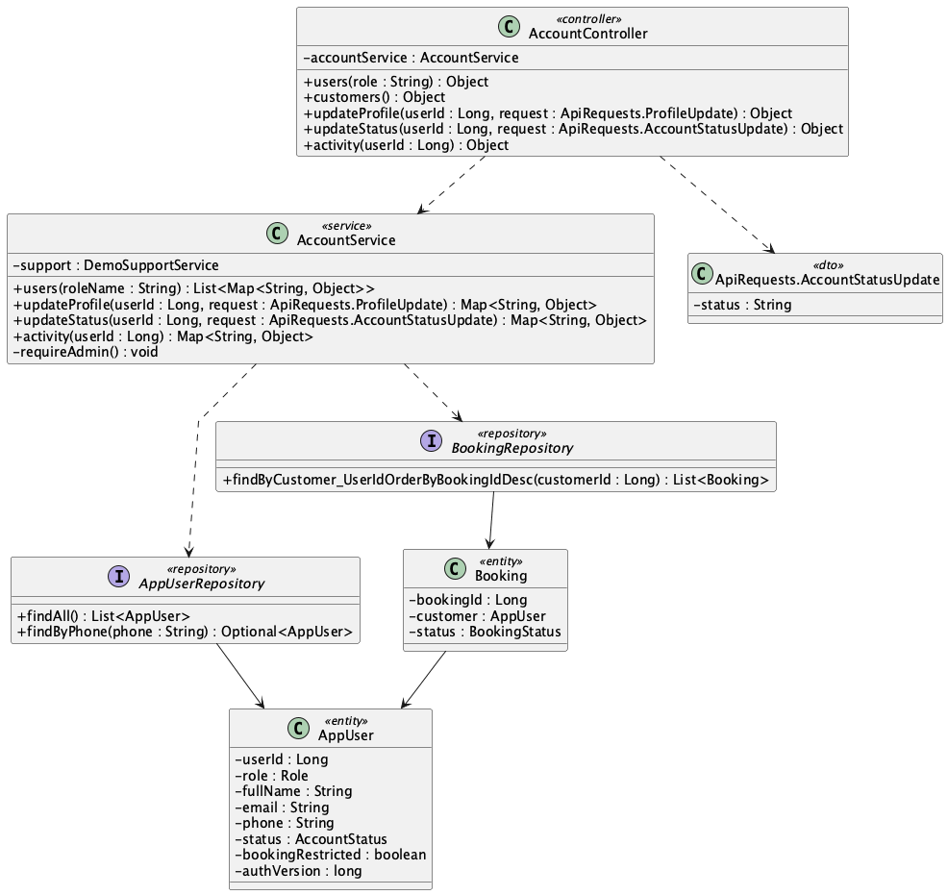

b. Class Specifications
AccountController
No | Method | Description
01 | users(role : String) : Object | Returns an Admin-only account list optionally filtered by role.
02 | updateProfile(userId : Long, request : ApiRequests.ProfileUpdate) : Object | Updates permitted customer profile fields.
03 | updateStatus(userId : Long, request : ApiRequests.AccountStatusUpdate) : Object | Locks or reactivates the selected account.
04 | activity(userId : Long) : Object | Returns selected customer activity details.

AccountService
No | Method | Description
01 | users(roleName : String) : List<Map<String, Object>> | Checks Admin role, loads accounts, and applies the requested role filter.
02 | updateStatus(userId : Long, request : ApiRequests.AccountStatusUpdate) : Map<String, Object> | Prevents Admin self-lock, stores status, and revokes target tokens.
03 | updateProfile(userId : Long, request : ApiRequests.ProfileUpdate) : Map<String, Object> | Updates only the allowed profile fields.
04 | activity(userId : Long) : Map<String, Object> | Builds the customer's recent operational history.

AppUserRepository
No | Method | Description
01 | findAll() : List<AppUser> | Loads accounts for the Admin list.
02 | findByPhone(phone : String) : Optional<AppUser> | Checks uniqueness during a profile update.

BookingRepository
No | Method | Description
01 | findByCustomer_UserIdOrderByBookingIdDesc(customerId : Long) : List<Booking> | Loads the customer's bookings for activity details.

c. Sequence Diagram
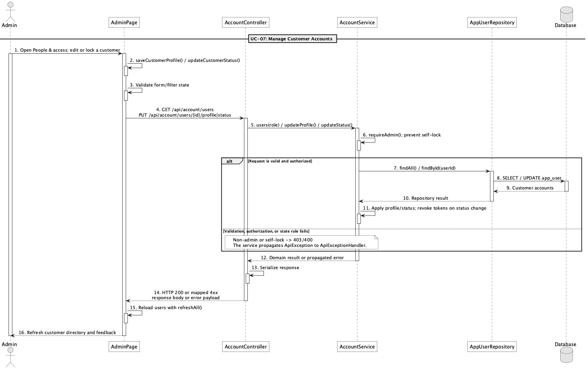

d. Database Queries
== Manage customer accounts ==

1. 1. List Customer accounts
SELECT u.*, r.* FROM app_user u JOIN role r ON r.role_id = u.role_id
WHERE r.role_name = 'Customer' ORDER BY u.user_id DESC;

2. 2. Update Customer status
UPDATE app_user SET status = ?, auth_version = auth_version + 1, updated_at = ?
WHERE user_id = ?;

3. 3. Read Customer activity
SELECT * FROM booking WHERE customer_id = ? ORDER BY booking_id DESC;
SELECT * FROM issue WHERE reporter_id = ? ORDER BY issue_id DESC;

8. Manage staff accounts

a. Class Diagram
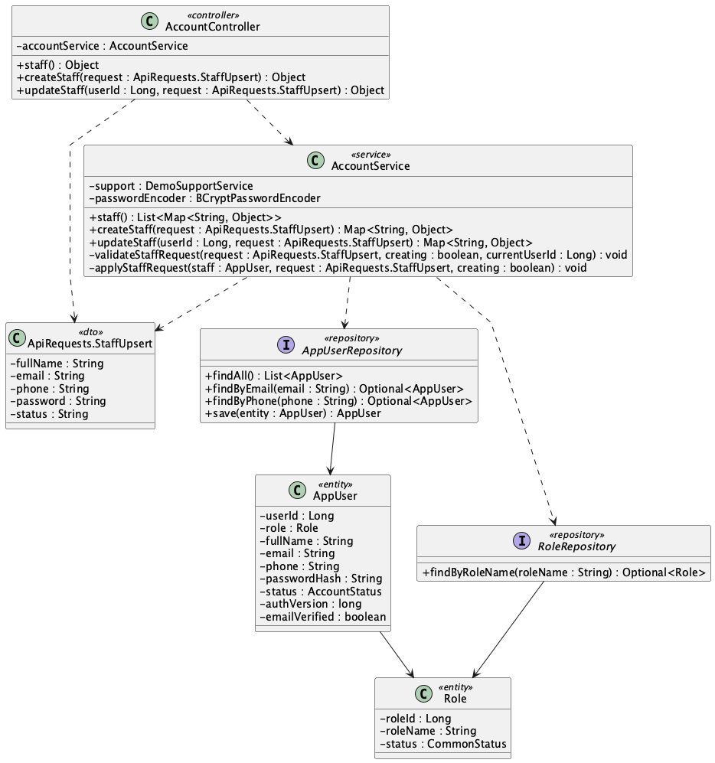

b. Class Specifications
AccountController
No | Method | Description
01 | staff() : Object | Returns the Admin-only Staff list.
02 | createStaff(request : ApiRequests.StaffUpsert) : Object | Creates a Staff account from Admin input.
03 | updateStaff(userId : Long, request : ApiRequests.StaffUpsert) : Object | Updates the selected Staff account.

AccountService
No | Method | Description
01 | staff() : List<Map<String, Object>> | Loads and filters Staff accounts for Admin.
02 | createStaff(request : ApiRequests.StaffUpsert) : Map<String, Object> | Validates identity/password, assigns Staff role, stores BCrypt hash, and marks email verified.
03 | updateStaff(userId : Long, request : ApiRequests.StaffUpsert) : Map<String, Object> | Updates Staff data and revokes tokens after password or non-active status changes.
04 | validateStaffRequest(request, creating, currentUserId) : void | Enforces required fields, formats, uniqueness, and password policy.

AppUserRepository
No | Method | Description
01 | findAll() : List<AppUser> | Loads accounts for the Staff filter.
02 | findByEmail(email : String) : Optional<AppUser> | Checks Staff email uniqueness.
03 | findByPhone(phone : String) : Optional<AppUser> | Checks Staff phone uniqueness.
04 | save(user : AppUser) : AppUser | Persists a newly provisioned Staff account.

RoleRepository
No | Method | Description
01 | findByRoleName(roleName : String) : Optional<Role> | Loads the seeded Staff role.

c. Sequence Diagram
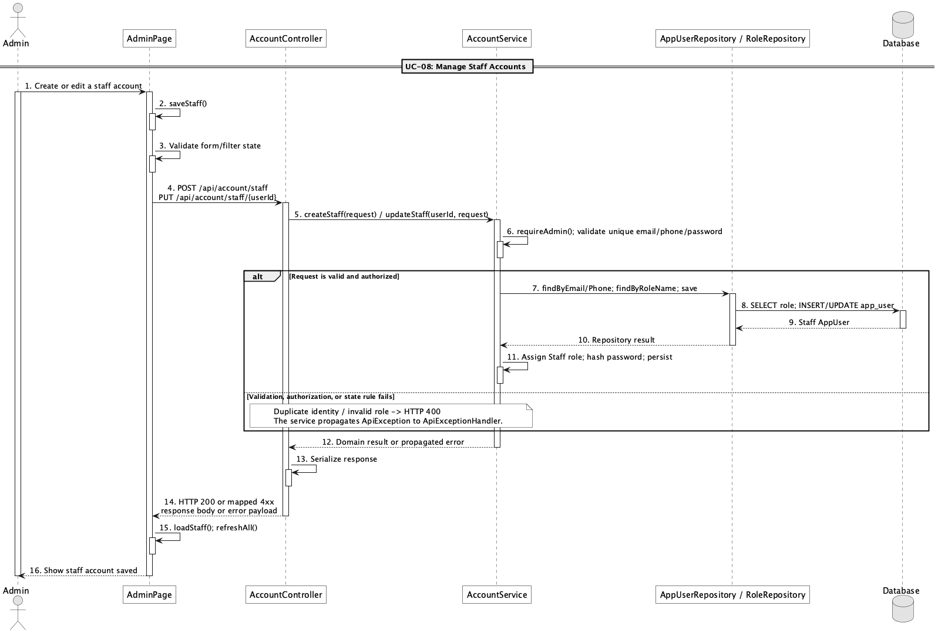

d. Database Queries
== Manage staff accounts ==

1. 1. List Staff accounts
SELECT u.*, r.* FROM app_user u JOIN role r ON r.role_id = u.role_id
WHERE r.role_name = 'Staff' ORDER BY u.user_id DESC;

2. 2. Check Staff identity uniqueness
SELECT * FROM app_user WHERE (email = ? OR phone = ?) AND user_id <> ?;

3. 3. Create Staff account
INSERT INTO app_user
(role_id, full_name, email, phone, password_hash, status, auth_version, email_verified, created_at, updated_at)
VALUES (?, ?, ?, ?, ?, ?, 0, true, ?, ?);

4. 4. Update Staff account
UPDATE app_user SET full_name = ?, email = ?, phone = ?, status = ?,
password_hash = COALESCE(?, password_hash), auth_version = ?, updated_at = ?
WHERE user_id = ?;

9. View customer activity status

a. Class Diagram
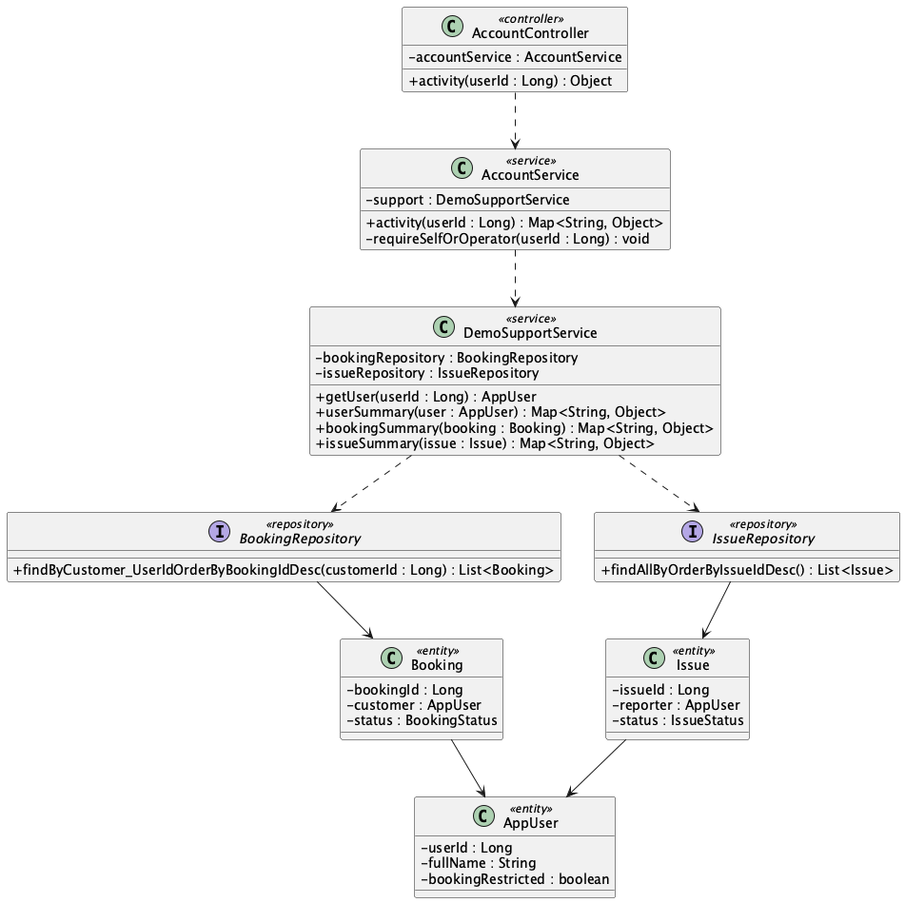

b. Class Specifications
AccountController
No | Method | Description
01 | activity(userId : Long) : Object | Returns the selected customer's operational activity response.

AccountService
No | Method | Description
01 | activity(userId : Long) : Map<String, Object> | Checks self/Staff/Admin access and aggregates user, recent bookings, completed count, and recent issues.
02 | requireSelfOrOperator(userId : Long) : void | Allows self access and cross-account access only to Staff or Admin.

BookingRepository
No | Method | Description
01 | findByCustomer_UserIdOrderByBookingIdDesc(customerId : Long) : List<Booking> | Loads recent bookings and supplies the completed-booking count source.

IssueRepository
No | Method | Description
01 | findAllByOrderByIssueIdDesc() : List<Issue> | Loads issues before filtering to the selected reporter and limiting the response.

DemoSupportService
No | Method | Description
01 | bookingSummary(booking : Booking) : Map<String, Object> | Builds each safe booking row.
02 | issueSummary(issue : Issue) : Map<String, Object> | Builds each safe issue row.
03 | userSummary(user : AppUser) : Map<String, Object> | Builds customer and membership summary data.

c. Sequence Diagram
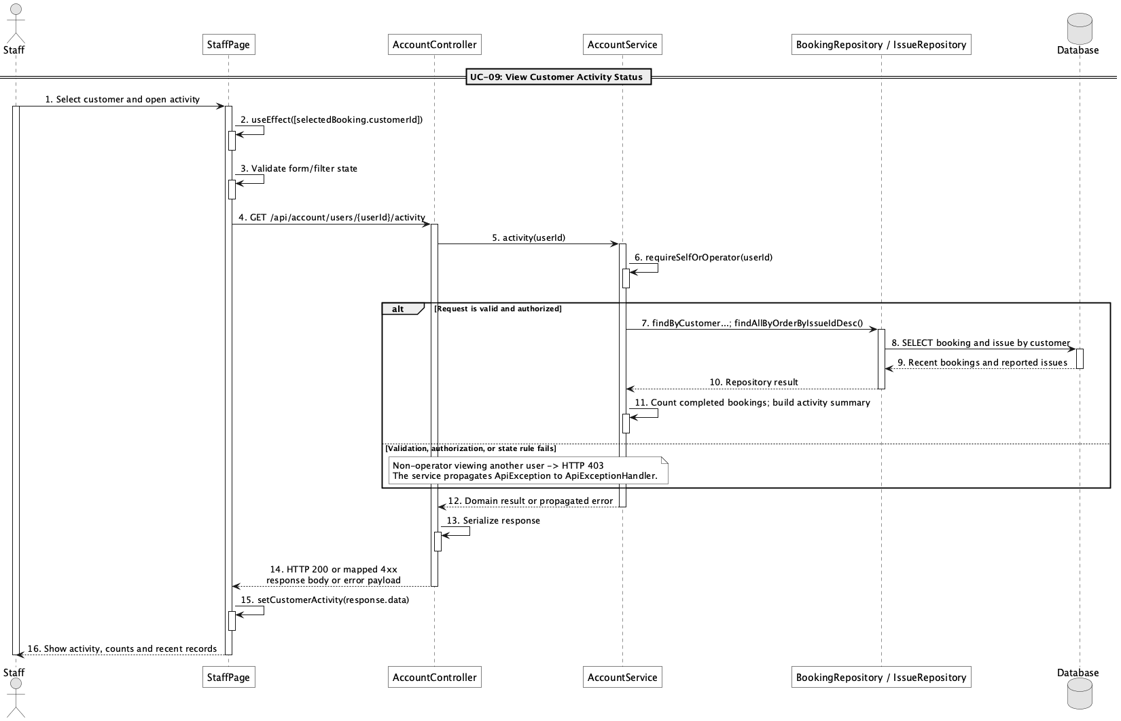

d. Database Queries
== View customer activity status ==

1. 1. Load Customer summary
SELECT u.*, r.* FROM app_user u JOIN role r ON r.role_id = u.role_id
WHERE u.user_id = ?;

2. 2. Load recent bookings
SELECT * FROM booking WHERE customer_id = ? ORDER BY booking_id DESC LIMIT 20;

3. 3. Count completed bookings
SELECT COUNT(*) FROM booking WHERE customer_id = ? AND status = 'completed';

4. 4. Load recent reported issues
SELECT * FROM issue WHERE reporter_id = ? ORDER BY issue_id DESC LIMIT 20;

10. Restrict/unrestrict customer booking ability

a. Class Diagram
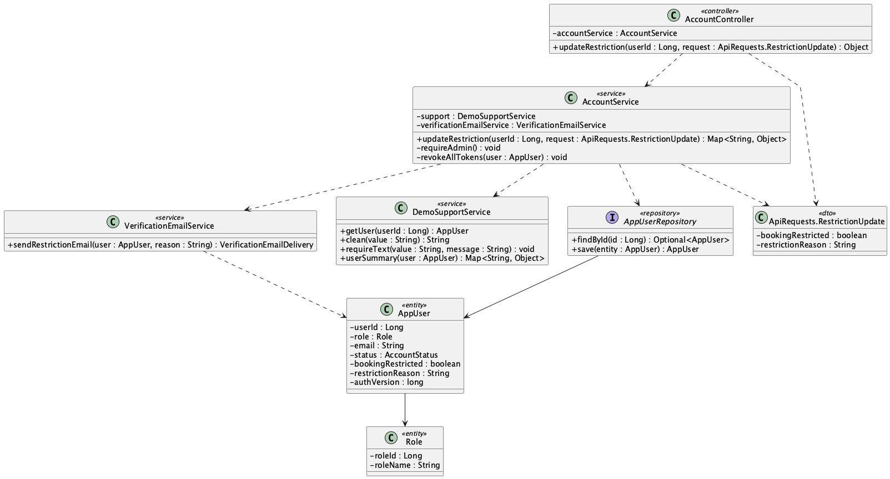

b. Class Specifications
AccountController
No | Method | Description
01 | updateRestriction(userId : Long, request : ApiRequests.RestrictionUpdate) : Object | Receives the Admin booking-access decision for a Customer.

AccountService
No | Method | Description
01 | updateRestriction(userId : Long, request : ApiRequests.RestrictionUpdate) : Map<String, Object> | Checks Admin and Customer role, requires a reason when restricting, stores the state, revokes tokens, and reports email delivery.
02 | requireAdmin() : void | Rejects non-Admin account-management requests.
03 | revokeAllTokens(user : AppUser) : void | Forces the Customer to obtain a token reflecting the latest restriction state.

VerificationEmailService
No | Method | Description
01 | sendRestrictionEmail(user : AppUser, reason : String) : VerificationEmailDelivery | Notifies the Customer of the booking restriction and returns delivery status.

DemoSupportService
No | Method | Description
01 | getUser(userId : Long) : AppUser | Loads the selected target account.
02 | clean(value : String) : String | Normalizes the restriction reason.
03 | requireText(value : String, message : String) : void | Requires a reason when booking access is restricted.
04 | userSummary(user : AppUser) : Map<String, Object> | Returns the updated access state.

c. Sequence Diagram
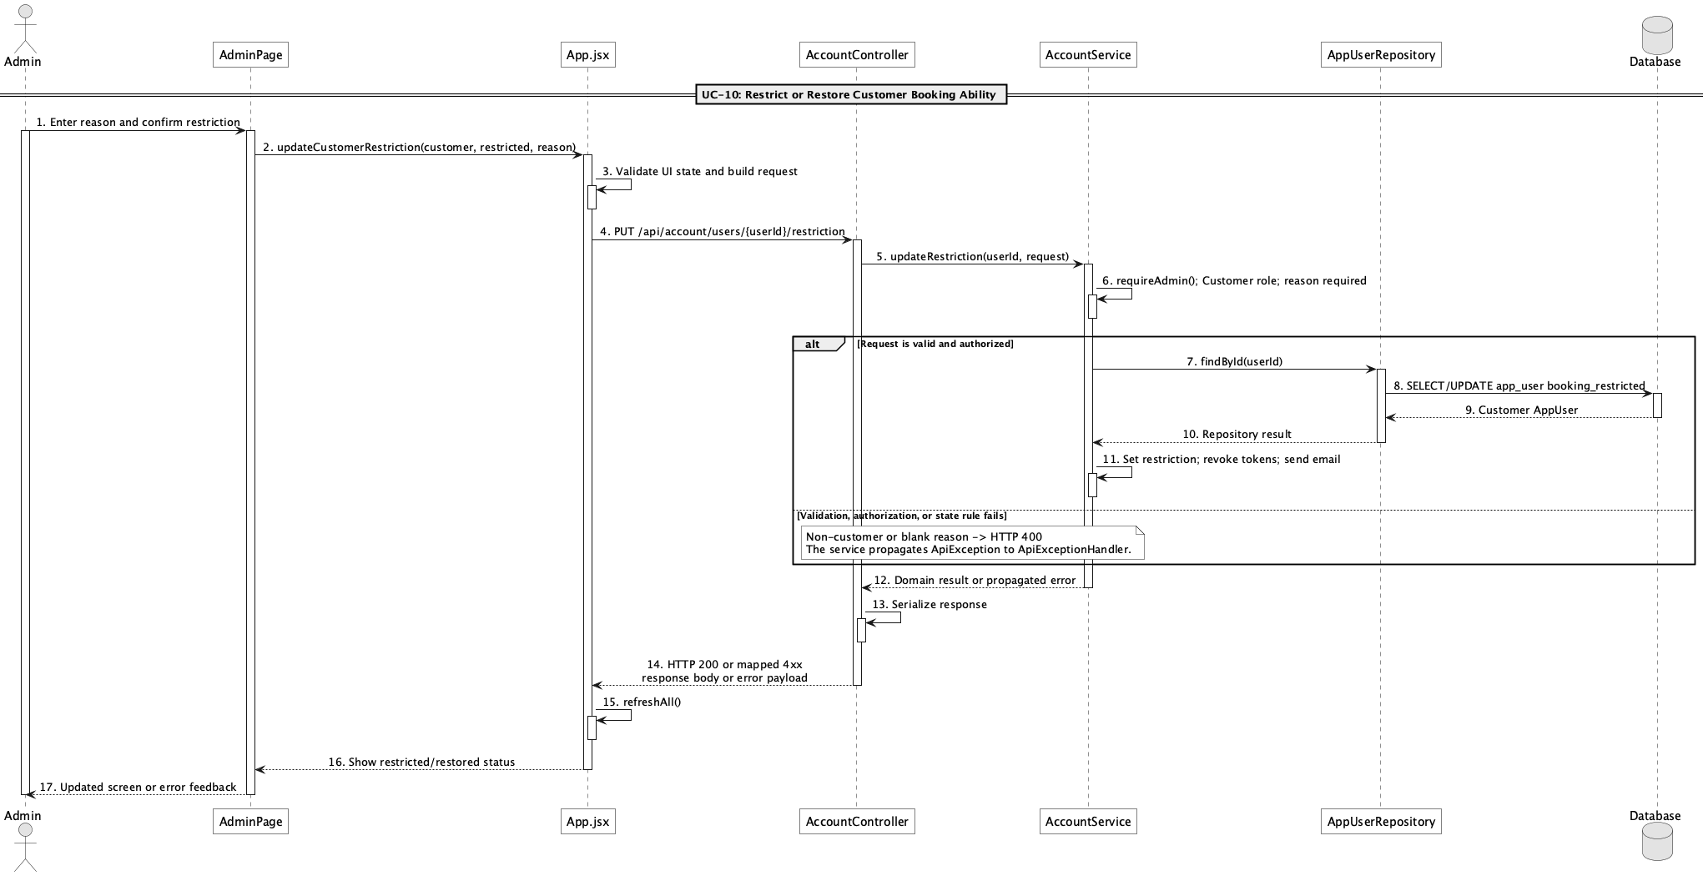

d. Database Queries
== Restrict/unrestrict customer booking ability ==

1. 1. Load and verify Customer account
SELECT u.*, r.* FROM app_user u JOIN role r ON r.role_id = u.role_id
WHERE u.user_id = ? AND r.role_name = 'Customer';

2. 2. Restrict booking access
UPDATE app_user SET booking_restricted = true, restriction_reason = ?,
auth_version = auth_version + 1, updated_at = ? WHERE user_id = ?;

3. 3. Restore booking access
UPDATE app_user SET booking_restricted = false, restriction_reason = NULL,
auth_version = auth_version + 1, updated_at = ? WHERE user_id = ?;

11. View field list

a. Class Diagram
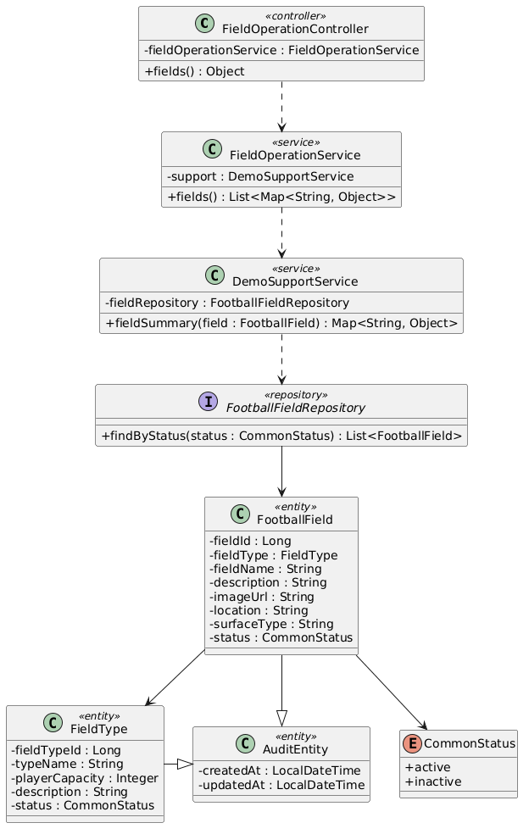

b. Class Specifications
FieldOperationController
No | Method | Description
01 | public Object fields() | Exposes GET /api/fields for the public catalogue.

FieldOperationService
No | Method | Description
01 | public List<Map<String, Object>> fields() | Loads active fields and maps them to catalogue summaries.

FootballFieldRepository
No | Method | Description
01 | List<FootballField> findByStatus(CommonStatus status) | Spring Data lookup used to exclude inactive fields.

c. Sequence Diagram
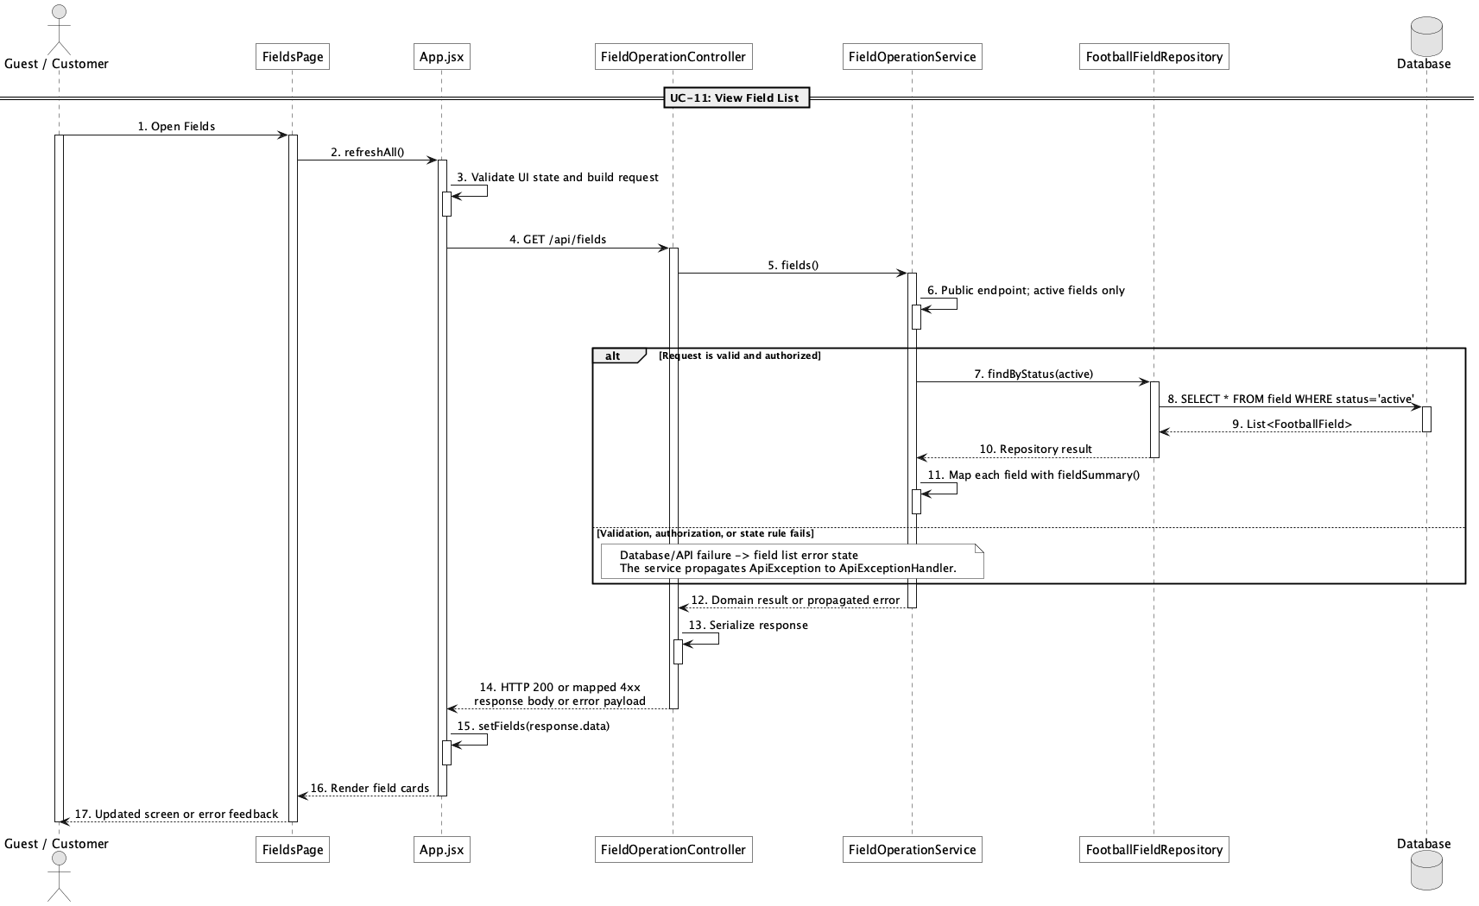

d. Database Queries
== View field list ==

1. Active field catalogue
SELECT f.field_id, f.field_name, ft.type_name, ft.player_capacity,
f.location, f.surface_type, f.image_url, f.status
FROM field f
JOIN field_type ft ON ft.field_type_id = f.field_type_id
WHERE f.status = 'active'
ORDER BY f.field_id;

Implementation note: The physical table name is field; FootballField is the Java entity name.

12. View field detail

a. Class Diagram
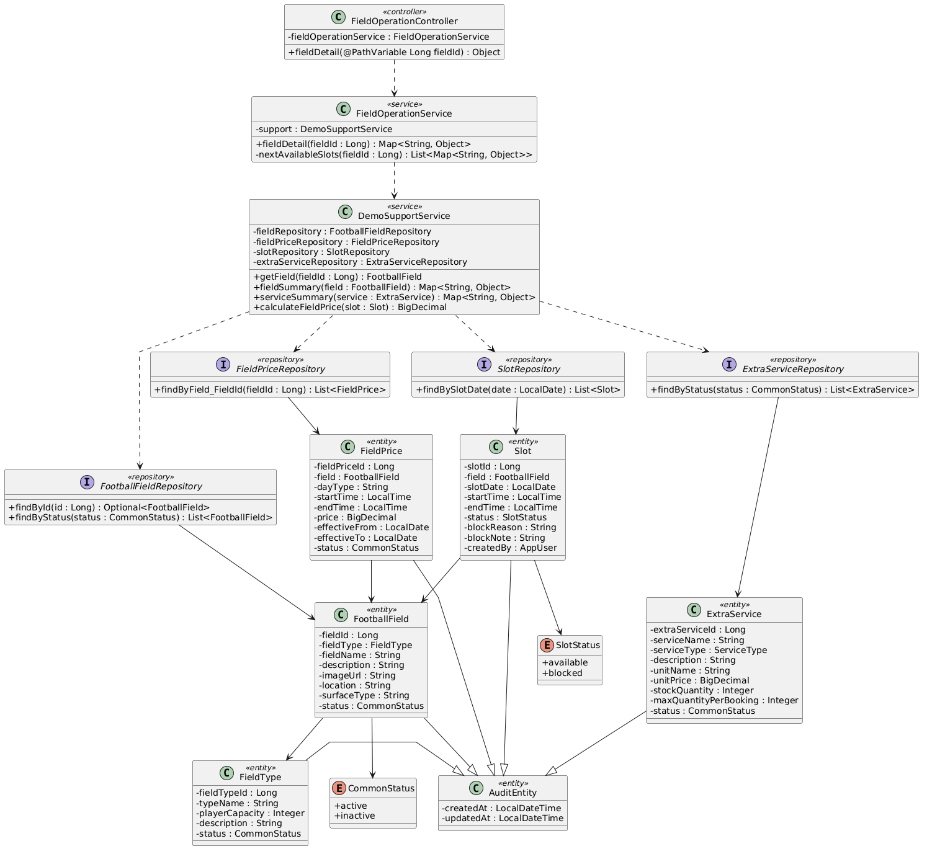

b. Class Specifications
FieldOperationController
No | Method | Description
01 | public Object fieldDetail(Long fieldId) | Exposes GET /api/fields/{fieldId}.

FieldOperationService
No | Method | Description
01 | public Map<String, Object> fieldDetail(Long fieldId) | Combines field identity, active price bands, services, and next available slots.

FieldPriceRepository
No | Method | Description
01 | List<FieldPrice> findByField_FieldId(Long fieldId) | Loads price bands for the selected field.

c. Sequence Diagram
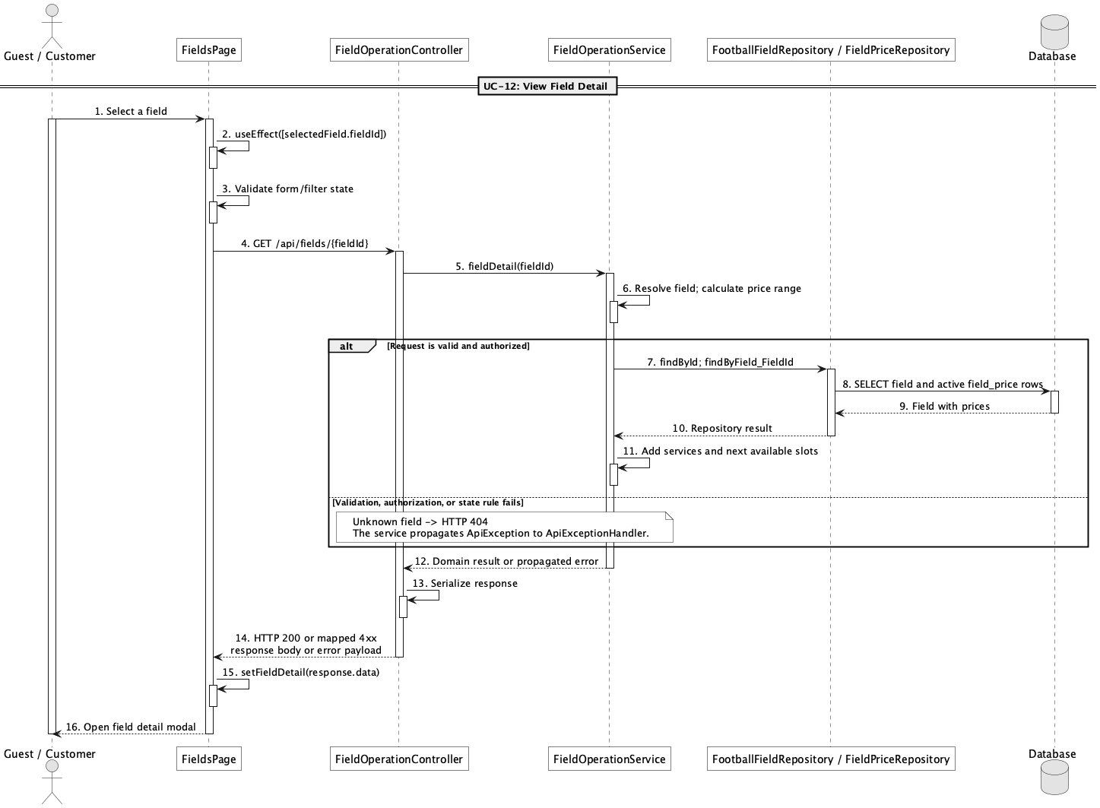

d. Database Queries
== View field detail ==

1. Field detail with active price bands
SELECT f.field_id, f.field_name, ft.type_name, f.description, f.image_url,
f.location, f.surface_type, fp.day_type, fp.start_time, fp.end_time, fp.price
FROM field f
JOIN field_type ft ON ft.field_type_id = f.field_type_id
LEFT JOIN field_price fp ON fp.field_id = f.field_id AND fp.status = 'active'
WHERE f.field_id = :fieldId
ORDER BY fp.day_type, fp.start_time;

Implementation note: Reviews are deferred: there is no review entity, repository, table, or workflow. The current response only adds an empty reviews list and explanatory reviewSummary placeholder.

13. Search available fields by date/time

a. Class Diagram
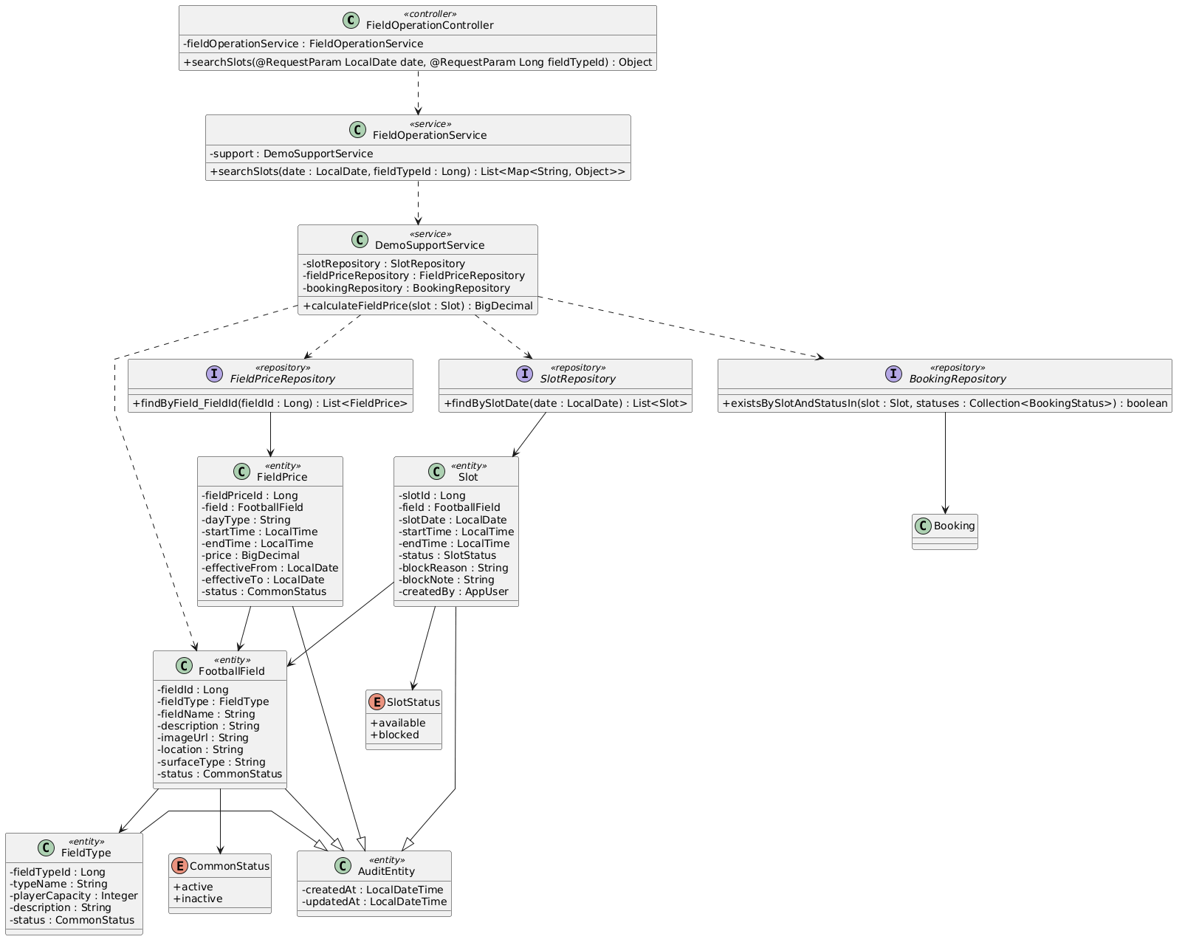

b. Class Specifications
FieldOperationController
No | Method | Description
01 | public Object searchSlots(LocalDate date, Long fieldTypeId) | Exposes GET /api/slots/search with optional date and fieldTypeId filters.

FieldOperationService
No | Method | Description
01 | public List<Map<String, Object>> searchSlots(LocalDate date, Long fieldTypeId) | Returns active-field slots, derived booked state, availability, and calculated price.

SlotRepository
No | Method | Description
01 | List<Slot> findBySlotDate(LocalDate slotDate) | Loads all slots for the requested date.

BookingRepository
No | Method | Description
01 | boolean existsBySlotAndStatusIn(Slot slot, Collection<BookingStatus> statuses) | Marks slots reserved by pending, confirmed, or checked-in bookings.

c. Sequence Diagram
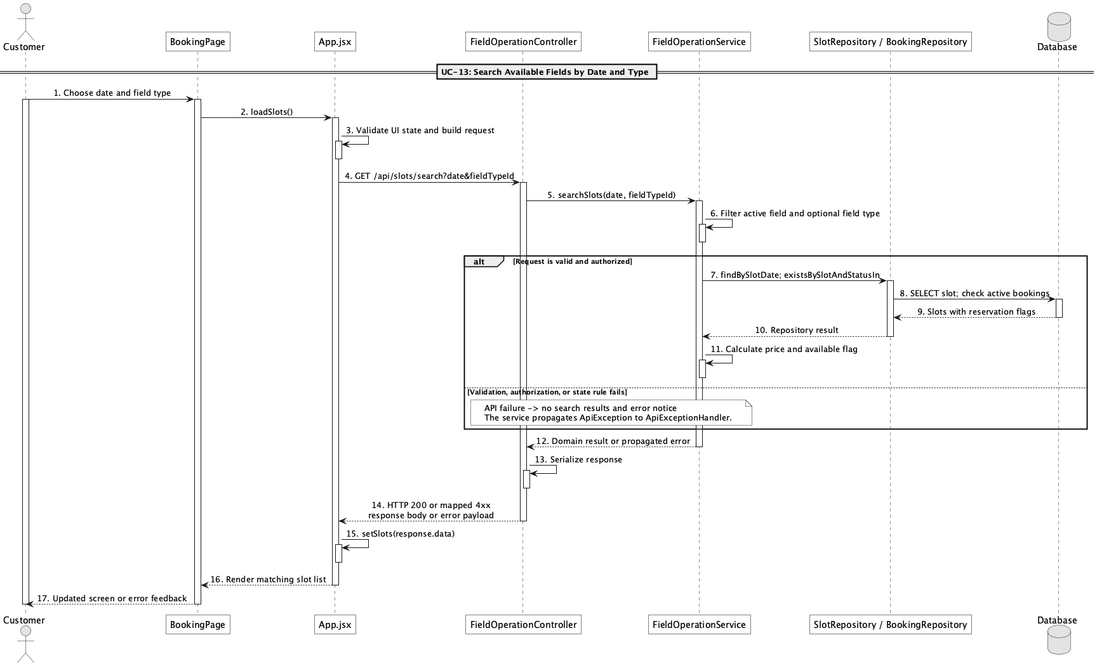

d. Database Queries
== Search available fields by date/time ==

1. Searchable slot availability
SELECT s.slot_id, s.slot_date, s.start_time, s.end_time, f.field_id, f.field_name,
ft.type_name, CASE WHEN EXISTS (
SELECT 1 FROM booking b
WHERE b.slot_id = s.slot_id
AND b.status IN ('pending','confirmed','checked_in')
) THEN 'booked' ELSE s.status END AS effective_status
FROM slot s
JOIN field f ON f.field_id = s.field_id AND f.status = 'active'
JOIN field_type ft ON ft.field_type_id = f.field_type_id
WHERE s.slot_date = :slotDate
AND (:fieldTypeId IS NULL OR ft.field_type_id = :fieldTypeId)
ORDER BY f.field_name, s.start_time;

Implementation note: The API accepts a date and field type; time is represented by the returned slot start_time/end_time rather than a separate time request parameter.

14. Manage football fields

a. Class Diagram
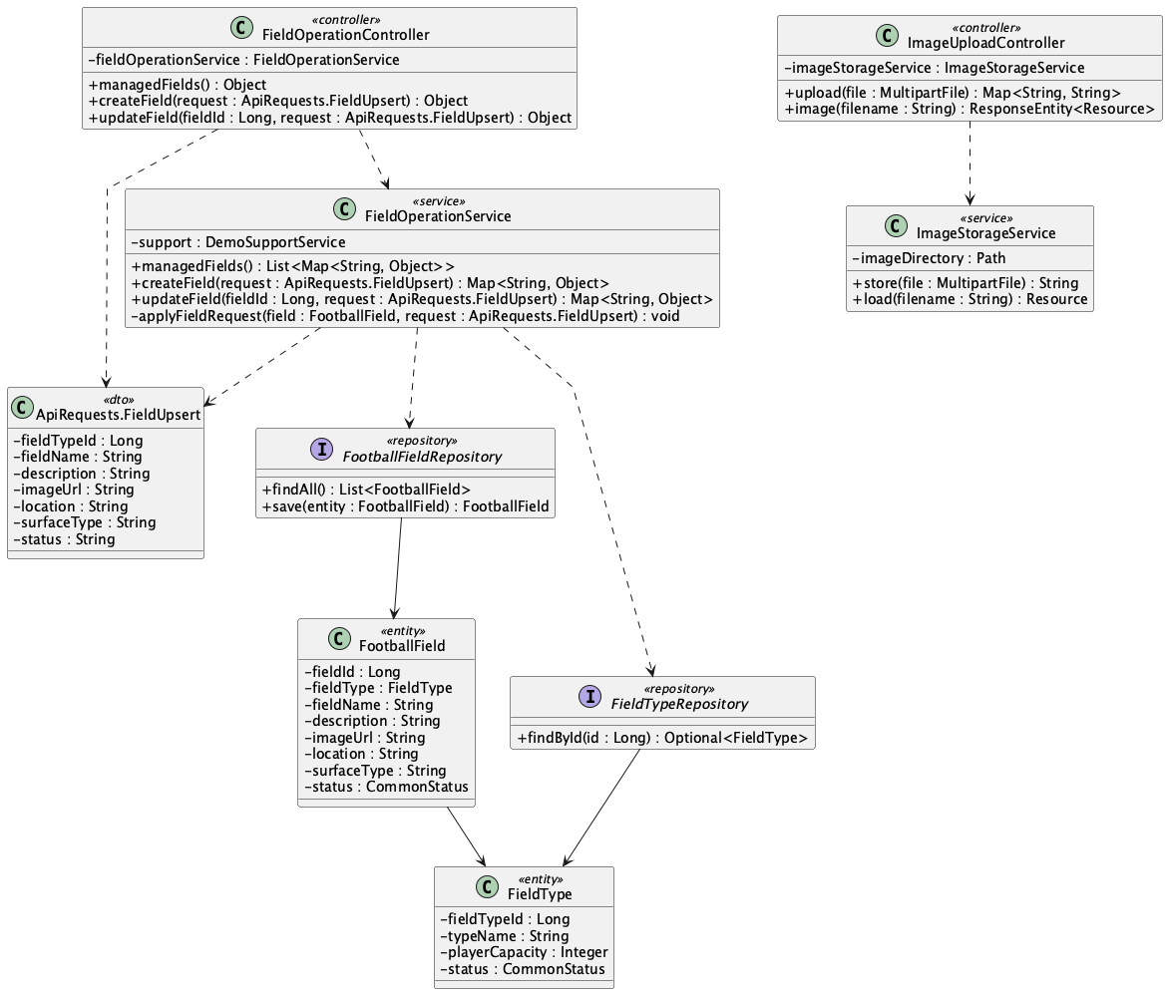

b. Class Specifications
FieldOperationController
No | Method | Description
01 | public Object managedFields() | Lists all fields for administration.
02 | public Object createField(ApiRequests.FieldUpsert request) | Creates a field through POST /api/admin/fields.
03 | public Object updateField(Long fieldId, ApiRequests.FieldUpsert request) | Updates field data and active/inactive state.

FieldOperationService
No | Method | Description
01 | public List<Map<String, Object>> managedFields() | Returns the complete field catalogue including inactive rows.
02 | public Map<String, Object> createField(ApiRequests.FieldUpsert request) | Validates and persists a new FootballField.
03 | public Map<String, Object> updateField(Long fieldId, ApiRequests.FieldUpsert request) | Applies an administrative field update.

c. Sequence Diagram
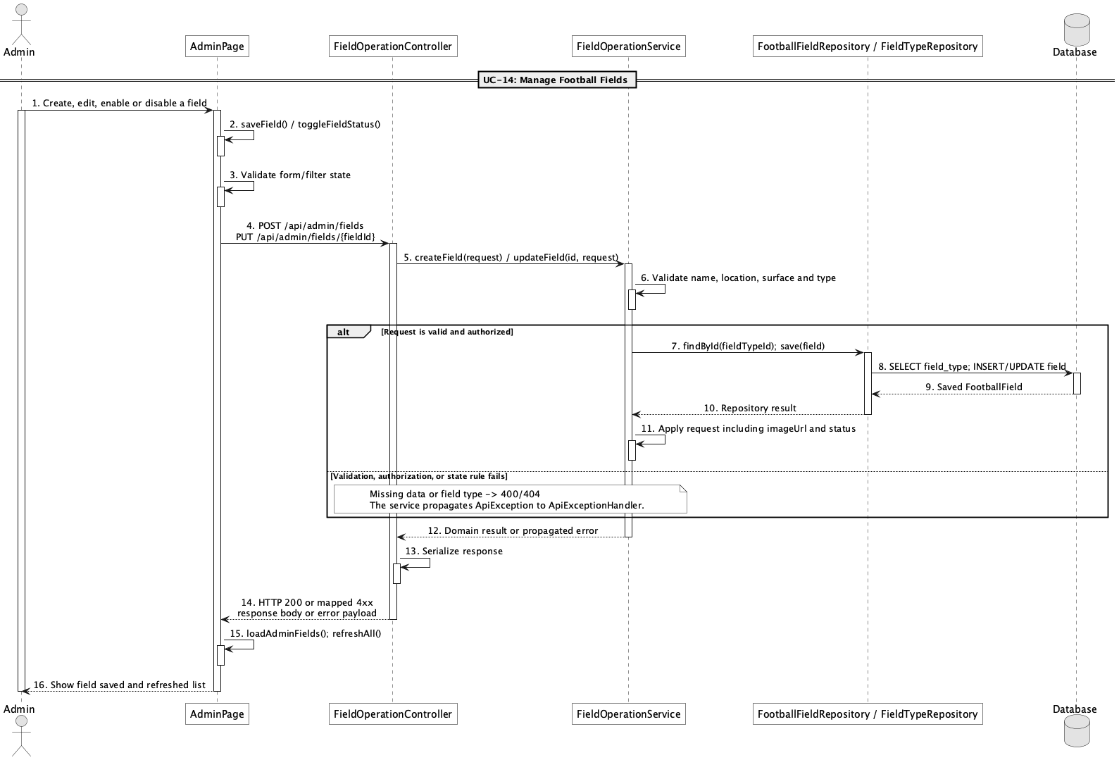

d. Database Queries
== Manage football fields ==

1. Create or update a field
INSERT INTO field (field_type_id, field_name, description, image_url, location, surface_type, status, created_at, updated_at)
VALUES (:fieldTypeId, :fieldName, :description, :imageUrl, :location, :surfaceType, :status, CURRENT_TIMESTAMP, CURRENT_TIMESTAMP);

UPDATE field
SET field_type_id = :fieldTypeId, field_name = :fieldName, description = :description,
image_url = :imageUrl, location = :location, surface_type = :surfaceType,
status = :status, updated_at = CURRENT_TIMESTAMP
WHERE field_id = :fieldId;

Implementation note: Role protection is centralized in SecurityConfig through /api/admin/**.

15. Manage field pricing by time range

a. Class Diagram
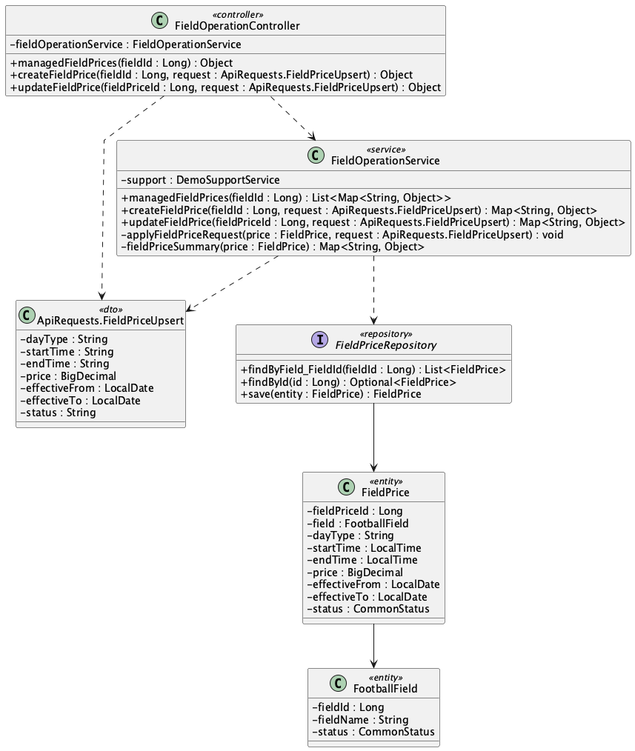

b. Class Specifications
FieldOperationController
No | Method | Description
01 | public Object managedFieldPrices(Long fieldId) | Lists all pricing rules for one field.
02 | public Object createFieldPrice(Long fieldId, ApiRequests.FieldPriceUpsert request) | Creates a day/time price band.
03 | public Object updateFieldPrice(Long fieldPriceId, ApiRequests.FieldPriceUpsert request) | Updates an existing price band.

FieldOperationService
No | Method | Description
01 | public List<Map<String, Object>> managedFieldPrices(Long fieldId) | Sorts pricing rules by day type and start time.
02 | public Map<String, Object> createFieldPrice(Long fieldId, ApiRequests.FieldPriceUpsert request) | Validates day type, time range, amount, effective dates, and status.
03 | public Map<String, Object> updateFieldPrice(Long fieldPriceId, ApiRequests.FieldPriceUpsert request) | Reuses the same pricing validation for edits.

FieldPriceRepository
No | Method | Description
01 | List<FieldPrice> findByField_FieldId(Long fieldId) | Reads pricing rules for pricing and field-detail flows.

c. Sequence Diagram
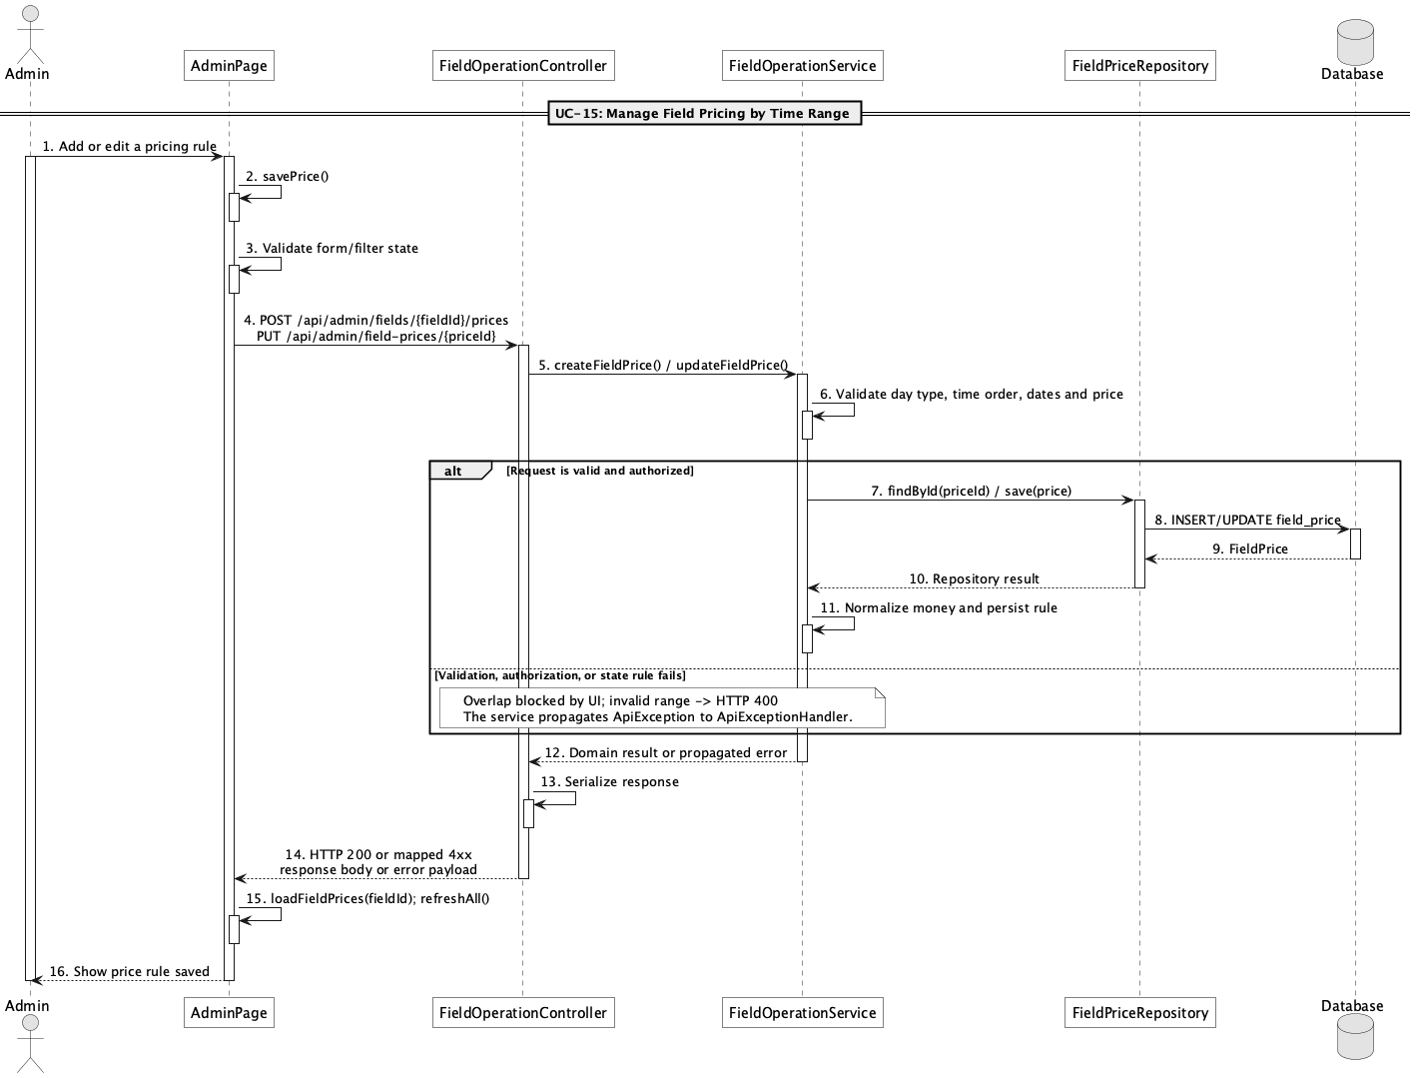

d. Database Queries
== Manage field pricing by time range ==

1. Field pricing rules
SELECT field_price_id, field_id, day_type, start_time, end_time, price,
effective_from, effective_to, status
FROM field_price
WHERE field_id = :fieldId
ORDER BY day_type, start_time;

Implementation note: Allowed day_type values in service validation are all, weekday, and weekend.

16. Manage unavailable slots

a. Class Diagram
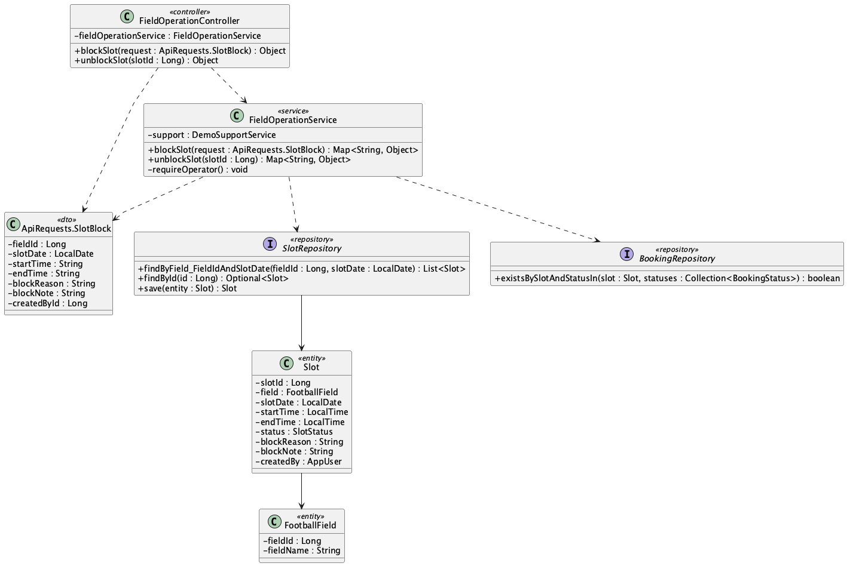

b. Class Specifications
FieldOperationController
No | Method | Description
01 | public Object blockSlot(ApiRequests.SlotBlock request) | Creates or changes a time slot to blocked.
02 | public Object unblockSlot(Long slotId) | Restores a blocked slot to available.

FieldOperationService
No | Method | Description
01 | public Map<String, Object> blockSlot(ApiRequests.SlotBlock request) | Validates operator, time range, active booking conflicts, and audit creator.
02 | public Map<String, Object> unblockSlot(Long slotId) | Clears block reason/note and makes the slot available.

SlotRepository
No | Method | Description
01 | List<Slot> findByField_FieldIdAndSlotDate(Long fieldId, LocalDate slotDate) | Finds an existing exact time range before creating a new blocked slot.

c. Sequence Diagram
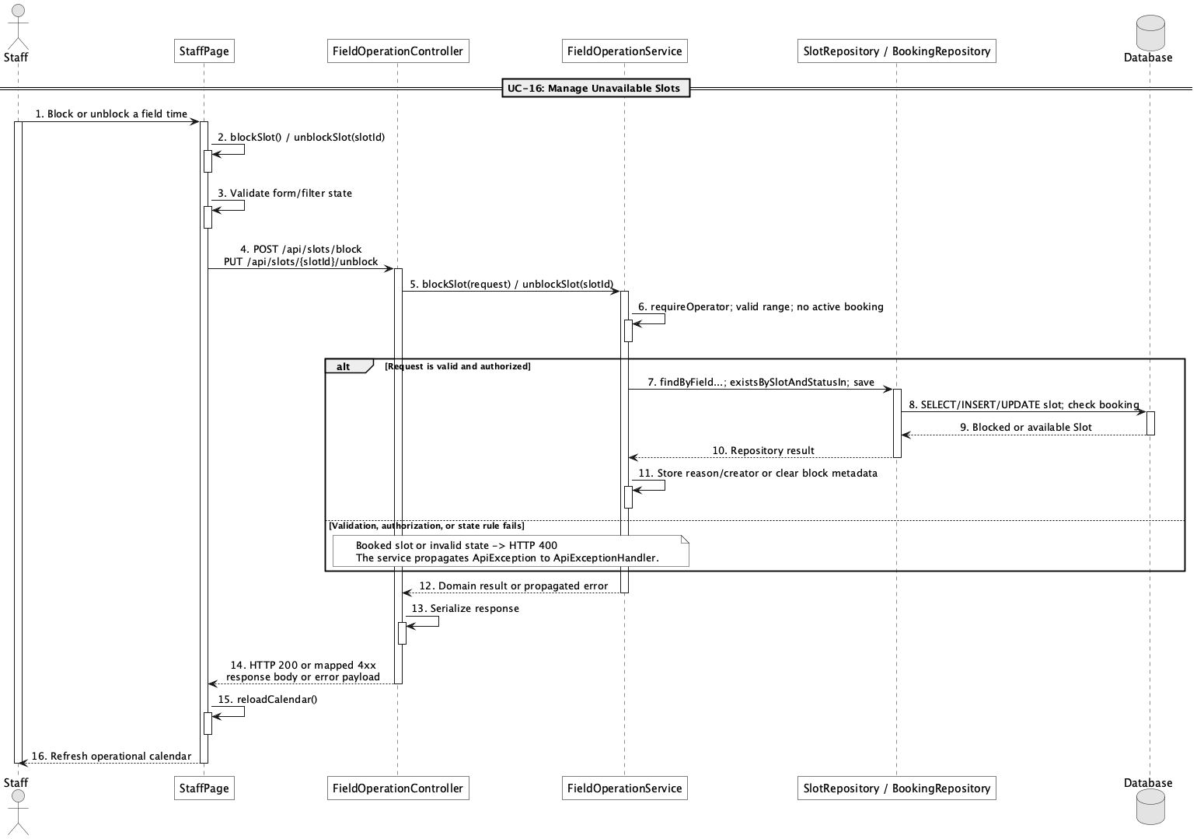

d. Database Queries
== Manage unavailable slots ==

1. Block and unblock a slot
UPDATE slot
SET status = 'blocked', block_reason = :reason, block_note = :note,
created_by = :operatorId, updated_at = CURRENT_TIMESTAMP
WHERE slot_id = :slotId;

UPDATE slot
SET status = 'available', block_reason = NULL, block_note = NULL, updated_at = CURRENT_TIMESTAMP
WHERE slot_id = :slotId AND status = 'blocked';

Implementation note: Blocking is rejected when an active booking already occupies the exact persisted slot.

17. View field operation calendar

a. Class Diagram
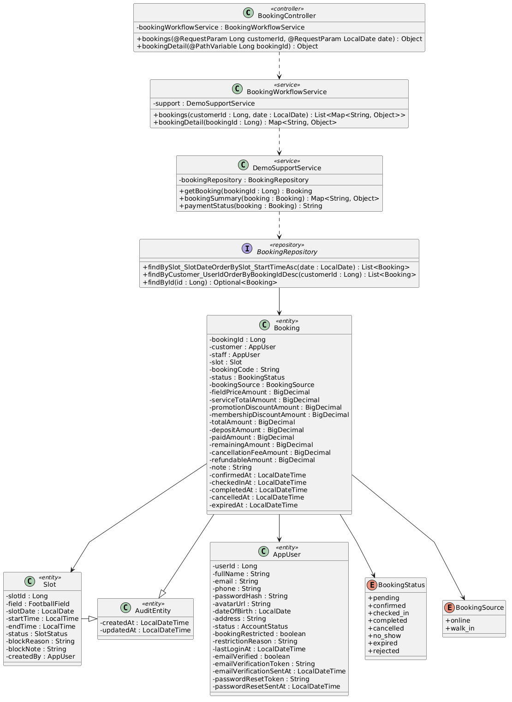

b. Class Specifications
FieldOperationController
No | Method | Description
01 | public Object operationCalendar(LocalDate date) | Exposes the staff/admin daily operations view.

FieldOperationService
No | Method | Description
01 | public List<Map<String, Object>> operationCalendar(LocalDate date) | Merges every slot on a date with its booking and operational status.

BookingRepository
No | Method | Description
01 | List<Booking> findBySlot_SlotDateOrderBySlot_StartTimeAsc(LocalDate slotDate) | Loads bookings for the selected operating date.

c. Sequence Diagram
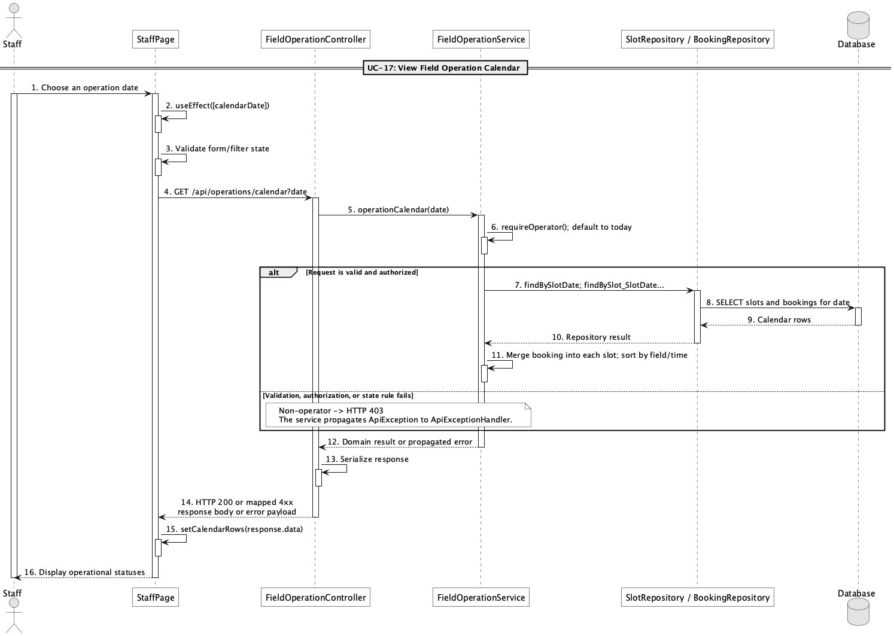

d. Database Queries
== View field operation calendar ==

1. Daily field operations
SELECT s.slot_id, f.field_name, s.start_time, s.end_time, s.status AS slot_status,
b.booking_id, b.booking_code, b.status AS booking_status, b.customer_id, b.staff_id
FROM slot s
JOIN field f ON f.field_id = s.field_id
LEFT JOIN booking b ON b.slot_id = s.slot_id
WHERE s.slot_date = :operationDate
ORDER BY f.field_name, s.start_time;

Implementation note: This is a date-focused operations calendar, not a month-grid scheduling engine.

18. Manage extra services

a. Class Diagram
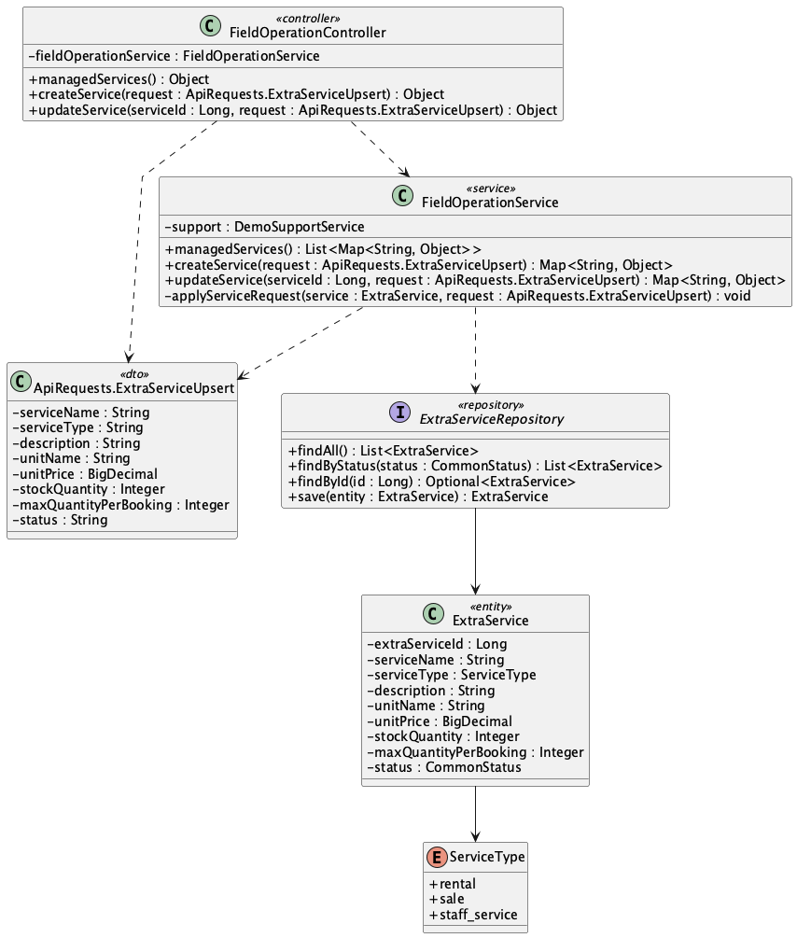

b. Class Specifications
FieldOperationController
No | Method | Description
01 | public Object managedServices() | Lists active and inactive services for Admin.
02 | public Object createService(ApiRequests.ExtraServiceUpsert request) | Creates an extra service.
03 | public Object updateService(Long serviceId, ApiRequests.ExtraServiceUpsert request) | Updates service pricing, inventory, limits, and status.

FieldOperationService
No | Method | Description
01 | public List<Map<String, Object>> managedServices() | Returns the complete service inventory.
02 | public Map<String, Object> createService(ApiRequests.ExtraServiceUpsert request) | Validates and persists a new ExtraService.
03 | public Map<String, Object> updateService(Long serviceId, ApiRequests.ExtraServiceUpsert request) | Applies validated changes to an ExtraService.

ExtraServiceRepository
No | Method | Description
01 | List<ExtraService> findByStatus(CommonStatus status) | Supplies active services to public and booking flows.

c. Sequence Diagram
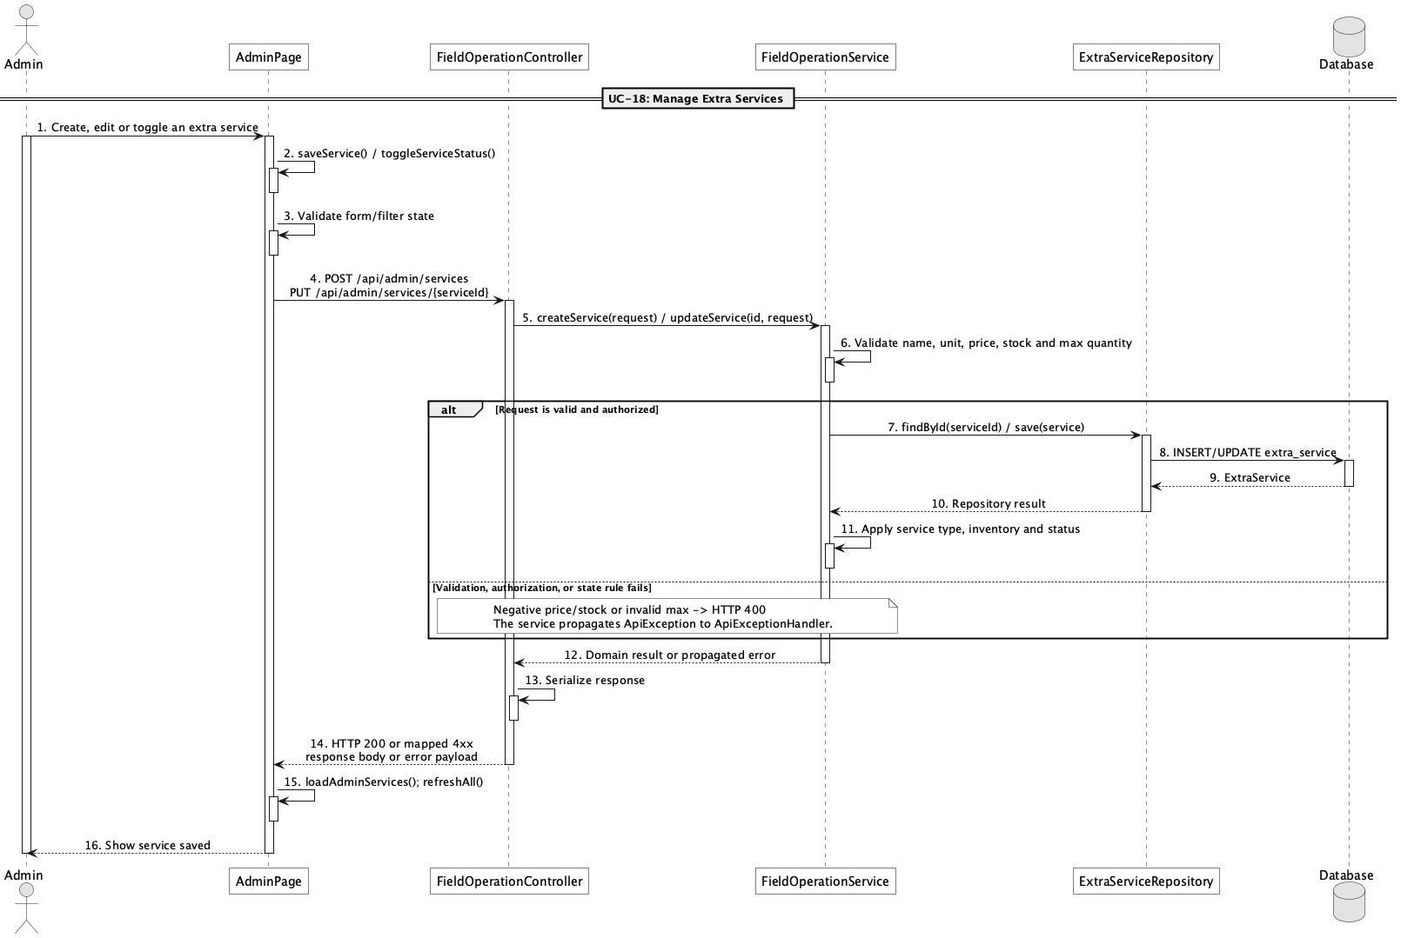

d. Database Queries
== Manage extra services ==

1. Managed service inventory
SELECT extra_service_id, service_name, service_type, description, unit_name,
unit_price, stock_quantity, max_quantity_per_booking, status
FROM extra_service
ORDER BY extra_service_id;

Implementation note: Service types map to rental, sale, and staff_service.

19. Check extra service availability

a. Class Diagram
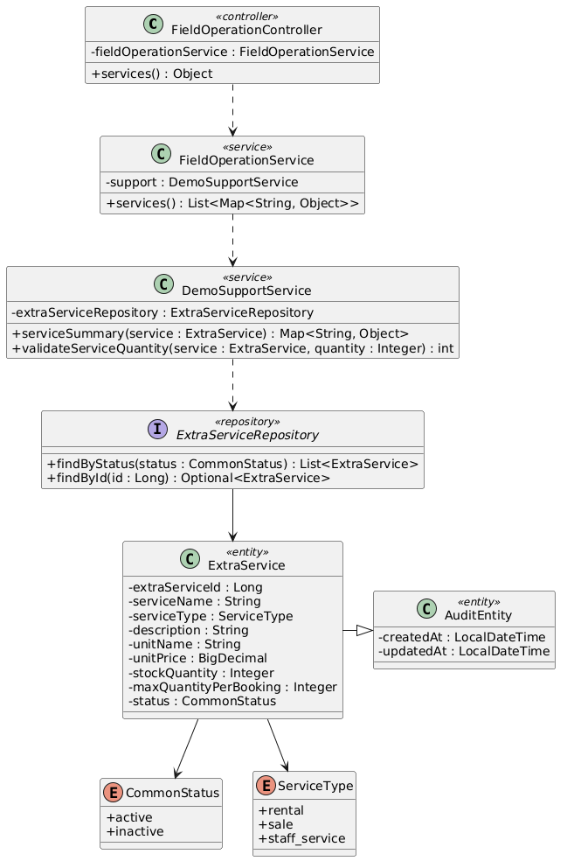

b. Class Specifications
DemoSupportService
No | Method | Description
01 | BigDecimal calculateServiceTotal(List<ApiRequests.ServiceSelection> selections, Slot slot, Long excludedBookingId) | Checks active status, per-booking maximum, stock reserved in overlapping active bookings, and computes total.
02 | int validateServiceQuantity(ExtraService service, Integer requestedQuantity) | Enforces active status, maximum quantity, and base stock constraints.

BookingServiceItemRepository
No | Method | Description
01 | long sumReservedForOverlappingSlots(Long serviceId, LocalDate slotDate, LocalTime startTime, LocalTime endTime, List<BookingStatus> statuses, Long excludedBookingId) | JPQL aggregate for inventory consumed by overlapping bookings.

c. Sequence Diagram
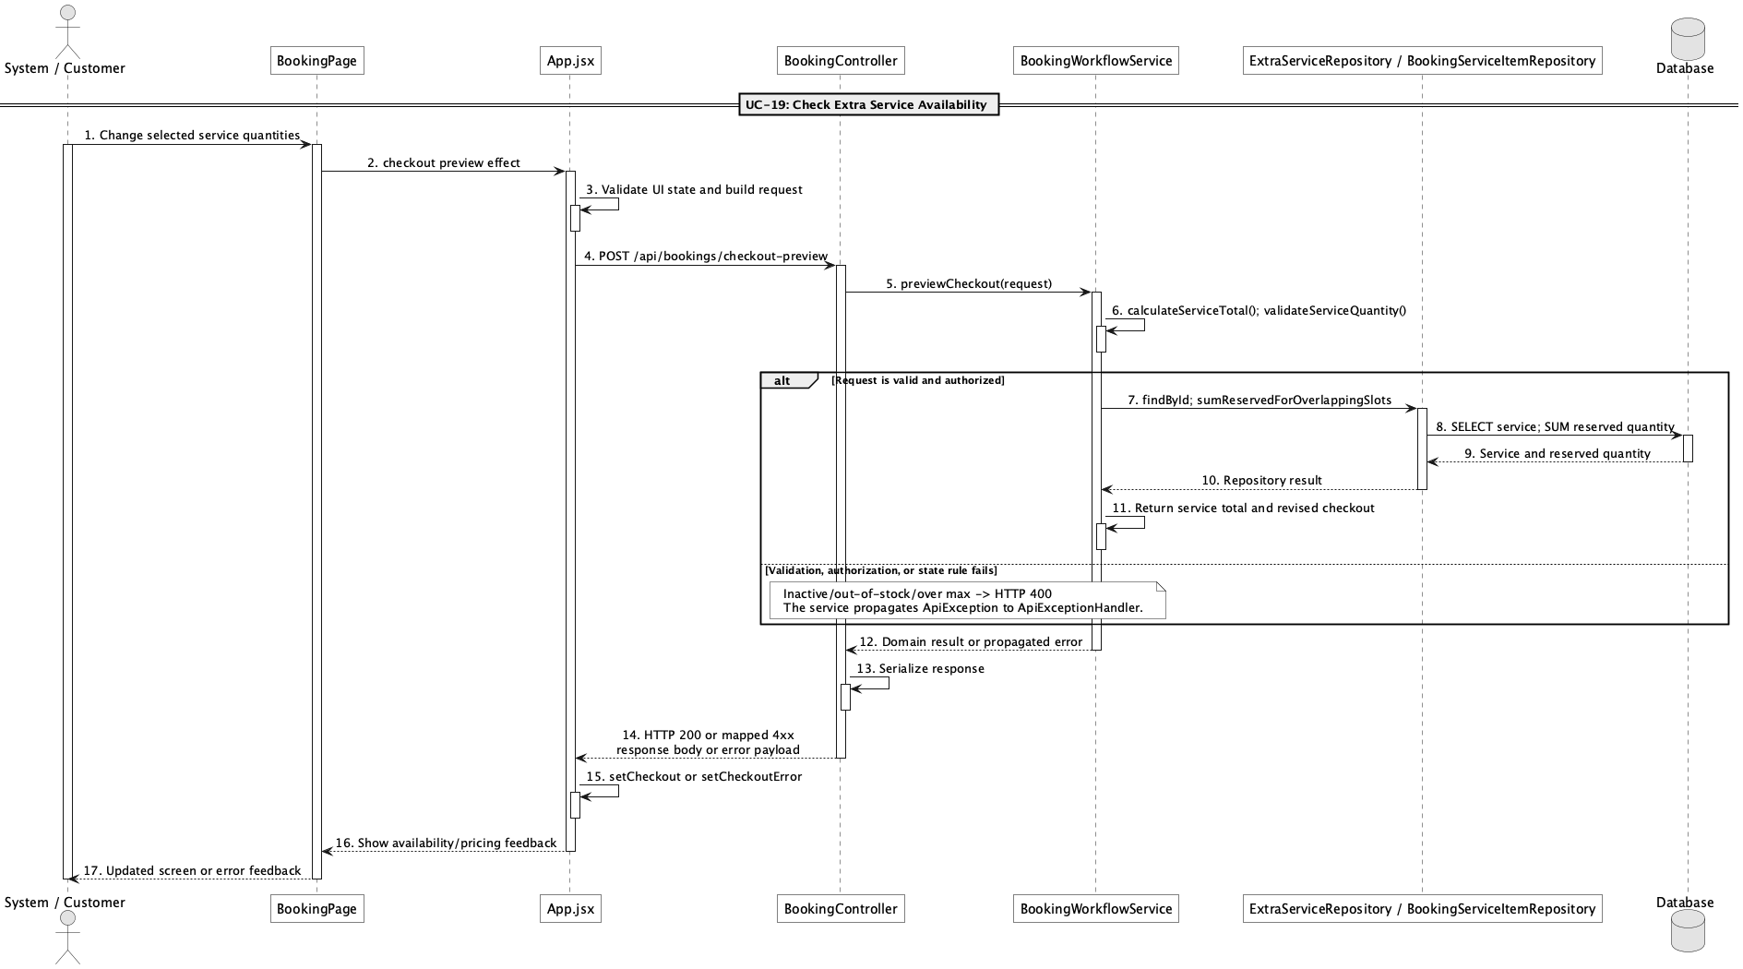

d. Database Queries
== Check extra service availability ==

1. Reserved service quantity for overlapping slots
SELECT COALESCE(SUM(bs.quantity), 0) AS reserved_quantity
FROM booking_service bs
JOIN booking b ON b.booking_id = bs.booking_id
JOIN slot s ON s.slot_id = b.slot_id
WHERE bs.extra_service_id = :serviceId
AND b.status IN ('pending','confirmed','checked_in')
AND s.slot_date = :slotDate
AND s.start_time < :endTime
AND s.end_time > :startTime
AND (:excludedBookingId IS NULL OR b.booking_id <> :excludedBookingId);

Implementation note: The repository implementation is JPQL; this SQL is the equivalent physical-table query.

20. Add extra services to booking

a. Class Diagram
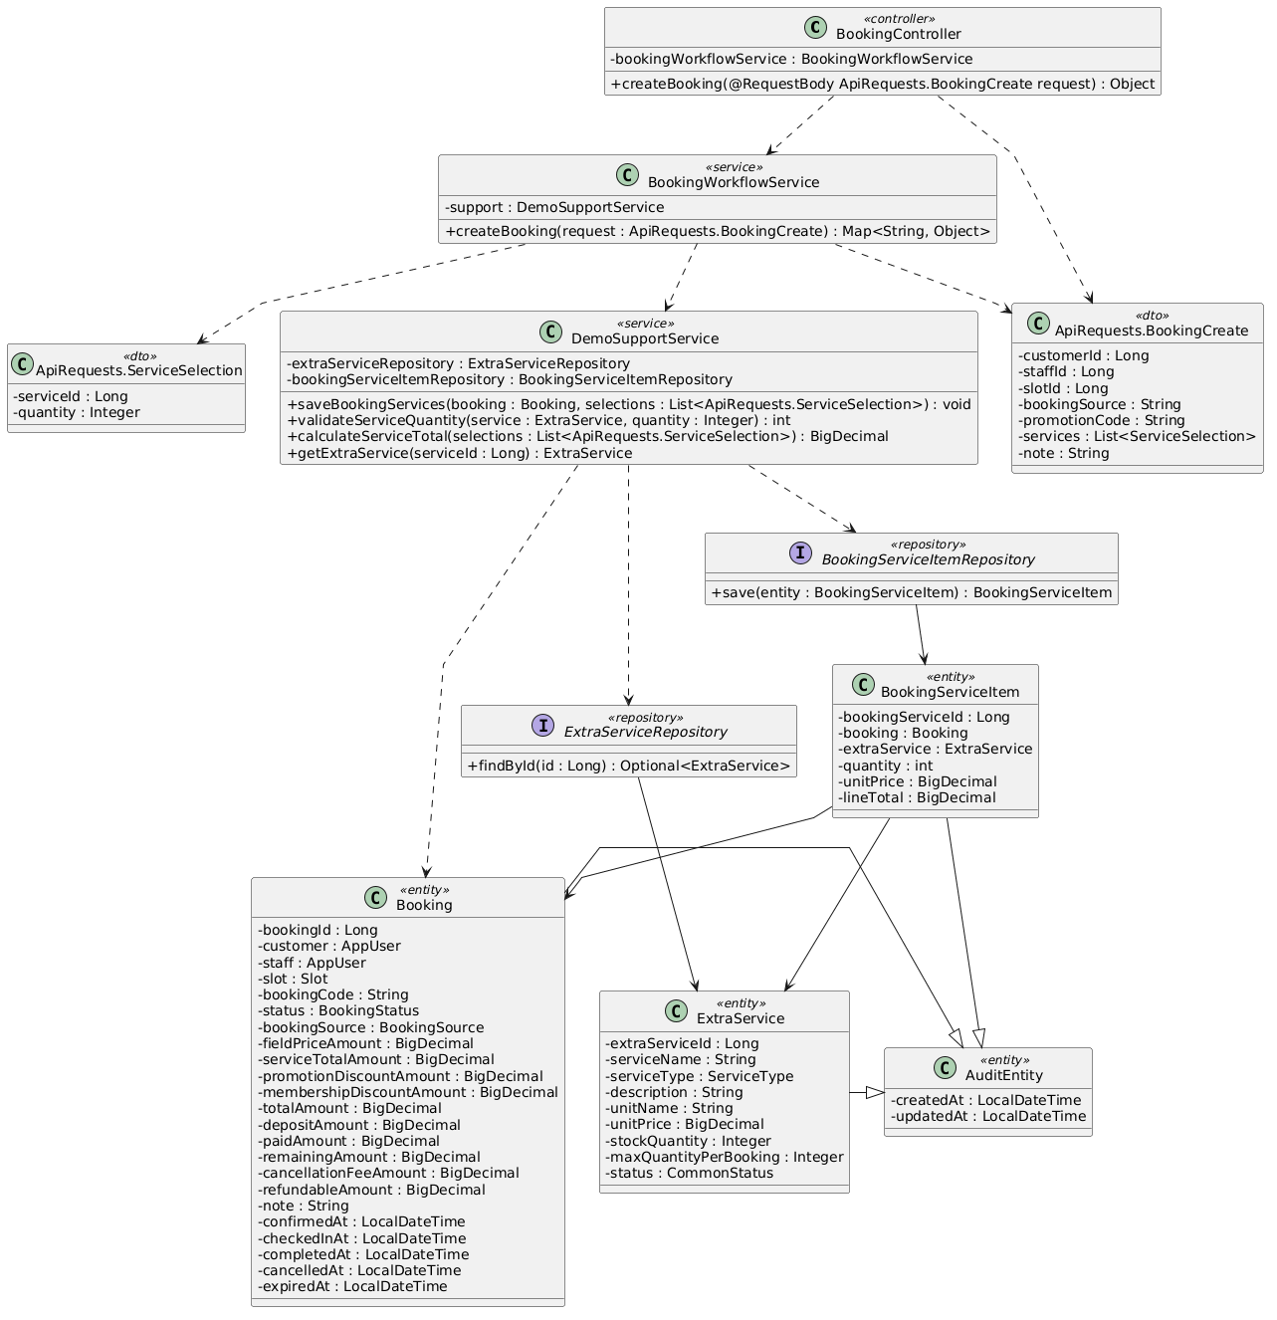

b. Class Specifications
BookingWorkflowService
No | Method | Description
01 | public Map<String, Object> createBooking(ApiRequests.BookingCreate request) | Accepts service selections as part of online or walk-in booking creation.

DemoSupportService
No | Method | Description
01 | BigDecimal calculateServiceTotal(List<ApiRequests.ServiceSelection> selections, Slot slot, Long excludedBookingId) | Prices and validates selected services.
02 | void saveBookingServices(Booking booking, List<ApiRequests.ServiceSelection> selections) | Persists unit-price and line-total snapshots in booking_service.

c. Sequence Diagram
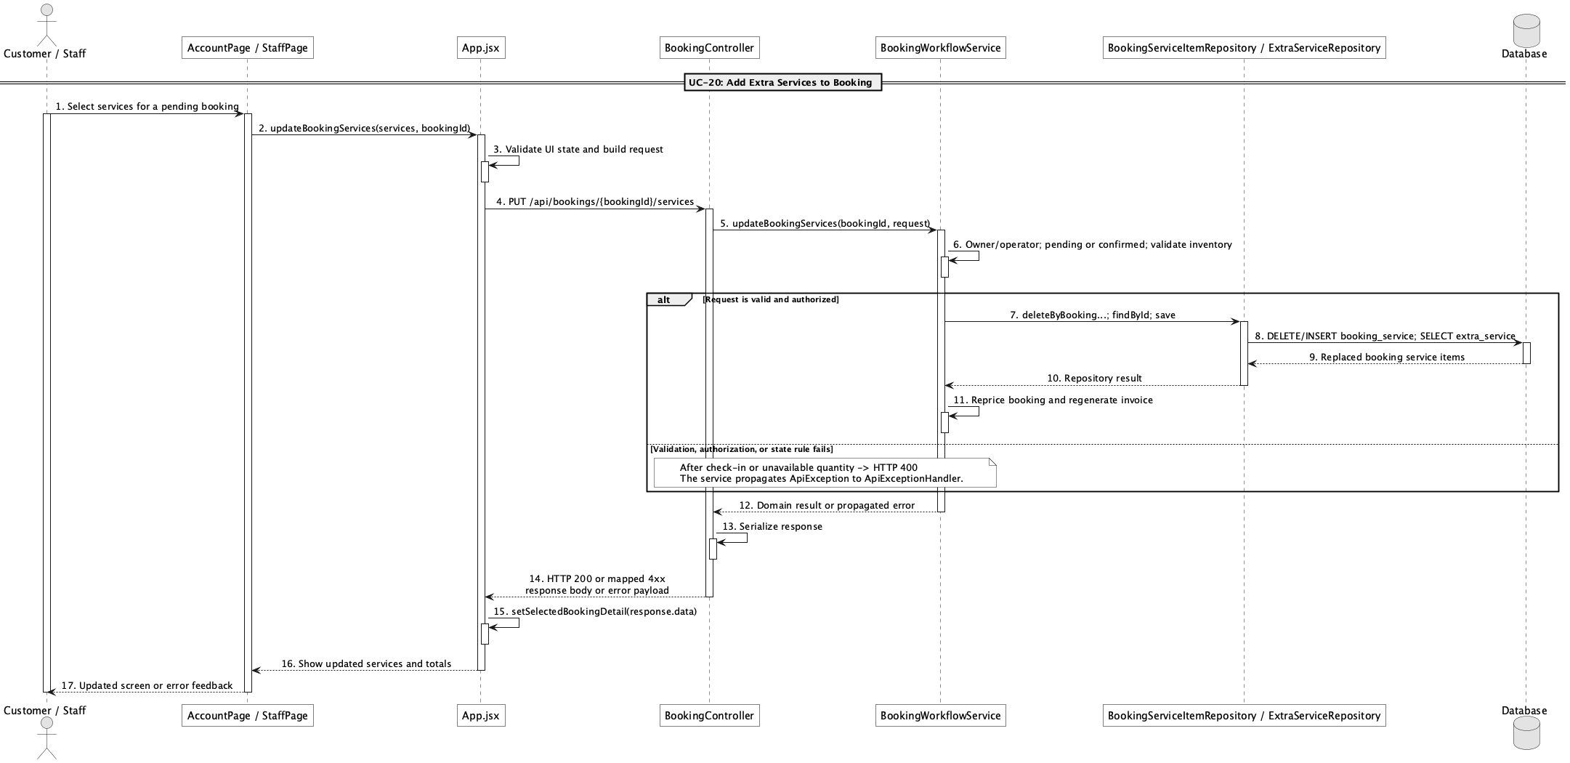

d. Database Queries
== Add extra services to booking ==

1. Persist booking service snapshots
INSERT INTO booking_service
(booking_id, extra_service_id, quantity, unit_price, line_total, created_at, updated_at)
SELECT :bookingId, es.extra_service_id, :quantity, es.unit_price,
es.unit_price * :quantity, CURRENT_TIMESTAMP, CURRENT_TIMESTAMP
FROM extra_service es
WHERE es.extra_service_id = :serviceId AND es.status = 'active';

Implementation note: booking_service stores snapshot prices so later catalogue price changes do not rewrite the booking total.

21. Update extra services before check-in

a. Class Diagram
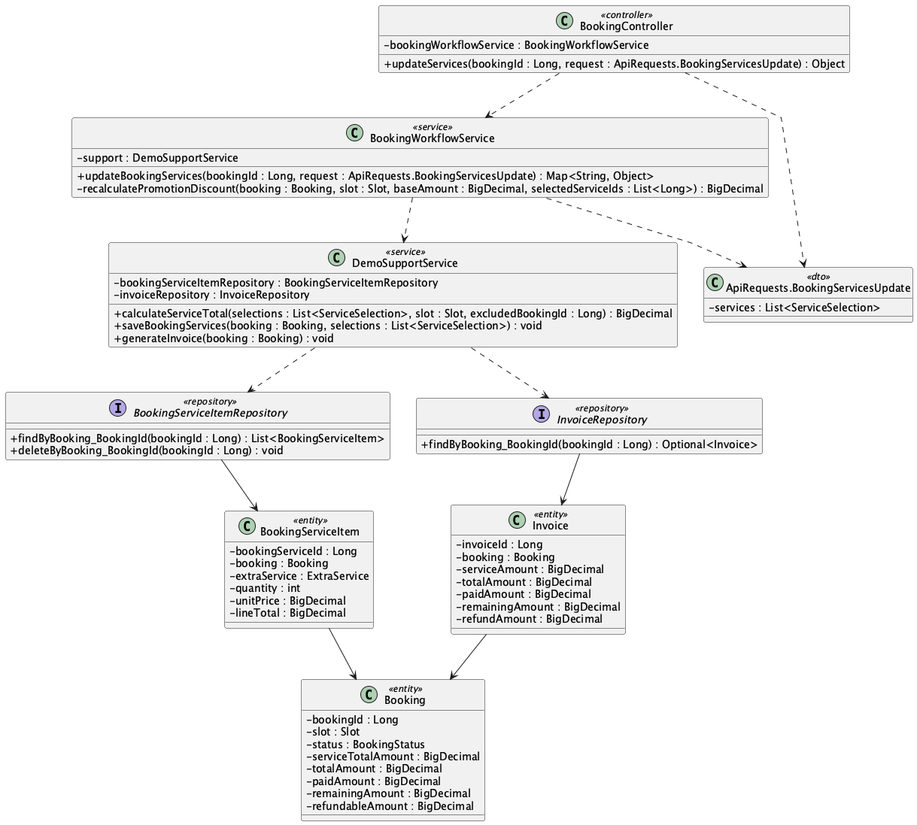

b. Class Specifications
BookingController
No | Method | Description
01 | public Object updateServices(Long bookingId, ApiRequests.BookingServicesUpdate request) | Exposes PUT /api/bookings/{bookingId}/services.

BookingWorkflowService
No | Method | Description
01 | public Map<String, Object> updateBookingServices(Long bookingId, ApiRequests.BookingServicesUpdate request) | Allows owner/operator changes only while pending or confirmed, then reprices discounts, balance/refund delta, and invoice.

BookingServiceItemRepository
No | Method | Description
01 | List<BookingServiceItem> findByBooking_BookingId(Long bookingId) | Reads current add-ons for repricing.
02 | void deleteByBooking_BookingId(Long bookingId) | Replaces the old service set before saving the revised selections.

c. Sequence Diagram
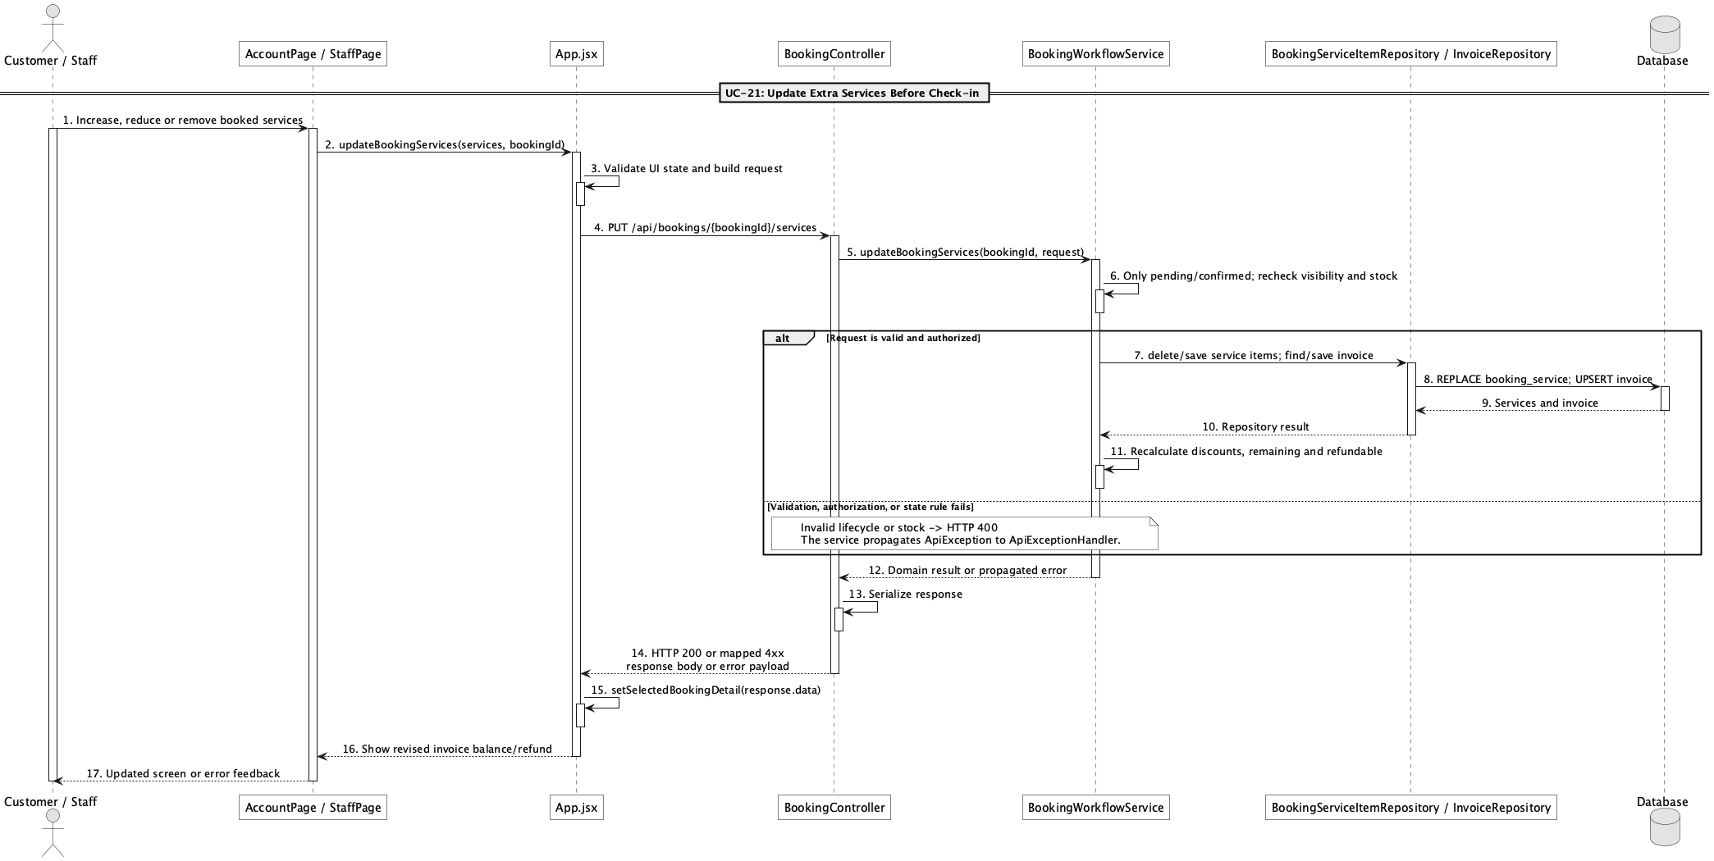

d. Database Queries
== Update extra services before check-in ==

1. Replace booking services and update totals
DELETE FROM booking_service WHERE booking_id = :bookingId;

UPDATE booking
SET service_total_amount = :serviceTotal, promotion_discount_amount = :promotionDiscount,
membership_discount_amount = :membershipDiscount, total_amount = :totalAmount,
deposit_amount = :depositAmount, remaining_amount = :remainingAmount,
refundable_amount = :refundableAmount, updated_at = CURRENT_TIMESTAMP
WHERE booking_id = :bookingId AND status IN ('pending','confirmed');

Implementation note: Customer ownership and Staff/Admin access are enforced before the change; edits after check-in are blocked.

22. Report field/service issue

a. Class Diagram
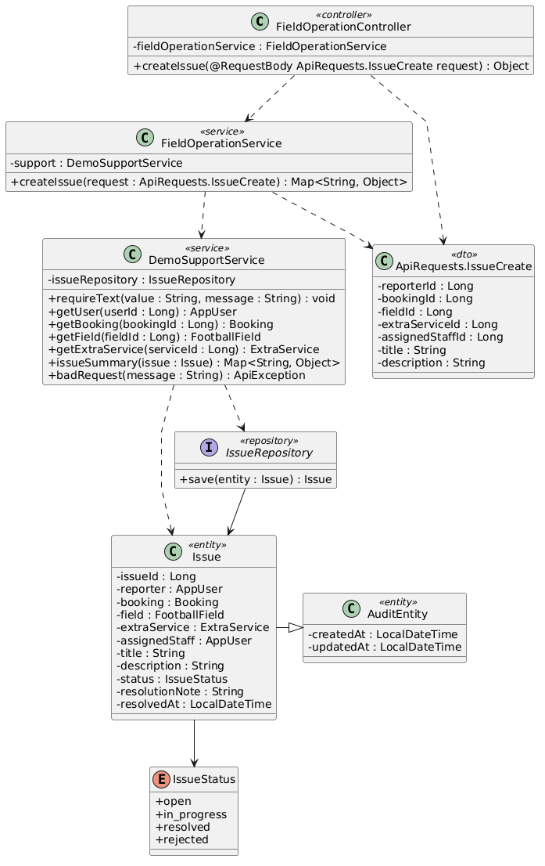

b. Class Specifications
FieldOperationController
No | Method | Description
01 | public Object createIssue(ApiRequests.IssueCreate request) | Exposes POST /api/issues.

FieldOperationService
No | Method | Description
01 | public Map<String, Object> createIssue(ApiRequests.IssueCreate request) | Creates an issue tied optionally to a booking, field, service, and assigned staff member.

IssueRepository
No | Method | Description
01 | List<Issue> findAllByOrderByIssueIdDesc() | Supplies the staff issue queue in newest-first order.

c. Sequence Diagram
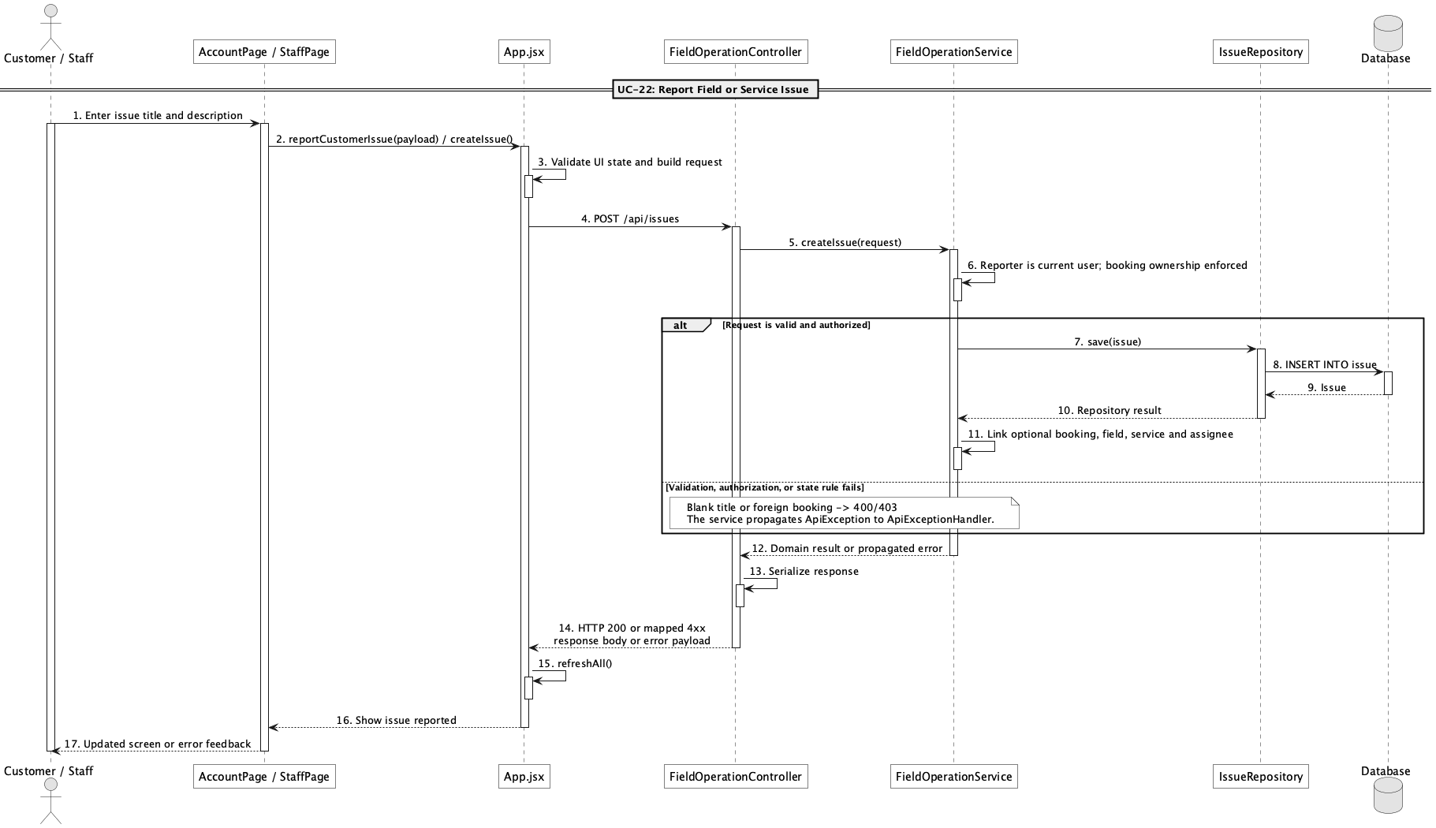

d. Database Queries
== Report field/service issue ==

1. Create issue report
INSERT INTO issue
(reporter_id, booking_id, field_id, extra_service_id, assigned_staff_id,
title, description, status, created_at, updated_at)
VALUES
(:reporterId, :bookingId, :fieldId, :extraServiceId, :assignedStaffId,
:title, :description, 'open', CURRENT_TIMESTAMP, CURRENT_TIMESTAMP);

Implementation note: A customer may report only under their own account and, when booking-linked, only for their own booking.

23. Resolve field/service issue

a. Class Diagram
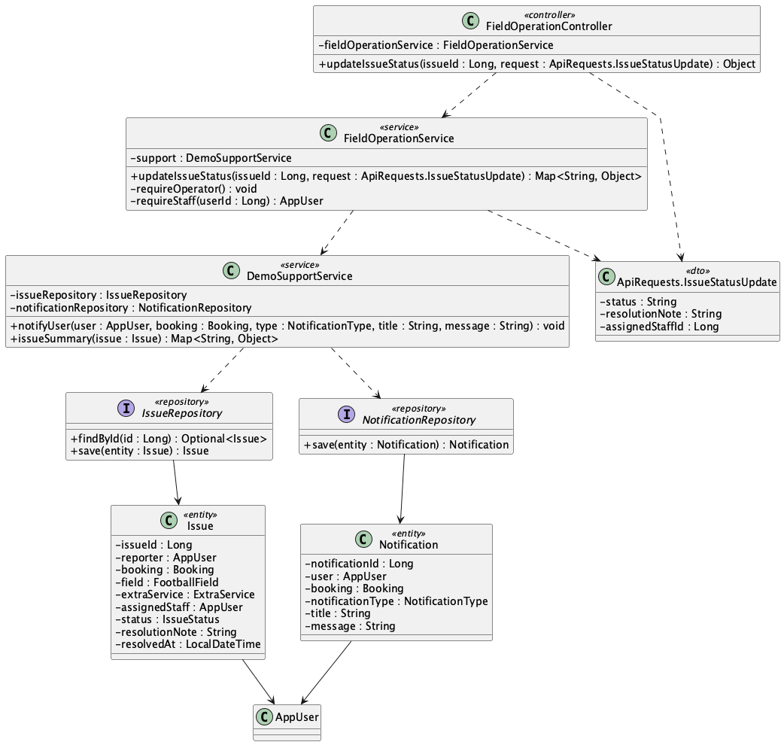

b. Class Specifications
FieldOperationController
No | Method | Description
01 | public Object updateIssueStatus(Long issueId, ApiRequests.IssueStatusUpdate request) | Exposes the Staff/Admin issue status endpoint.

FieldOperationService
No | Method | Description
01 | public Map<String, Object> updateIssueStatus(Long issueId, ApiRequests.IssueStatusUpdate request) | Assigns staff, validates closure notes, records resolution time, and notifies the reporter.

DemoSupportService
No | Method | Description
01 | void notifyUser(AppUser user, Booking booking, NotificationType type, String title, String message) | Persists the issue status notification.

c. Sequence Diagram
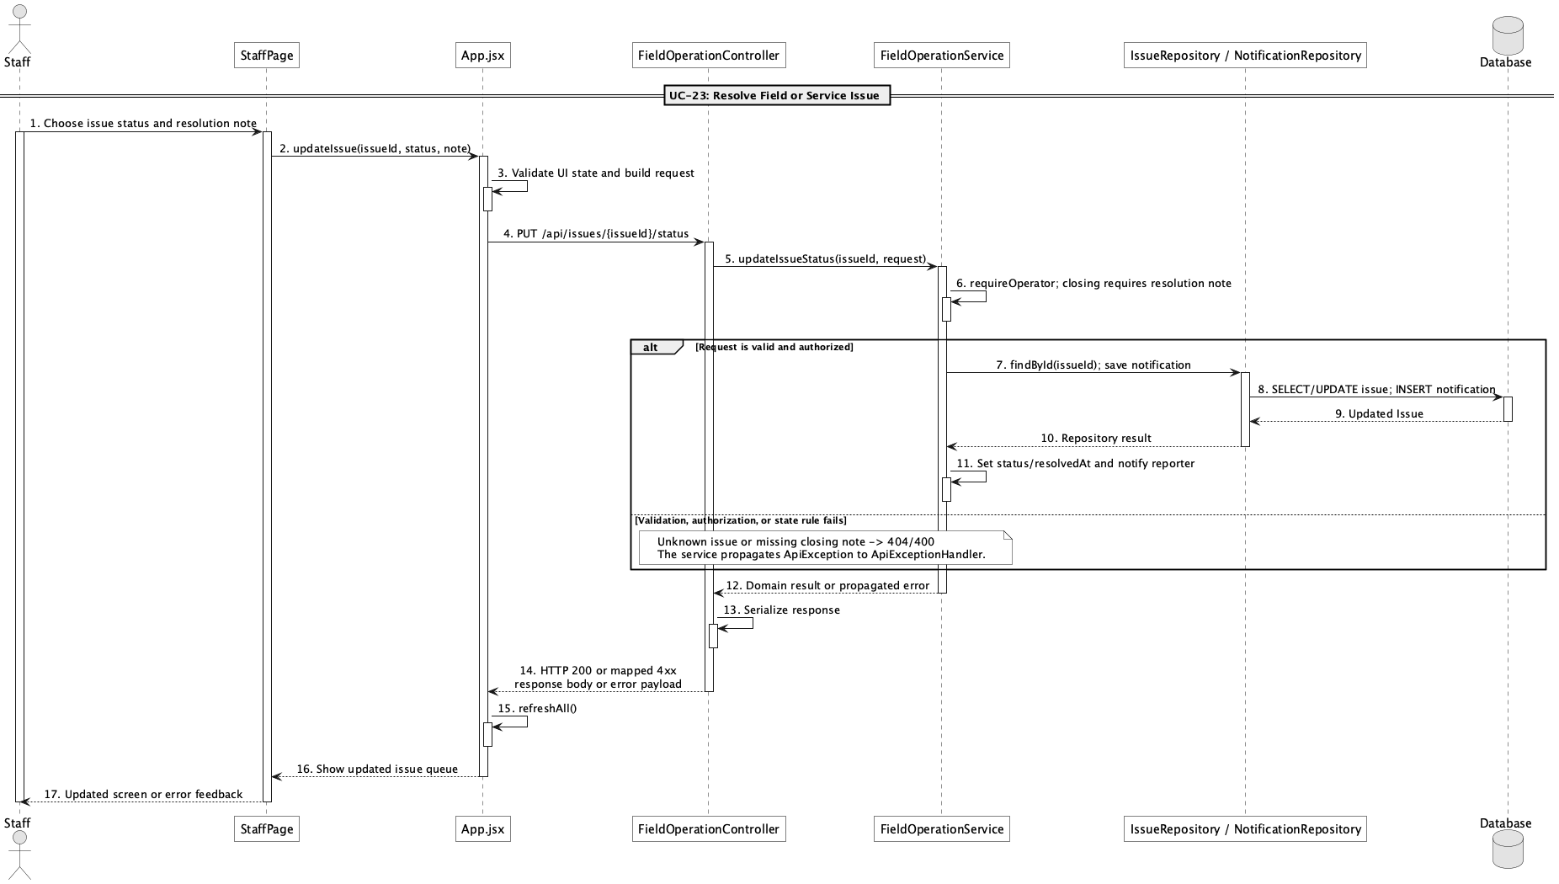

d. Database Queries
== Resolve field/service issue ==

1. Resolve or reject an issue
UPDATE issue
SET assigned_staff_id = :assignedStaffId, status = :status,
resolution_note = :resolutionNote,
resolved_at = CASE WHEN :status IN ('resolved','rejected') THEN CURRENT_TIMESTAMP ELSE NULL END,
updated_at = CURRENT_TIMESTAMP
WHERE issue_id = :issueId;

Implementation note: Closing statuses resolved and rejected require a nonblank resolution note.

24. Create online booking

a. Class Diagram
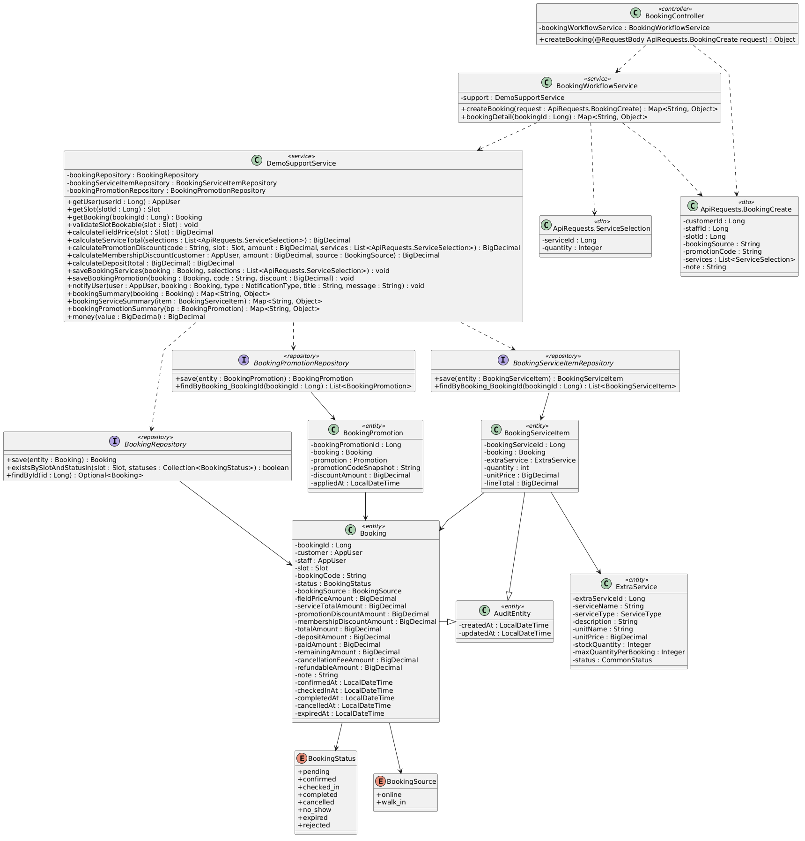

b. Class Specifications
BookingController
No | Method | Description
01 | public Object createBooking(ApiRequests.BookingCreate request) | Exposes authenticated POST /api/bookings.

BookingWorkflowService
No | Method | Description
01 | public Map<String, Object> createBooking(ApiRequests.BookingCreate request) | Enforces that a Customer creates only their own online booking, then prices and persists it as pending.

DemoSupportService
No | Method | Description
01 | void validateSlotBookable(Slot slot) | Rejects blocked, past, or actively reserved slots.

c. Sequence Diagram
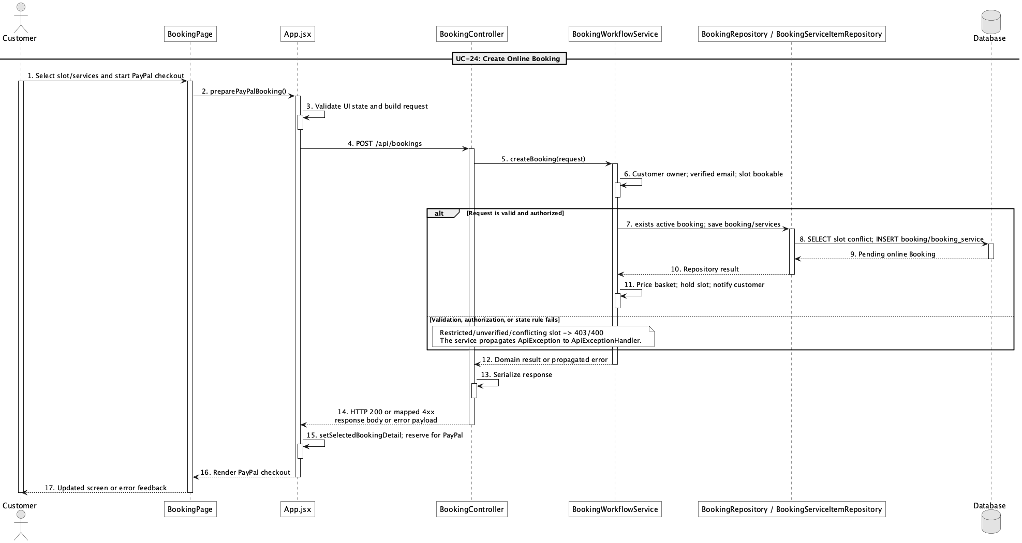

d. Database Queries
== Create online booking ==

1. Create pending online booking
INSERT INTO booking
(customer_id, slot_id, booking_code, status, booking_source, field_price_amount,
service_total_amount, promotion_discount_amount, membership_discount_amount,
total_amount, deposit_amount, paid_amount, remaining_amount, created_at, updated_at)
VALUES
(:customerId, :slotId, :bookingCode, 'pending', 'online', :fieldPrice,
:serviceTotal, :promotionDiscount, :membershipDiscount, :totalAmount,
:depositAmount, 0, :totalAmount, CURRENT_TIMESTAMP, CURRENT_TIMESTAMP);

Implementation note: Online booking is rejected for an unverified email or booking-restricted customer.

25. Create walk-in booking

a. Class Diagram
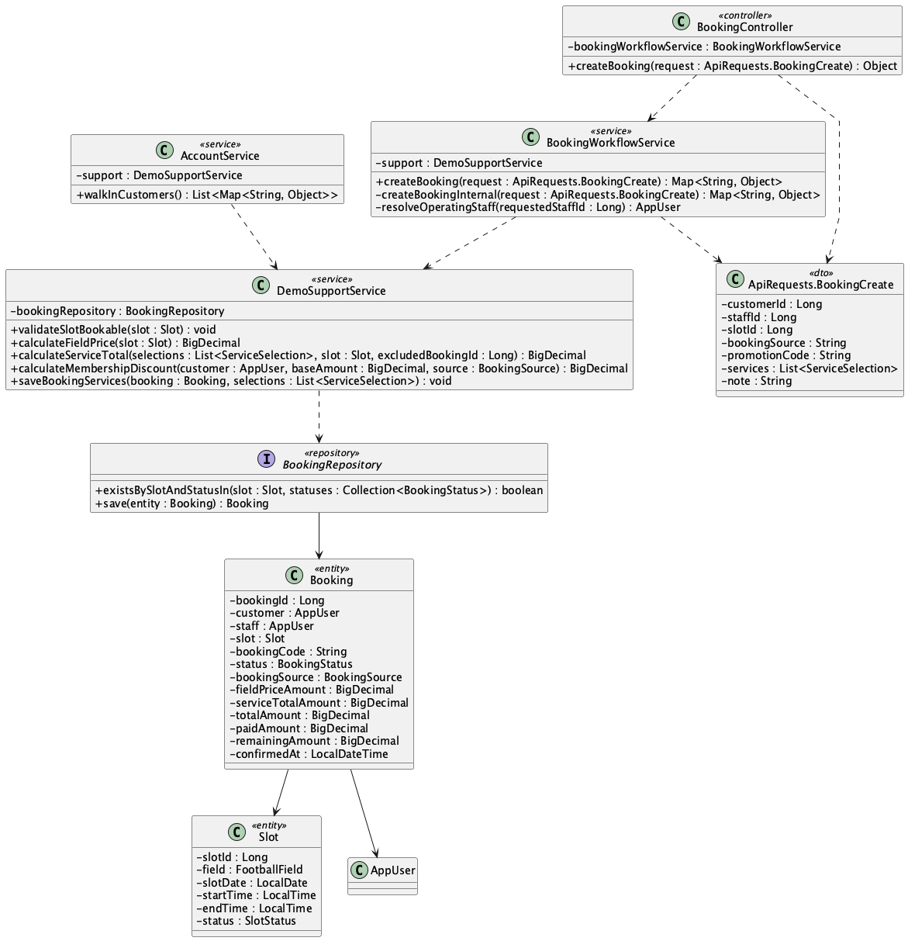

b. Class Specifications
BookingWorkflowService
No | Method | Description
01 | public Map<String, Object> createBooking(ApiRequests.BookingCreate request) | Allows Staff/Admin to create only walk-in bookings for an existing customer.

AccountService
No | Method | Description
01 | public java.util.List<Map<String, Object>> walkInCustomers() | Provides the counter-safe customer directory used to select an existing customer.

DemoSupportService
No | Method | Description
01 | BigDecimal calculateMembershipDiscount(AppUser customer, BigDecimal baseAmount, BookingSource source) | Returns zero membership discount for walk-in source.

c. Sequence Diagram
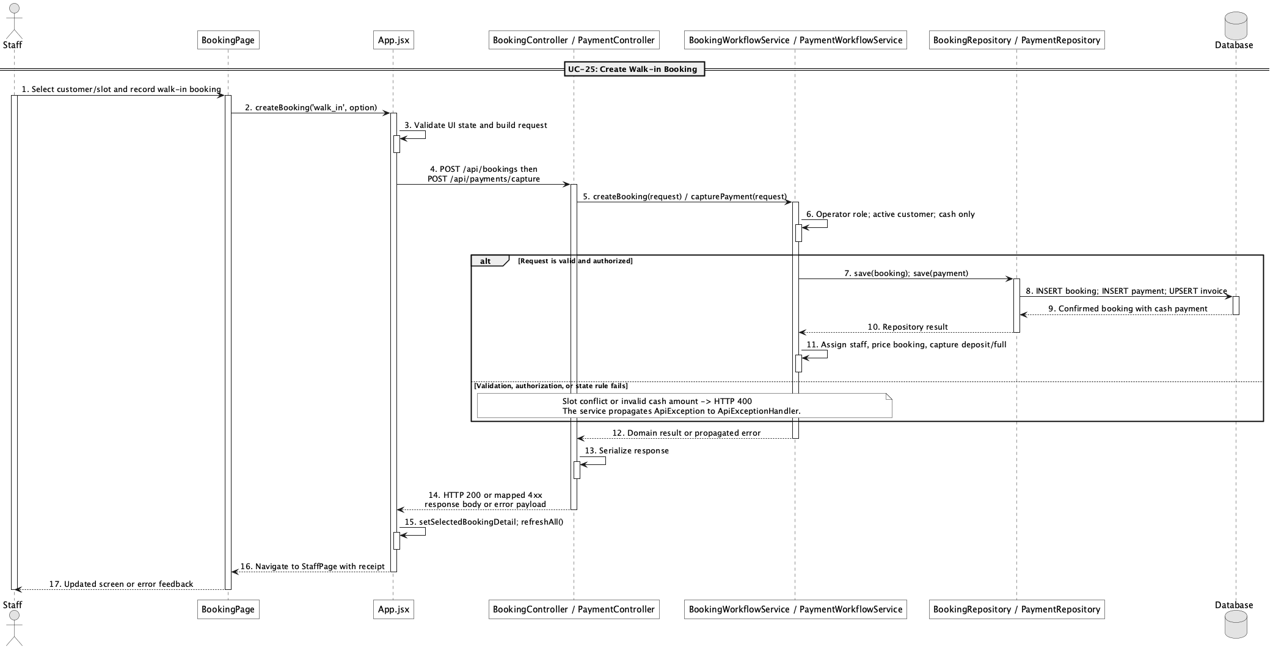

d. Database Queries
== Create walk-in booking ==

1. Create confirmed walk-in booking
INSERT INTO booking
(customer_id, staff_id, slot_id, booking_code, status, booking_source,
field_price_amount, service_total_amount, total_amount, deposit_amount,
paid_amount, remaining_amount, confirmed_at, created_at, updated_at)
VALUES
(:customerId, :staffId, :slotId, :bookingCode, 'confirmed', 'walk_in',
:fieldPrice, :serviceTotal, :totalAmount, :depositAmount,
0, :totalAmount, CURRENT_TIMESTAMP, CURRENT_TIMESTAMP, CURRENT_TIMESTAMP);

Implementation note: The counter booking starts confirmed; cash capture is a separate payment action.

26. View booking detail

a. Class Diagram
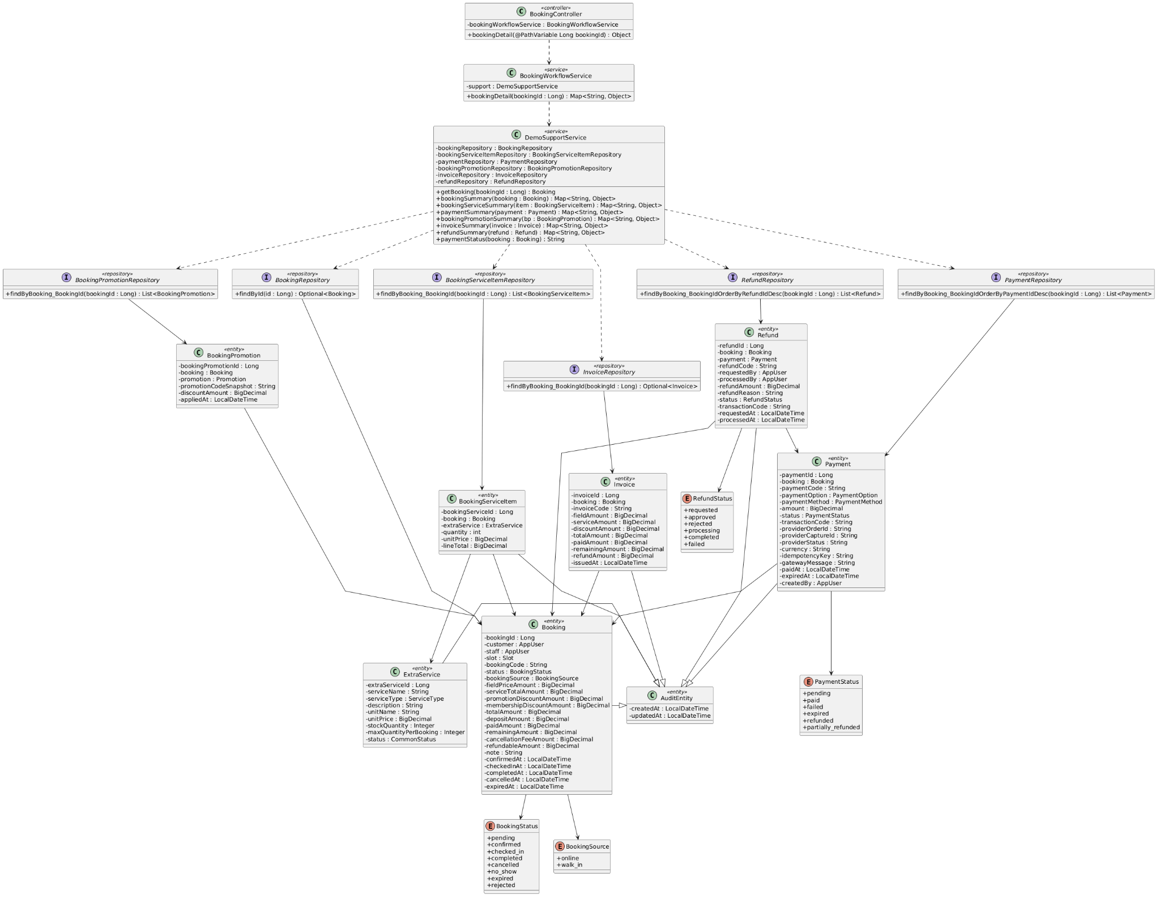

b. Class Specifications
BookingController
No | Method | Description
01 | public Object bookingDetail(Long bookingId) | Exposes GET /api/bookings/{bookingId}.

BookingWorkflowService
No | Method | Description
01 | public Map<String, Object> bookingDetail(Long bookingId) | Returns the booking plus services, payments, promotions, invoice, refunds, and derived payment status.

InvoiceRepository
No | Method | Description
01 | Optional<Invoice> findByBooking_BookingId(Long bookingId) | Loads the one-to-one booking invoice.

c. Sequence Diagram
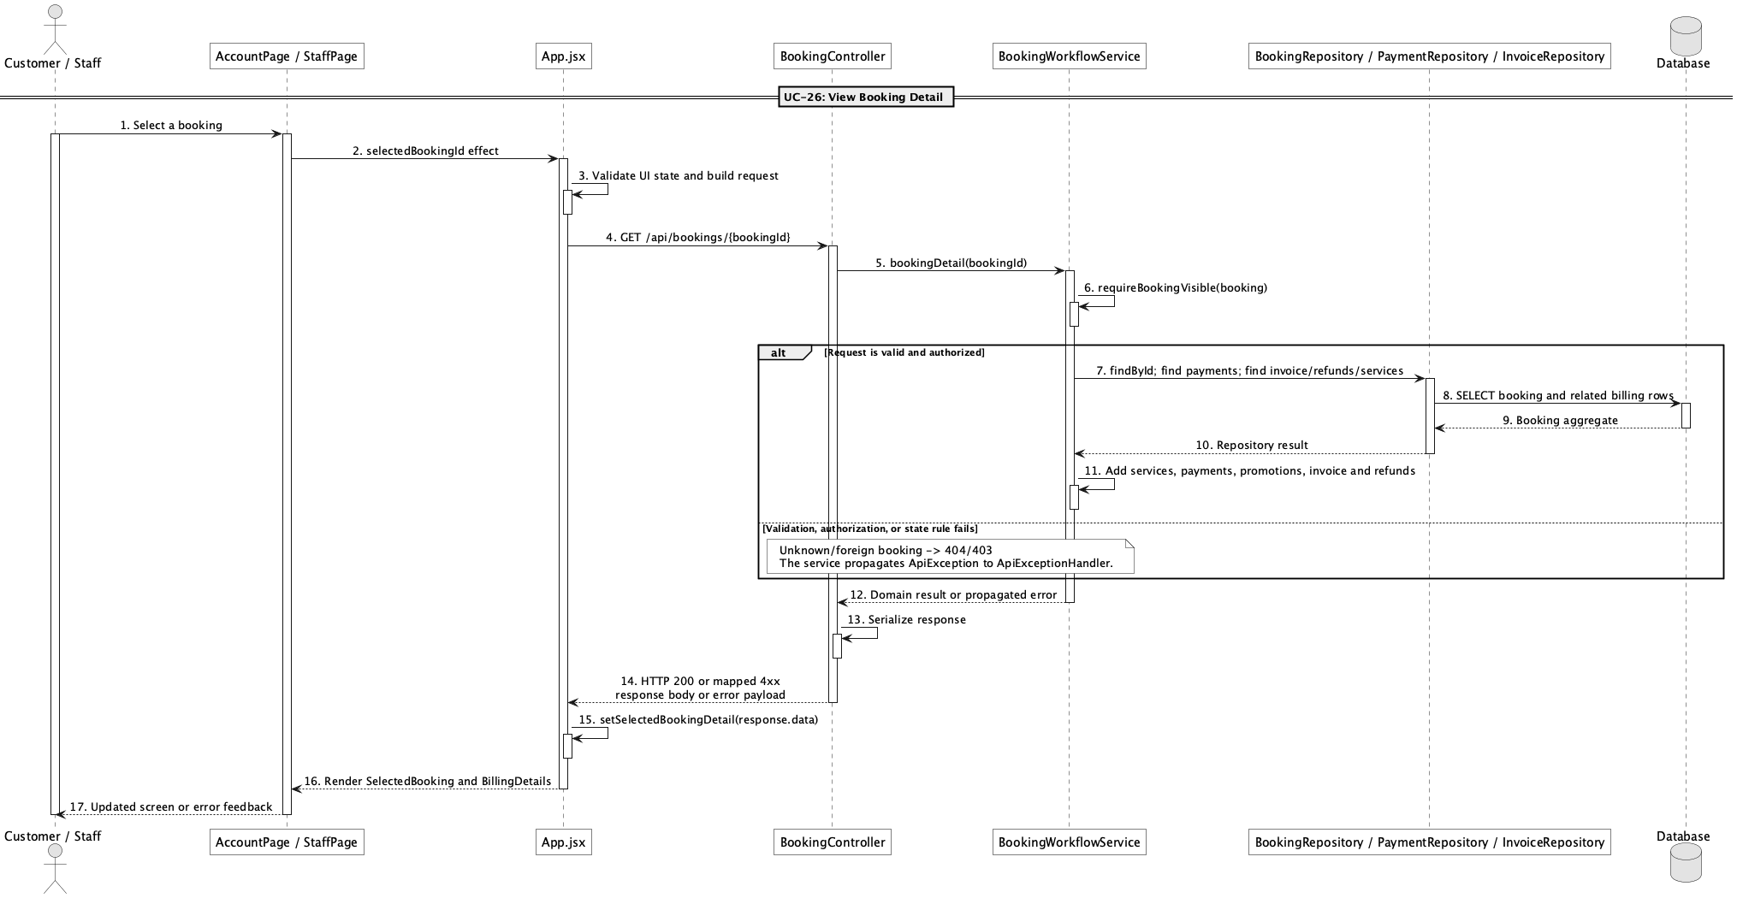

d. Database Queries
== View booking detail ==

1. Booking detail core
SELECT b.*, s.slot_date, s.start_time, s.end_time, f.field_name,
u.full_name AS customer_name, i.invoice_code, i.total_amount AS invoice_total,
i.paid_amount AS invoice_paid, i.remaining_amount AS invoice_remaining
FROM booking b
JOIN app_user u ON u.user_id = b.customer_id
JOIN slot s ON s.slot_id = b.slot_id
JOIN field f ON f.field_id = s.field_id
LEFT JOIN invoice i ON i.booking_id = b.booking_id
WHERE b.booking_id = :bookingId;

Implementation note: Visibility is limited to the owning customer or an operator when an authenticated principal is present.

27. View my bookings

a. Class Diagram
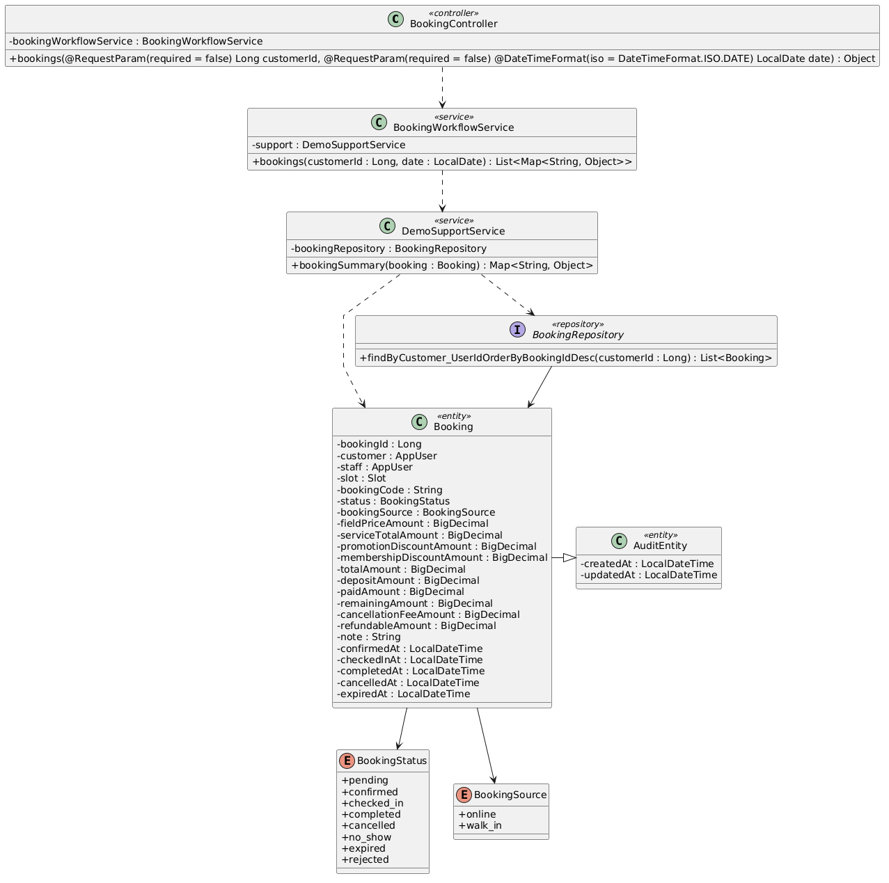

b. Class Specifications
BookingController
No | Method | Description
01 | public Object bookings(Long customerId, LocalDate date) | Exposes the filtered booking list endpoint.

BookingWorkflowService
No | Method | Description
01 | public List<Map<String, Object>> bookings(Long customerId, LocalDate date) | Forces non-operators to their own customer id and returns summaries.

BookingRepository
No | Method | Description
01 | List<Booking> findByCustomer_UserIdOrderByBookingIdDesc(Long customerId) | Loads a customer's bookings newest first.

c. Sequence Diagram
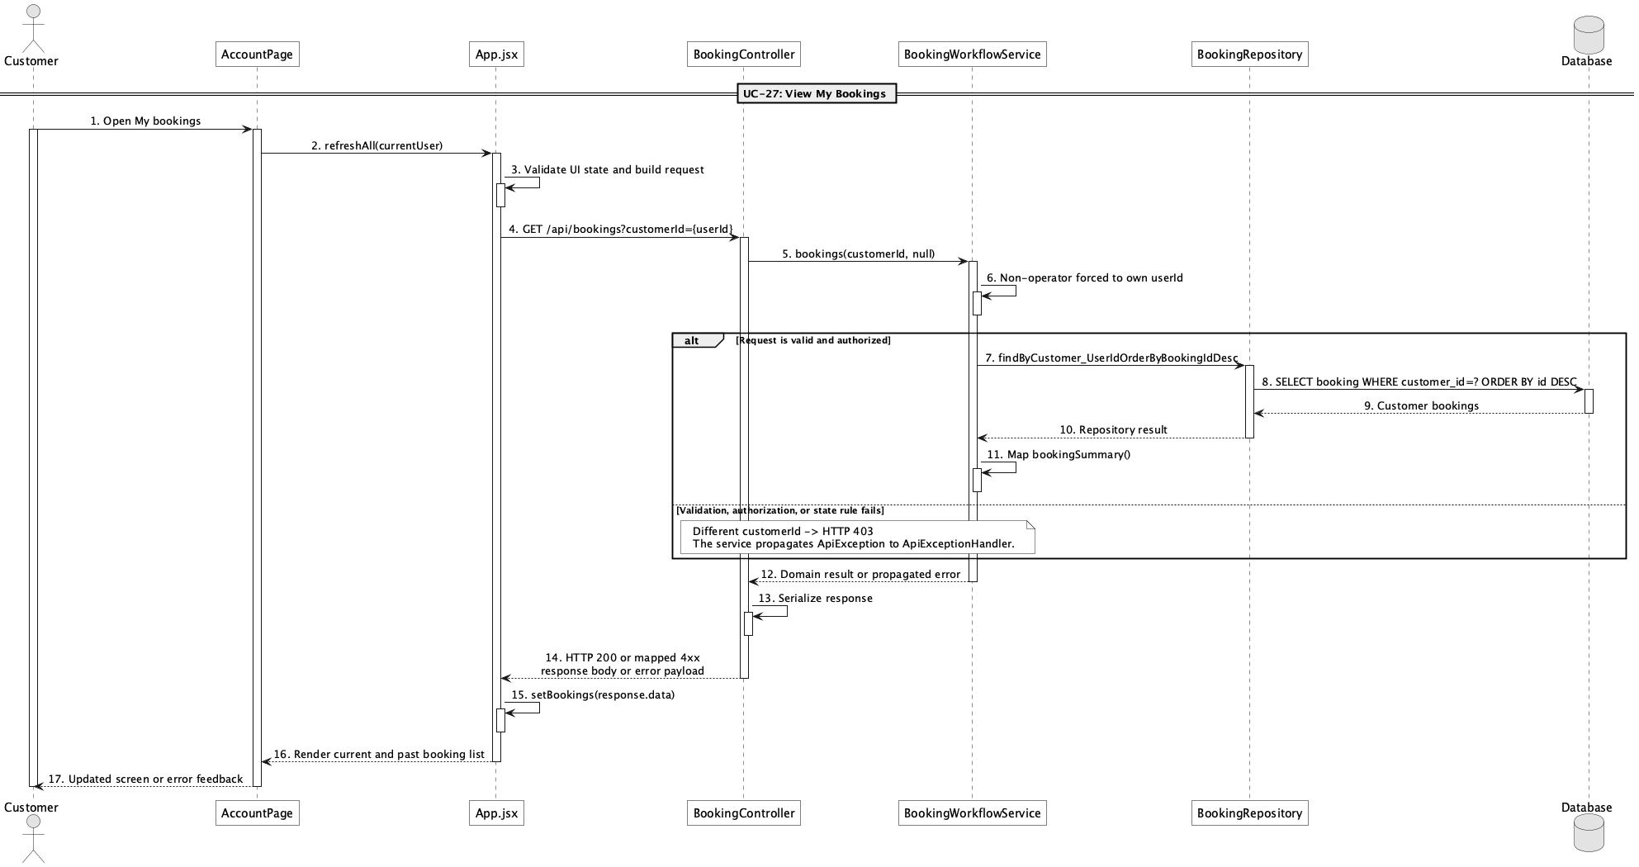

d. Database Queries
== View my bookings ==

1. Customer booking history
SELECT b.booking_id, b.booking_code, b.status, b.booking_source, b.total_amount,
b.paid_amount, b.remaining_amount, s.slot_date, s.start_time, s.end_time, f.field_name
FROM booking b
JOIN slot s ON s.slot_id = b.slot_id
JOIN field f ON f.field_id = s.field_id
WHERE b.customer_id = :currentCustomerId
ORDER BY b.booking_id DESC;

28. View booking calendar

a. Class Diagram
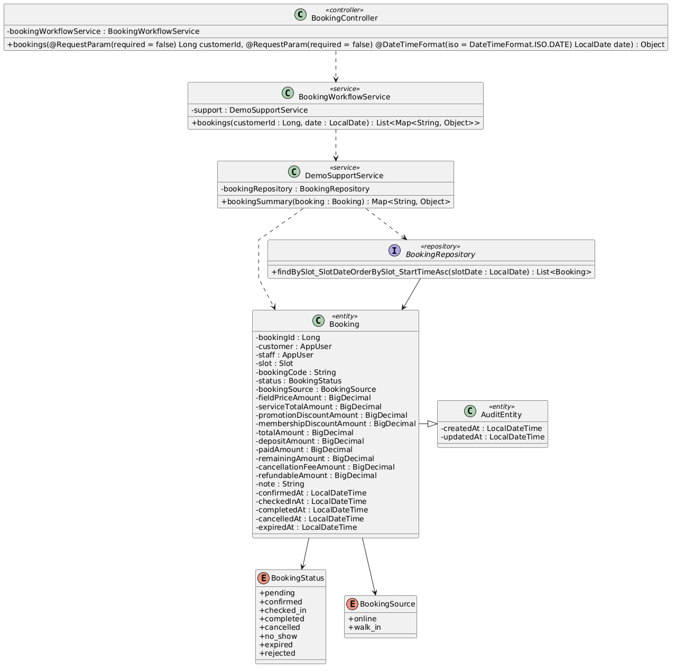

b. Class Specifications
BookingWorkflowService
No | Method | Description
01 | public List<Map<String, Object>> bookings(Long customerId, LocalDate date) | Returns booking summaries filtered by date for operators.

BookingRepository
No | Method | Description
01 | List<Booking> findBySlot_SlotDateOrderBySlot_StartTimeAsc(LocalDate slotDate) | Orders bookings chronologically for a date.

c. Sequence Diagram
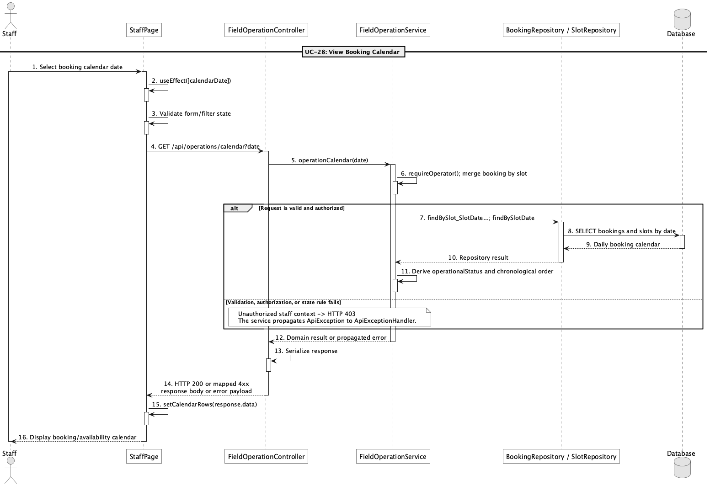

d. Database Queries
== View booking calendar ==

1. Bookings by calendar date
SELECT b.booking_id, b.booking_code, b.status, b.customer_id, b.staff_id,
f.field_name, s.slot_date, s.start_time, s.end_time
FROM booking b
JOIN slot s ON s.slot_id = b.slot_id
JOIN field f ON f.field_id = s.field_id
WHERE s.slot_date = :calendarDate
ORDER BY s.start_time;

Implementation note: The implemented view is daily rather than a recurring/monthly calendar model.

29. Confirm booking

a. Class Diagram
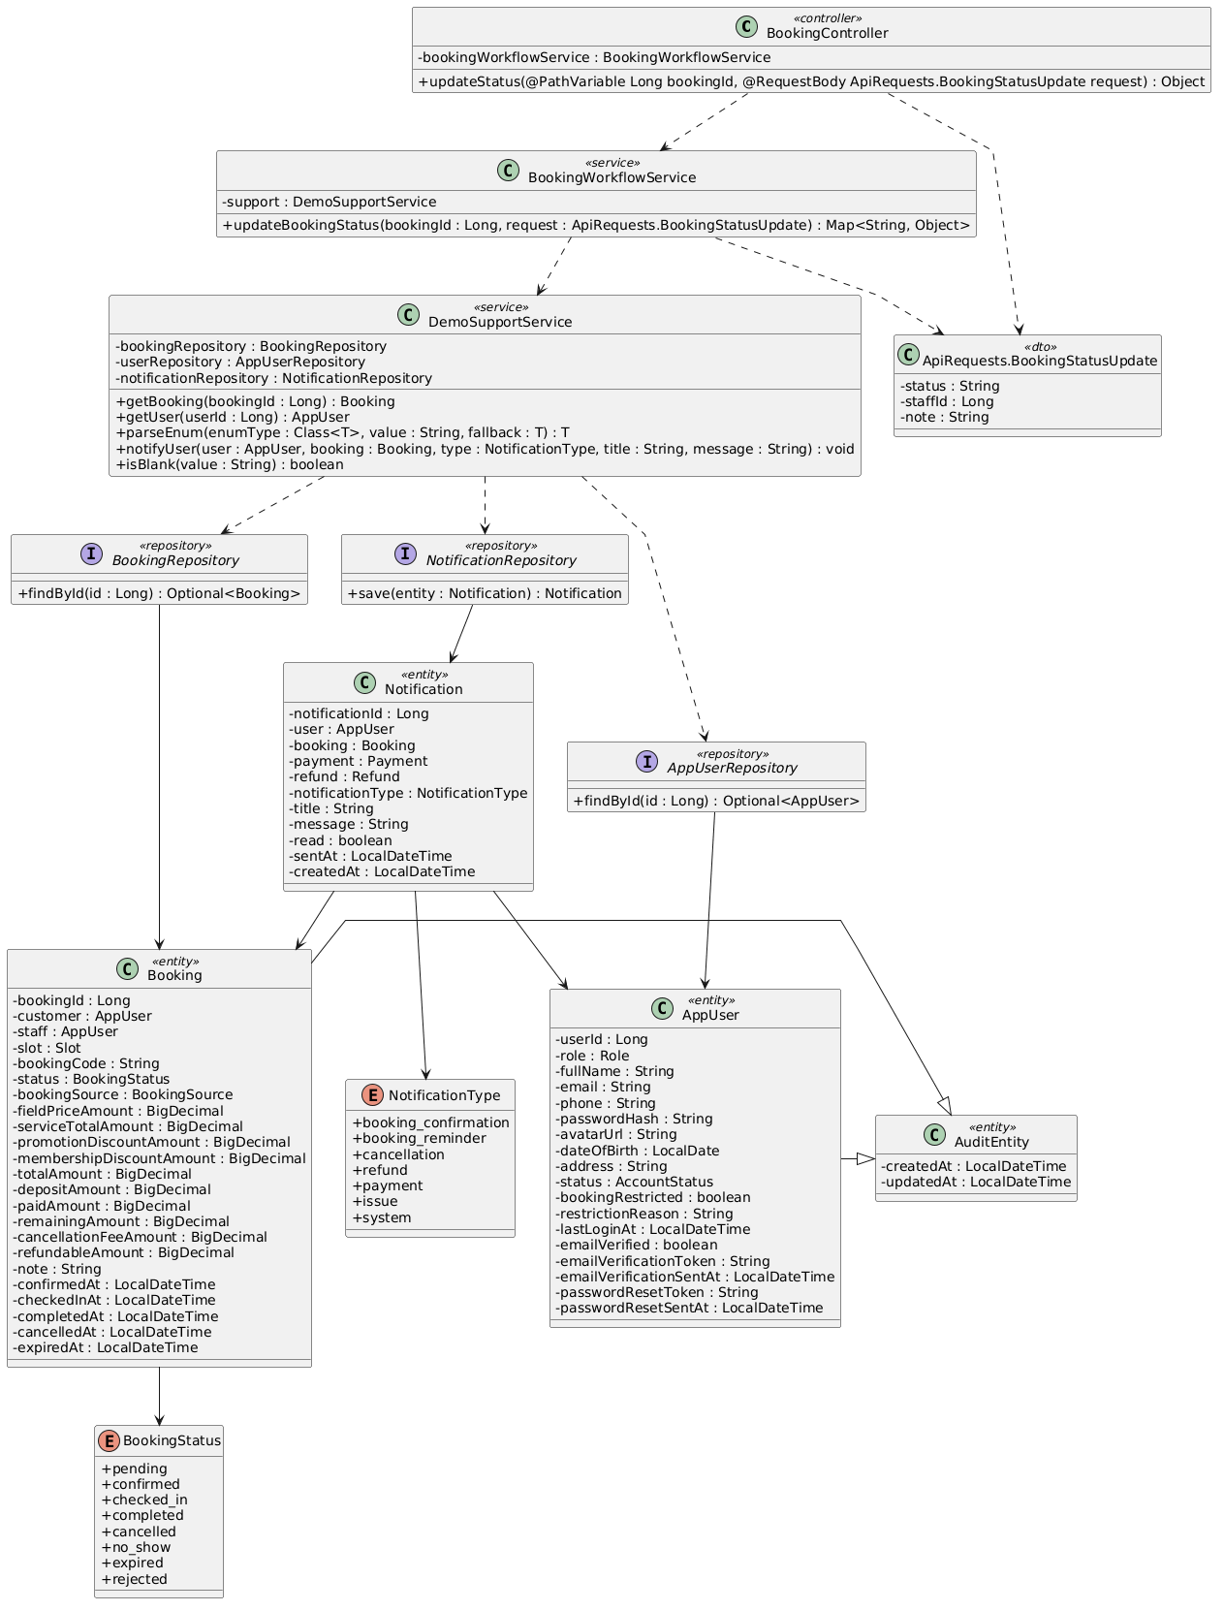

b. Class Specifications
BookingController
No | Method | Description
01 | public Object updateStatus(Long bookingId, ApiRequests.BookingStatusUpdate request) | Routes lifecycle status updates.

BookingWorkflowService
No | Method | Description
01 | public Map<String, Object> updateBookingStatus(Long bookingId, ApiRequests.BookingStatusUpdate request) | Validates pending-to-confirmed transition, timestamps it, assigns operator, and notifies the customer.

PayPalCheckoutService
No | Method | Description
01 | public Map<String, Object> captureOrder(Long bookingId, String orderId, ApiRequests.PayPalOrderCapture request) | Also confirms a pending online booking when captured funds reach the deposit amount.

c. Sequence Diagram
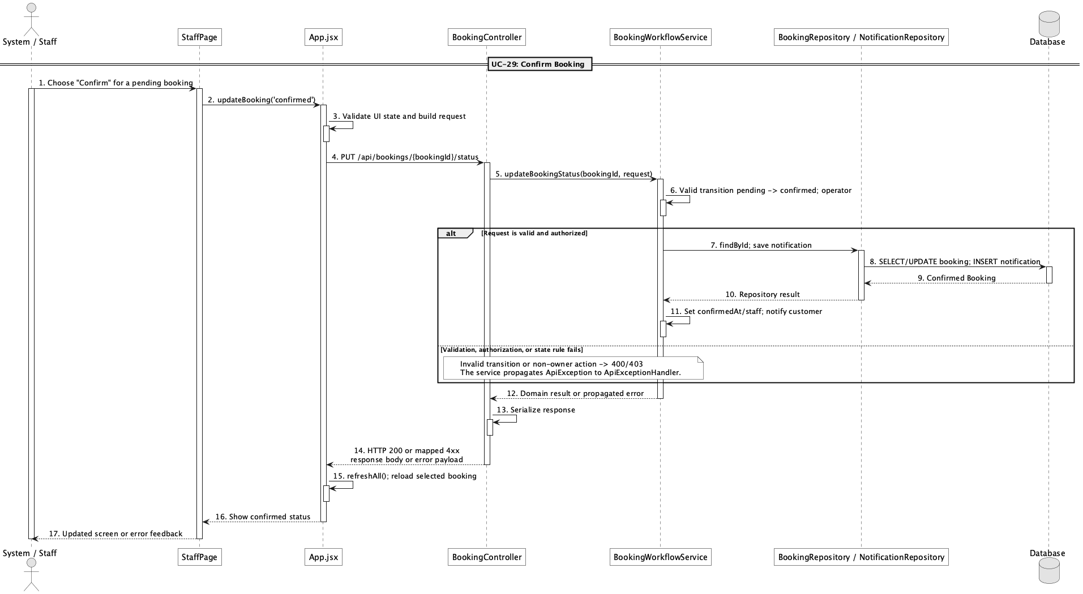

d. Database Queries
== Confirm booking ==

1. Confirm pending booking
UPDATE booking
SET status = 'confirmed', confirmed_at = CURRENT_TIMESTAMP, staff_id = :staffId,
updated_at = CURRENT_TIMESTAMP
WHERE booking_id = :bookingId AND status = 'pending';

Implementation note: Confirmation can result from an operator lifecycle action or successful qualifying PayPal capture.

30. Reject booking request

a. Class Diagram
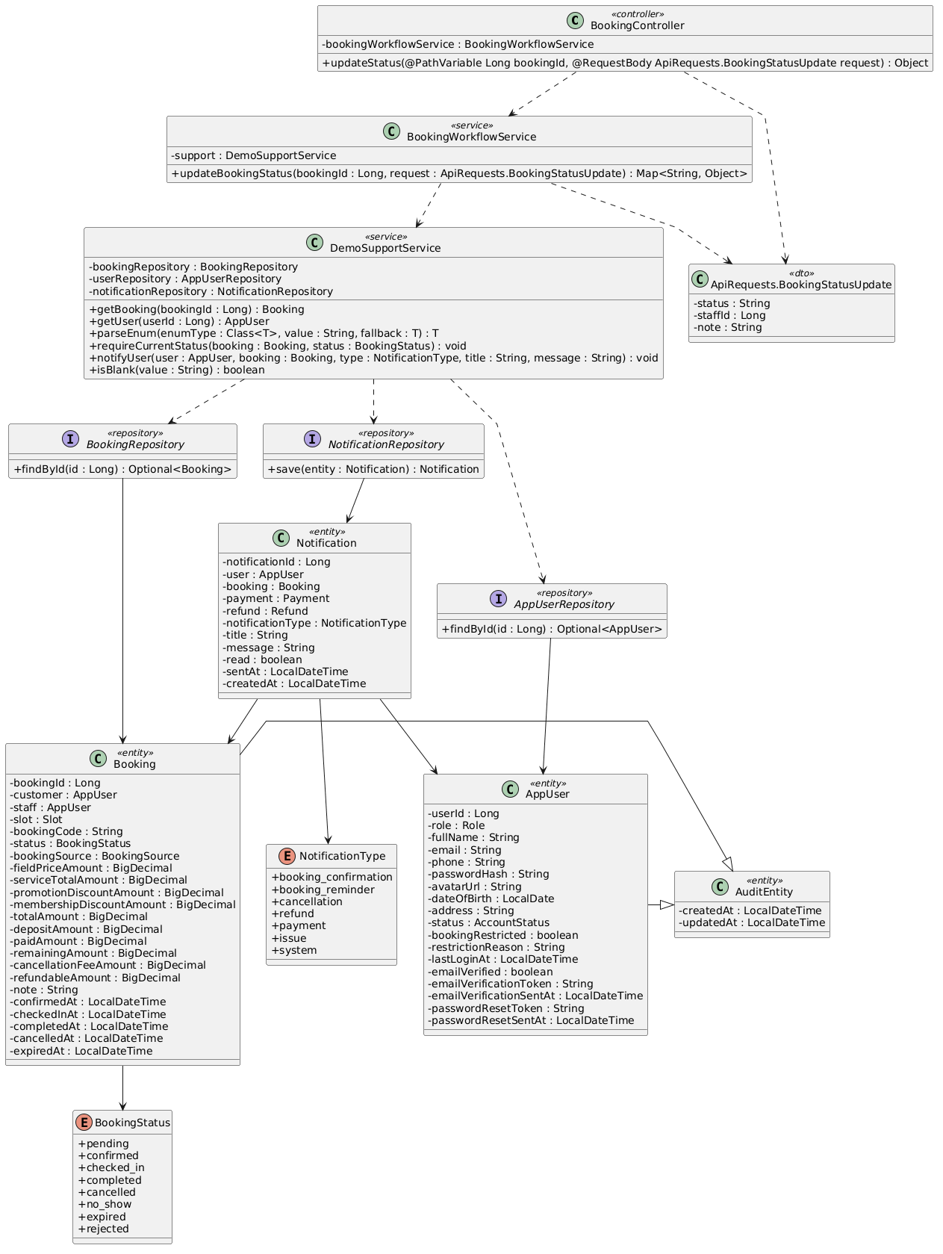

b. Class Specifications
BookingController
No | Method | Description
01 | public Object updateStatus(Long bookingId, ApiRequests.BookingStatusUpdate request) | Accepts the rejected target status.

BookingWorkflowService
No | Method | Description
01 | public Map<String, Object> updateBookingStatus(Long bookingId, ApiRequests.BookingStatusUpdate request) | Allows pending-to-rejected and creates a customer notification.

DemoSupportService
No | Method | Description
01 | void notifyUser(AppUser user, Booking booking, NotificationType type, String title, String message) | Stores the rejection notification.

c. Sequence Diagram
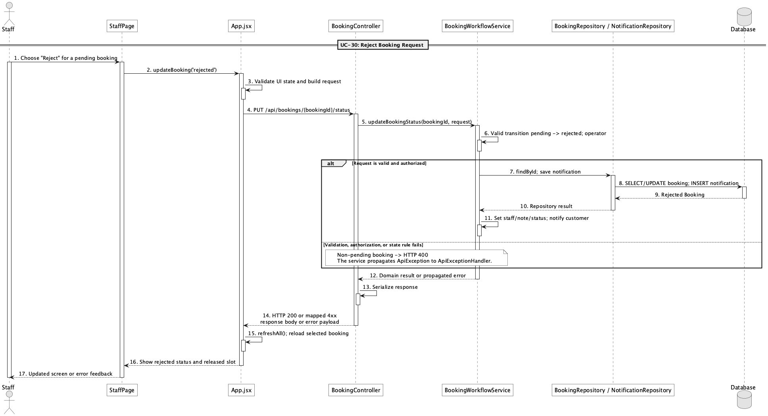

d. Database Queries
== Reject booking request ==

1. Reject pending booking
UPDATE booking
SET status = 'rejected', staff_id = :staffId, note = :note, updated_at = CURRENT_TIMESTAMP
WHERE booking_id = :bookingId AND status = 'pending';

Implementation note: There is no rejected_at column; the audit updated_at and optional note are the persisted timing/context.

31. Reschedule booking

a. Class Diagram
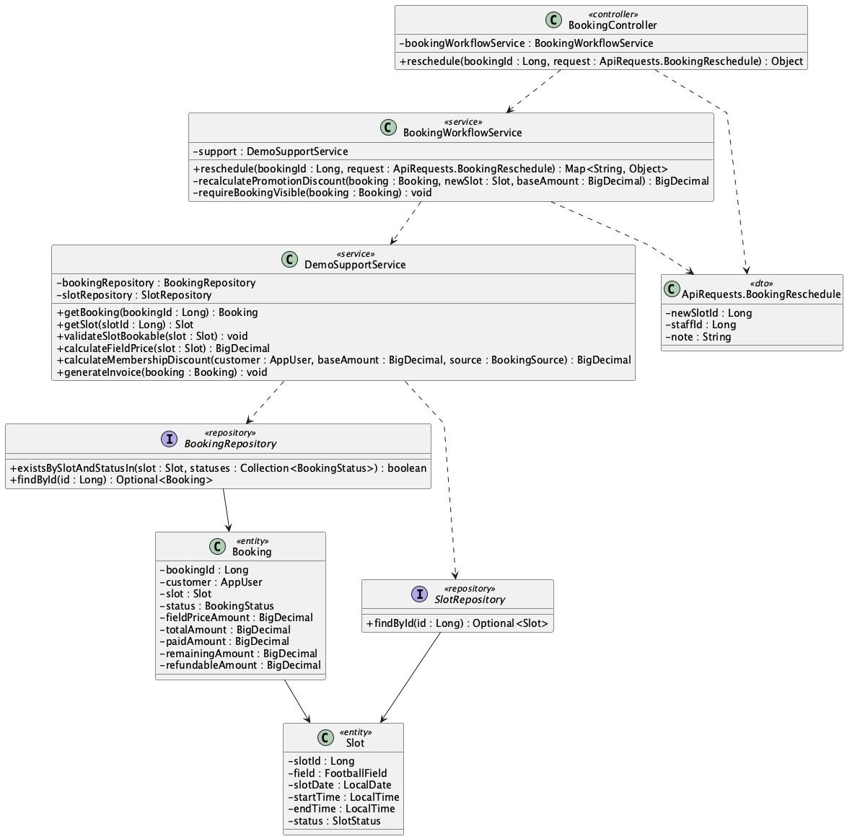

b. Class Specifications
BookingController
No | Method | Description
01 | public Object reschedule(Long bookingId, ApiRequests.BookingReschedule request) | Exposes PUT /api/bookings/{bookingId}/reschedule.

BookingWorkflowService
No | Method | Description
01 | public Map<String, Object> reschedule(Long bookingId, ApiRequests.BookingReschedule request) | Moves pending/confirmed booking to a free slot while preserving payment history and repricing totals.

DemoSupportService
No | Method | Description
01 | void validateSlotBookable(Slot slot) | Prevents rescheduling into a blocked, past, or actively booked slot.

c. Sequence Diagram
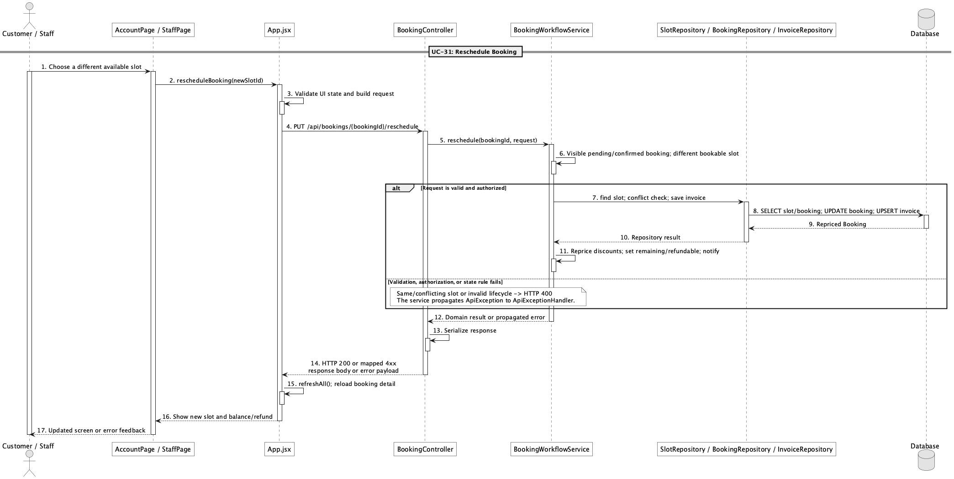

d. Database Queries
== Reschedule booking ==

1. Persist rescheduled slot and price delta
UPDATE booking
SET slot_id = :newSlotId, field_price_amount = :fieldPrice,
promotion_discount_amount = :promotionDiscount, membership_discount_amount = :membershipDiscount,
total_amount = :newTotal, deposit_amount = :depositAmount,
remaining_amount = GREATEST(:newTotal - paid_amount, 0),
refundable_amount = GREATEST(paid_amount - :newTotal, 0), updated_at = CURRENT_TIMESTAMP
WHERE booking_id = :bookingId AND status IN ('pending','confirmed');

Implementation note: No payment rows are deleted or rewritten during reschedule.

32. Preview cancellation fee/refund

a. Class Diagram
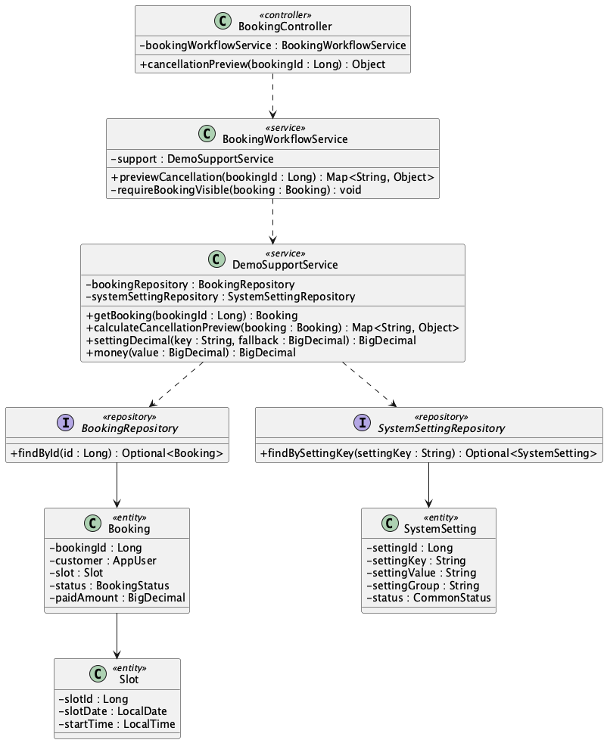

b. Class Specifications
BookingController
No | Method | Description
01 | public Object cancellationPreview(Long bookingId) | Exposes GET /api/bookings/{bookingId}/cancellation-preview.

BookingWorkflowService
No | Method | Description
01 | public Map<String, Object> previewCancellation(Long bookingId) | Checks visibility and delegates policy calculation without mutating the booking.

DemoSupportService
No | Method | Description
01 | Map<String, Object> calculateCancellationPreview(Booking booking) | Calculates fee/refundable amount from paid amount, start time, and refund policy settings.

c. Sequence Diagram
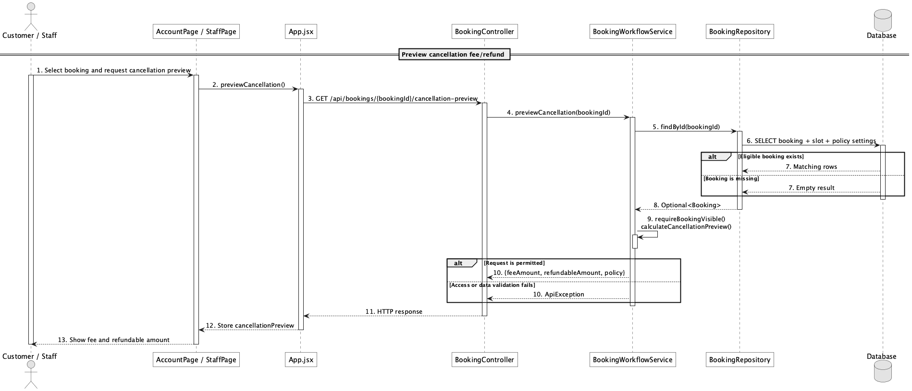

d. Database Queries
== Preview cancellation fee/refund ==

1. Cancellation inputs and policy
SELECT b.booking_id, b.booking_code, b.status, b.paid_amount,
s.slot_date, s.start_time,
MAX(CASE WHEN ss.setting_key = 'refund.before_24h_percent' THEN ss.setting_value END) AS before_24h_percent,
MAX(CASE WHEN ss.setting_key = 'refund.same_day_percent' THEN ss.setting_value END) AS same_day_percent
FROM booking b
JOIN slot s ON s.slot_id = b.slot_id
CROSS JOIN system_setting ss
WHERE b.booking_id = :bookingId
GROUP BY b.booking_id, b.booking_code, b.status, b.paid_amount, s.slot_date, s.start_time;

Implementation note: Preview is valid only for pending or confirmed bookings.

33. Cancel booking

a. Class Diagram
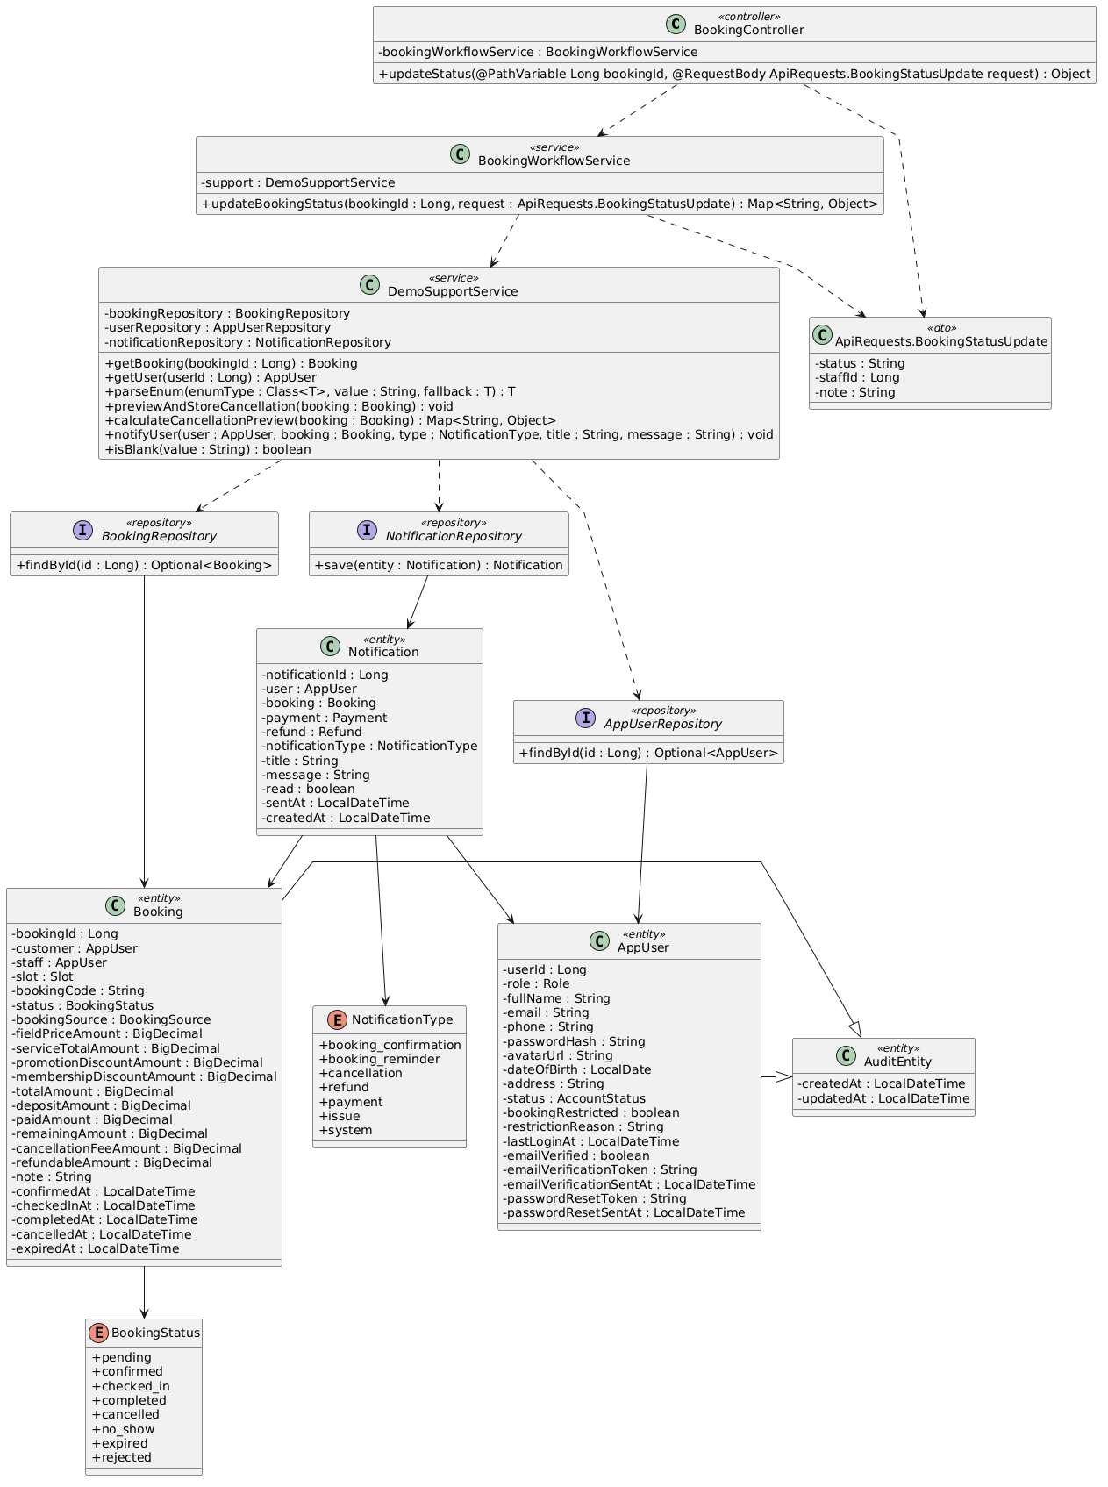

b. Class Specifications
BookingWorkflowService
No | Method | Description
01 | public Map<String, Object> updateBookingStatus(Long bookingId, ApiRequests.BookingStatusUpdate request) | Allows owner cancellation or operator cancellation from eligible states.

DemoSupportService
No | Method | Description
01 | void previewAndStoreCancellation(Booking booking) | Stores cancellation fee and refundable amount using the configured policy.
02 | void notifyUser(AppUser user, Booking booking, NotificationType type, String title, String message) | Creates the cancellation notification.

c. Sequence Diagram
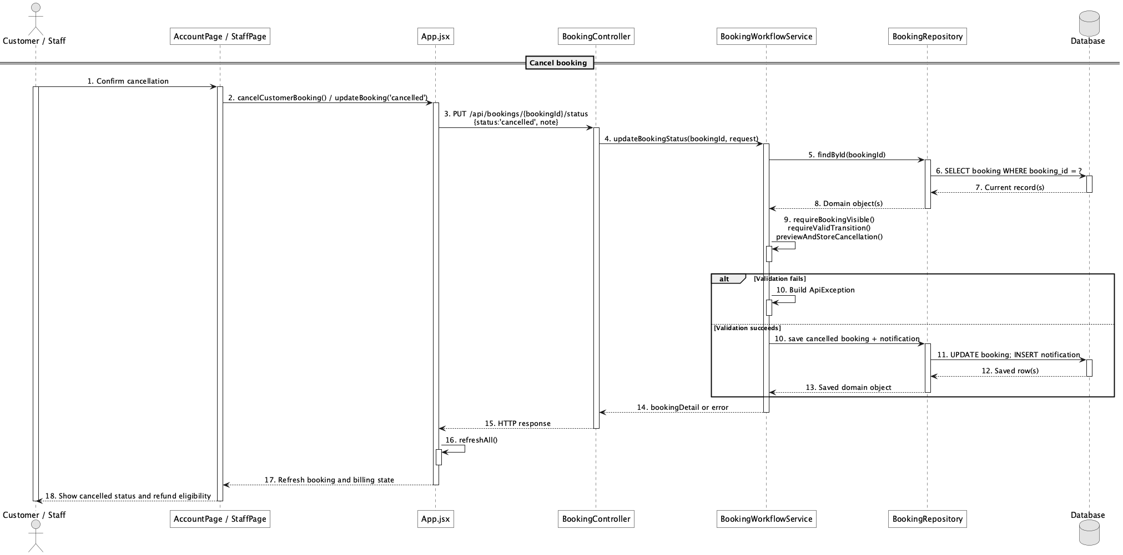

d. Database Queries
== Cancel booking ==

1. Cancel and store refund calculation
UPDATE booking
SET status = 'cancelled', cancelled_at = CURRENT_TIMESTAMP,
cancellation_fee_amount = :feeAmount, refundable_amount = :refundableAmount,
note = COALESCE(:note, note), updated_at = CURRENT_TIMESTAMP
WHERE booking_id = :bookingId AND status IN ('pending','confirmed');

Implementation note: Cancellation computes eligibility but does not itself complete a refund transaction.

34. Check-in booking

a. Class Diagram
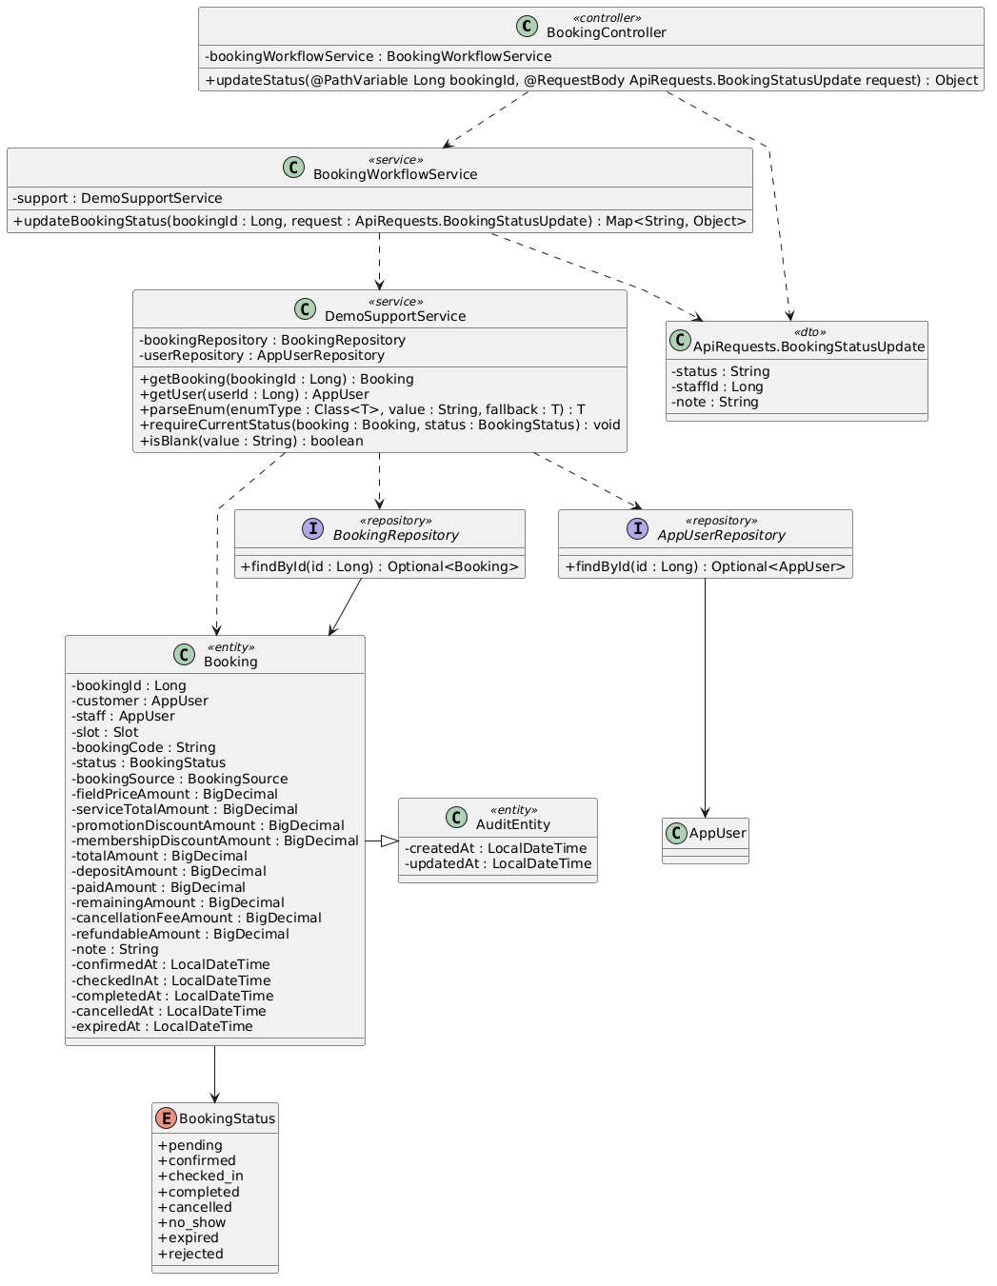

b. Class Specifications
BookingController
No | Method | Description
01 | public Object updateStatus(Long bookingId, ApiRequests.BookingStatusUpdate request) | Receives checked_in status from the staff workspace.

BookingWorkflowService
No | Method | Description
01 | public Map<String, Object> updateBookingStatus(Long bookingId, ApiRequests.BookingStatusUpdate request) | Allows only confirmed-to-checked_in and records checked_in_at.

c. Sequence Diagram
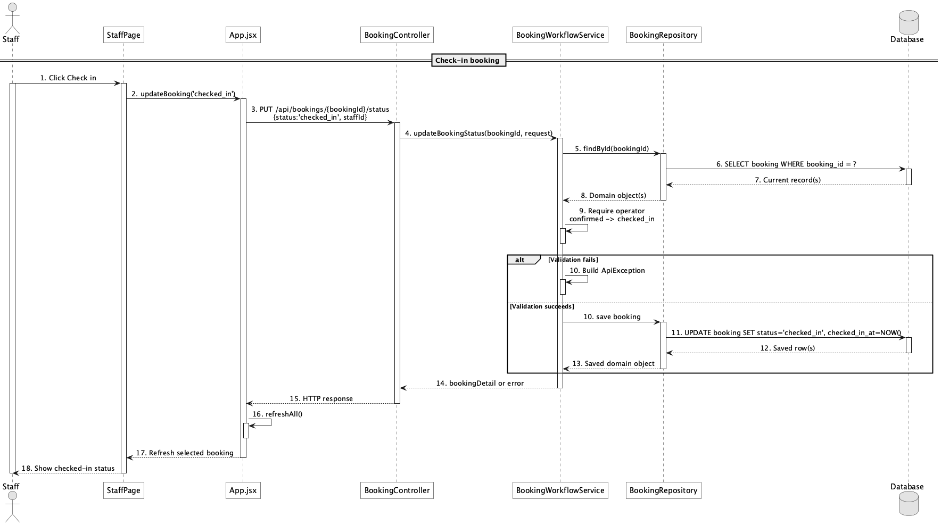

d. Database Queries
== Check-in booking ==

1. Check in confirmed booking
UPDATE booking
SET status = 'checked_in', checked_in_at = CURRENT_TIMESTAMP, staff_id = :staffId,
updated_at = CURRENT_TIMESTAMP
WHERE booking_id = :bookingId AND status = 'confirmed';

35. Complete booking

a. Class Diagram
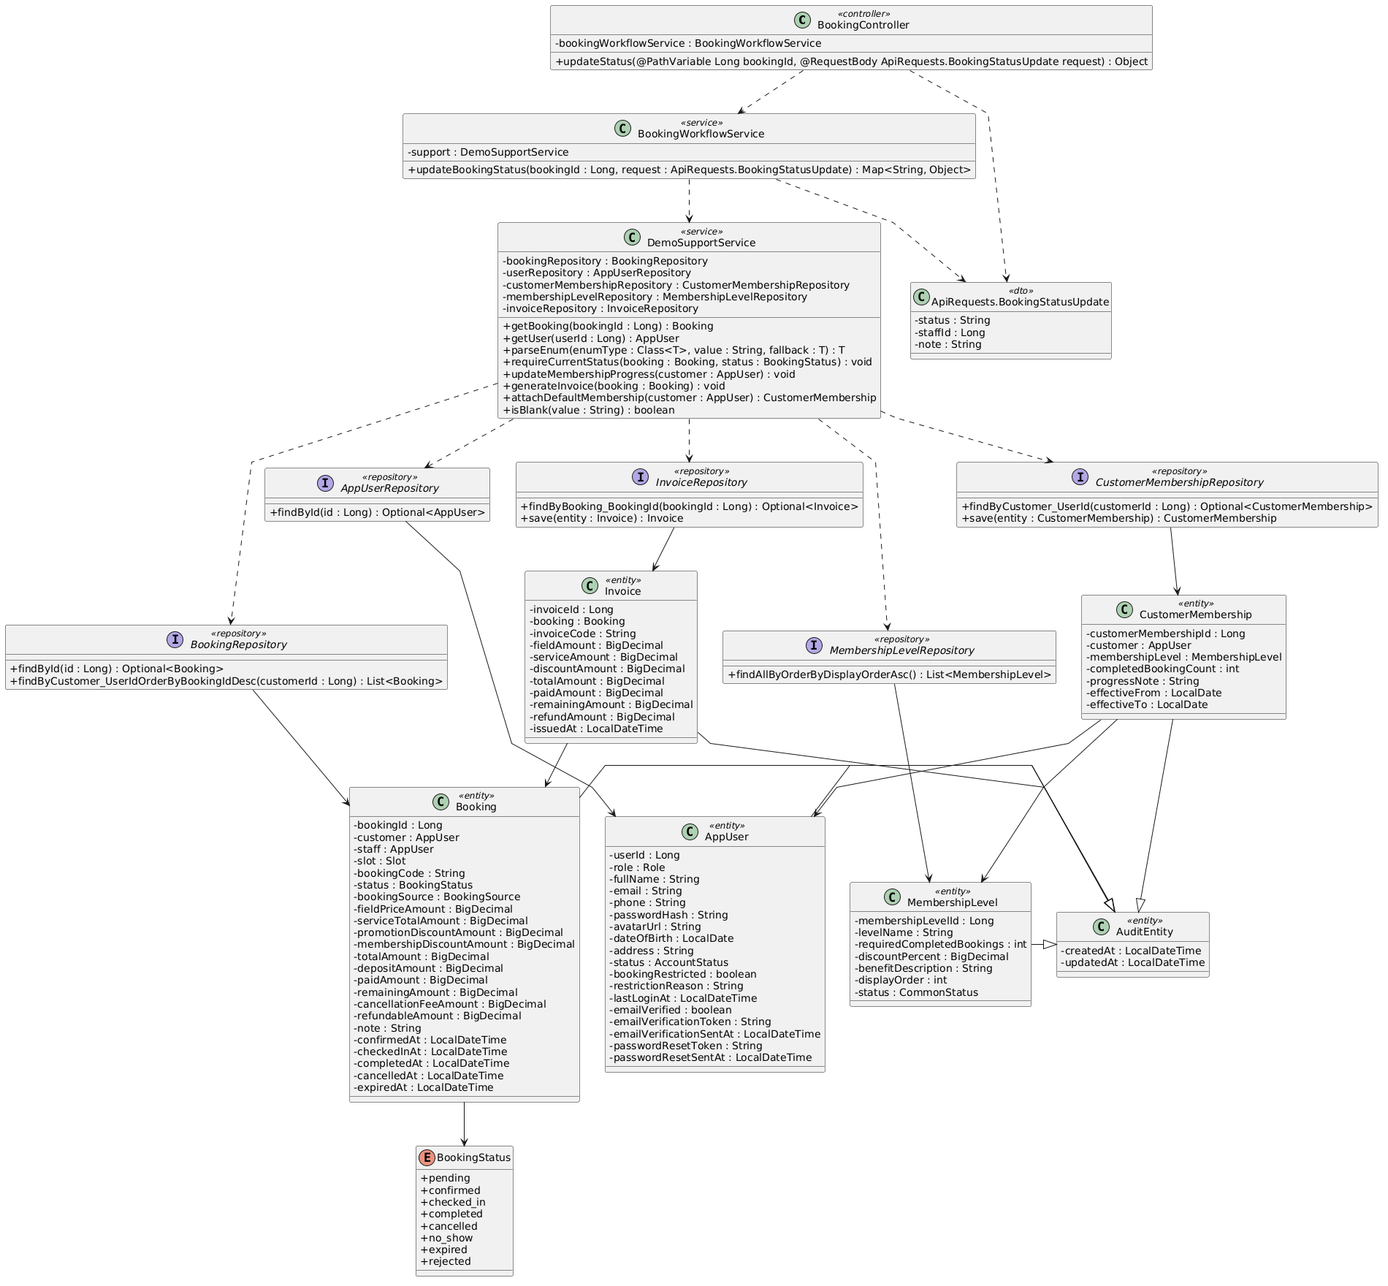

b. Class Specifications
BookingWorkflowService
No | Method | Description
01 | public Map<String, Object> updateBookingStatus(Long bookingId, ApiRequests.BookingStatusUpdate request) | Allows checked_in-to-completed, timestamps completion, updates membership, and generates invoice.

DemoSupportService
No | Method | Description
01 | void updateMembershipProgress(AppUser customer) | Refreshes the lifetime audit count and resolves the highest active level whose configured period rule is met.
02 | void generateInvoice(Booking booking) | Creates or refreshes the booking invoice.

c. Sequence Diagram
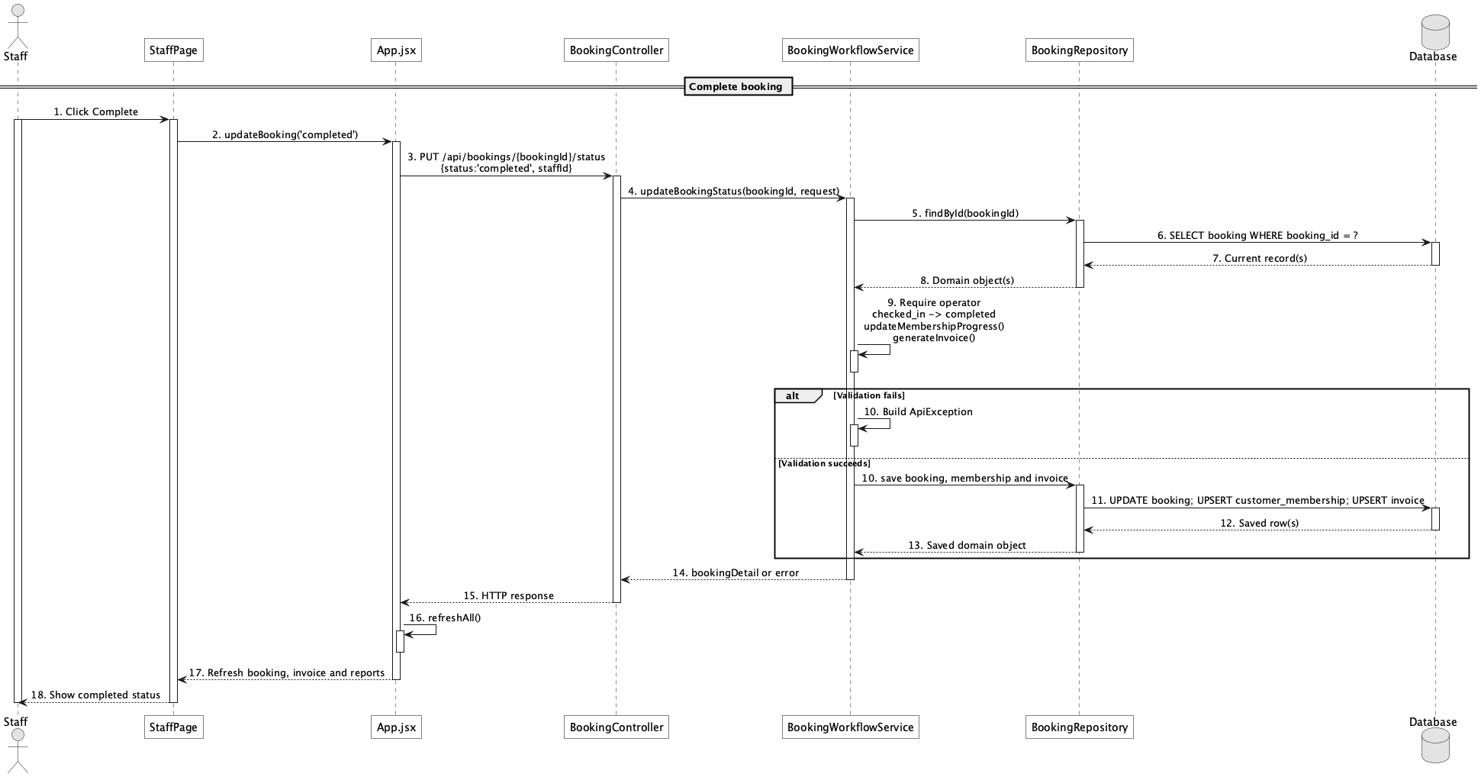

d. Database Queries
== Complete booking ==

1. Complete booking and count membership progress
UPDATE booking
SET status = 'completed', completed_at = CURRENT_TIMESTAMP, updated_at = CURRENT_TIMESTAMP
WHERE booking_id = :bookingId AND status = 'checked_in';

SELECT COUNT(*) AS completed_booking_count
FROM booking
WHERE customer_id = :customerId AND status = 'completed';

Implementation note: Only completed bookings count; eligibility supports lifetime, current-month, or consecutive qualifying-week rules.

36. Mark no-show

a. Class Diagram


b. Class Specifications
BookingController
No | Method | Description
01 | public Object updateStatus(Long bookingId, ApiRequests.BookingStatusUpdate request) | Routes no_show status update.

BookingWorkflowService
No | Method | Description
01 | public Map<String, Object> updateBookingStatus(Long bookingId, ApiRequests.BookingStatusUpdate request) | Allows confirmed-to-no_show through the explicit transition map.

c. Sequence Diagram
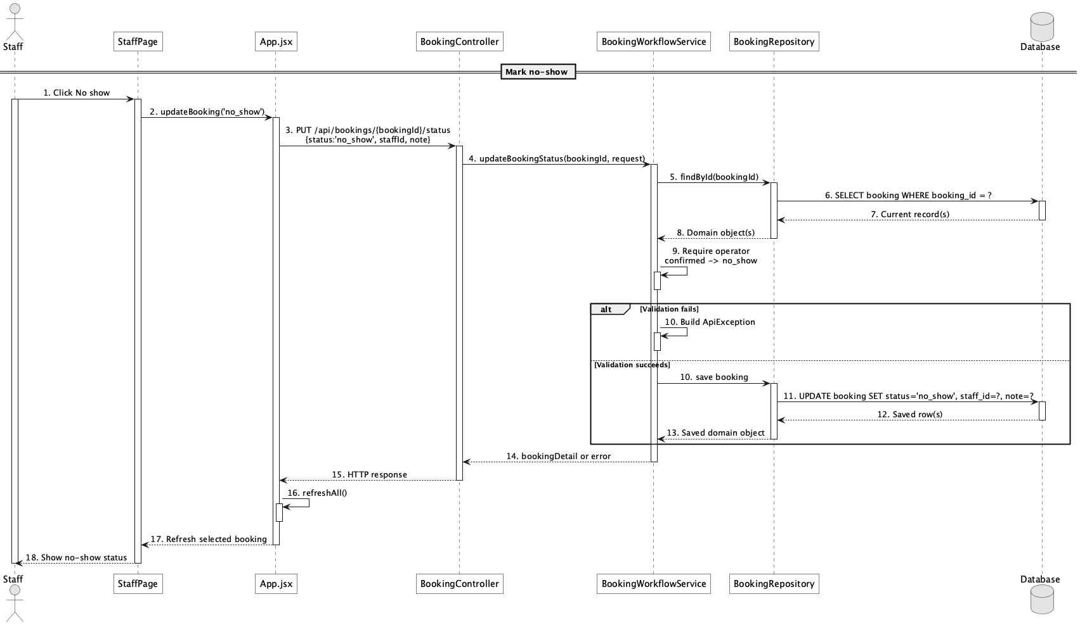

d. Database Queries
== Mark no-show ==

1. Mark confirmed booking no-show
UPDATE booking
SET status = 'no_show', staff_id = :staffId, note = COALESCE(:note, note),
updated_at = CURRENT_TIMESTAMP
WHERE booking_id = :bookingId AND status = 'confirmed';

Implementation note: There is no no_show_at column; only status, note, staff_id, and audit timestamp persist this event.

37. Handle booking conflict

a. Class Diagram
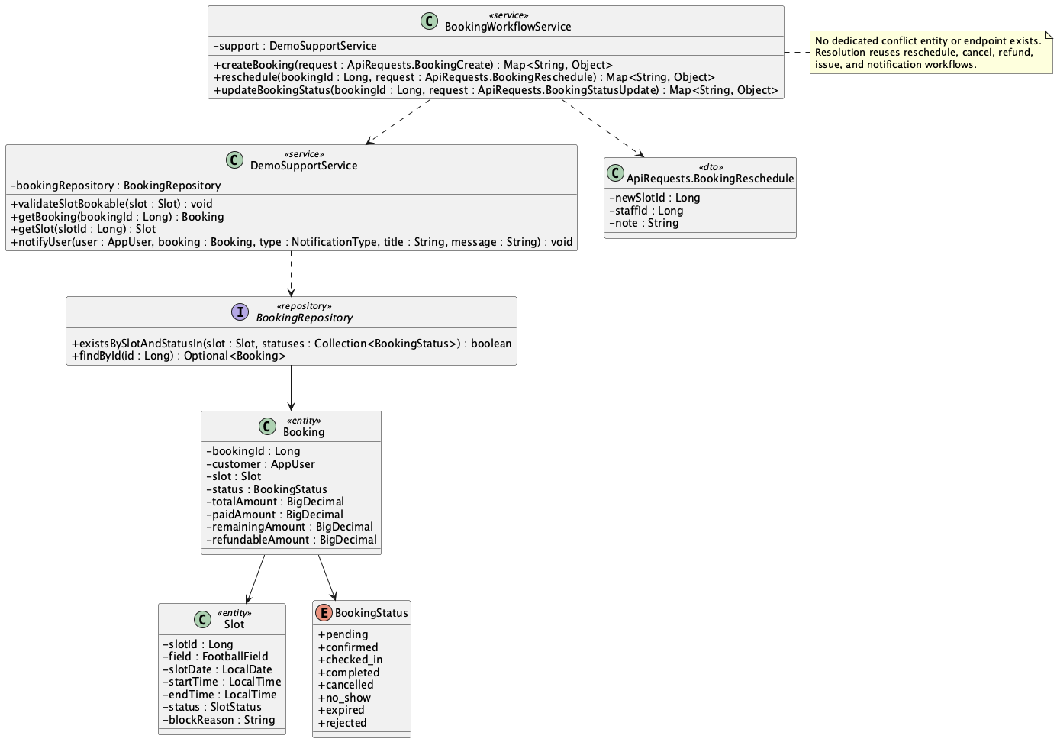

b. Class Specifications
DemoSupportService
No | Method | Description
01 | void validateSlotBookable(Slot slot) | Raises a conflict when the slot has an active booking.

BookingRepository
No | Method | Description
01 | boolean existsBySlotAndStatusIn(Slot slot, Collection<BookingStatus> statuses) | Detects active-slot occupancy.

BookingWorkflowService
No | Method | Description
01 | public Map<String, Object> reschedule(Long bookingId, ApiRequests.BookingReschedule request) | Provides the implemented resolution route by moving an eligible booking to another free slot.

c. Sequence Diagram
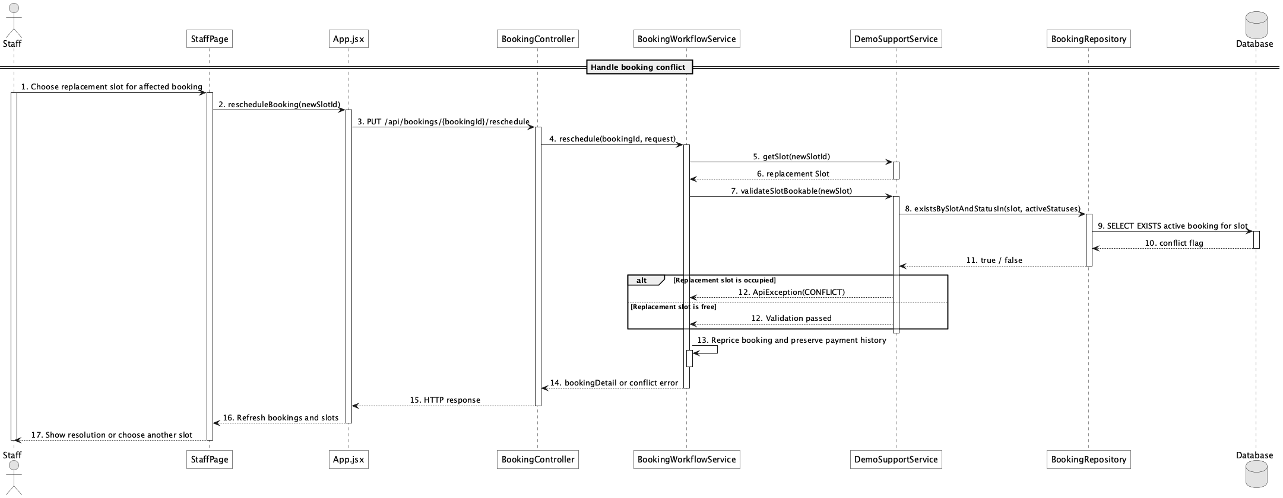

d. Database Queries
== Handle booking conflict ==

1. Detect active slot conflict
SELECT EXISTS (
SELECT 1
FROM booking
WHERE slot_id = :slotId
AND status IN ('pending','confirmed','checked_in')
) AS has_active_conflict;

Implementation note: There is no conflict table, Conflict entity, or dedicated conflict-management endpoint. The implementation prevents double booking and uses reschedule/cancel/refund/notification paths as resolution tools.

38. View checkout summary

a. Class Diagram
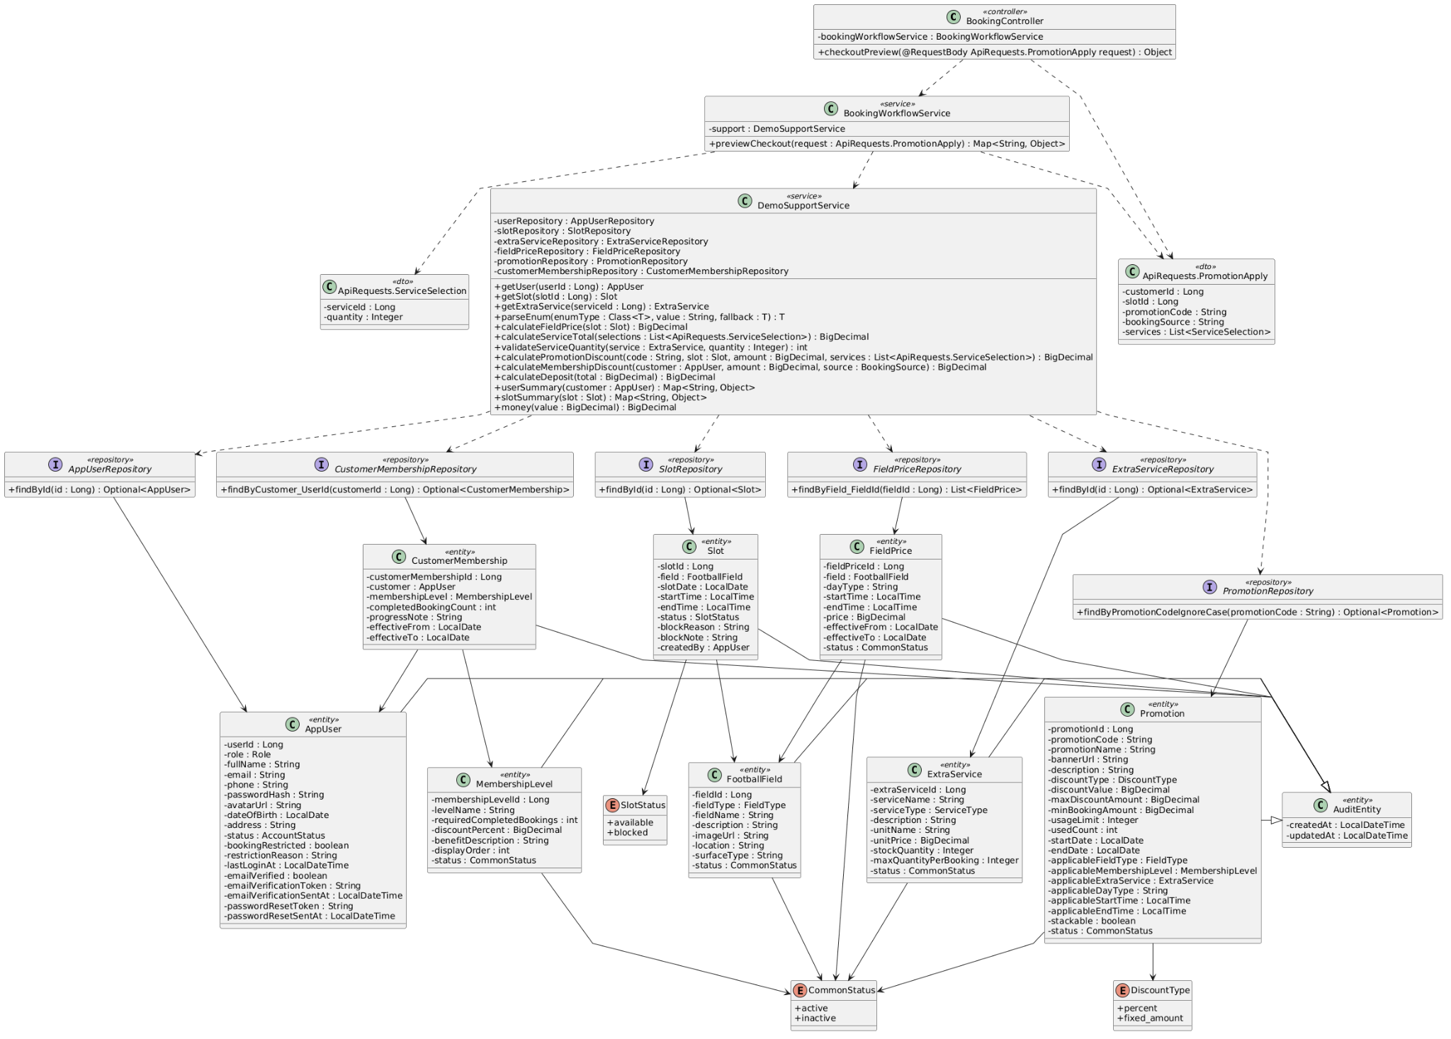

b. Class Specifications
BookingController
No | Method | Description
01 | public Object checkoutPreview(ApiRequests.PromotionApply request) | Exposes the public checkout preview endpoint.

BookingWorkflowService
No | Method | Description
01 | public Map<String, Object> previewCheckout(ApiRequests.PromotionApply request) | Calculates field, service, promotion, membership, total, deposit, and post-deposit balance.

DemoSupportService
No | Method | Description
01 | BigDecimal calculateDeposit(BigDecimal total) | Applies deposit.default_percent to the computed total.

c. Sequence Diagram
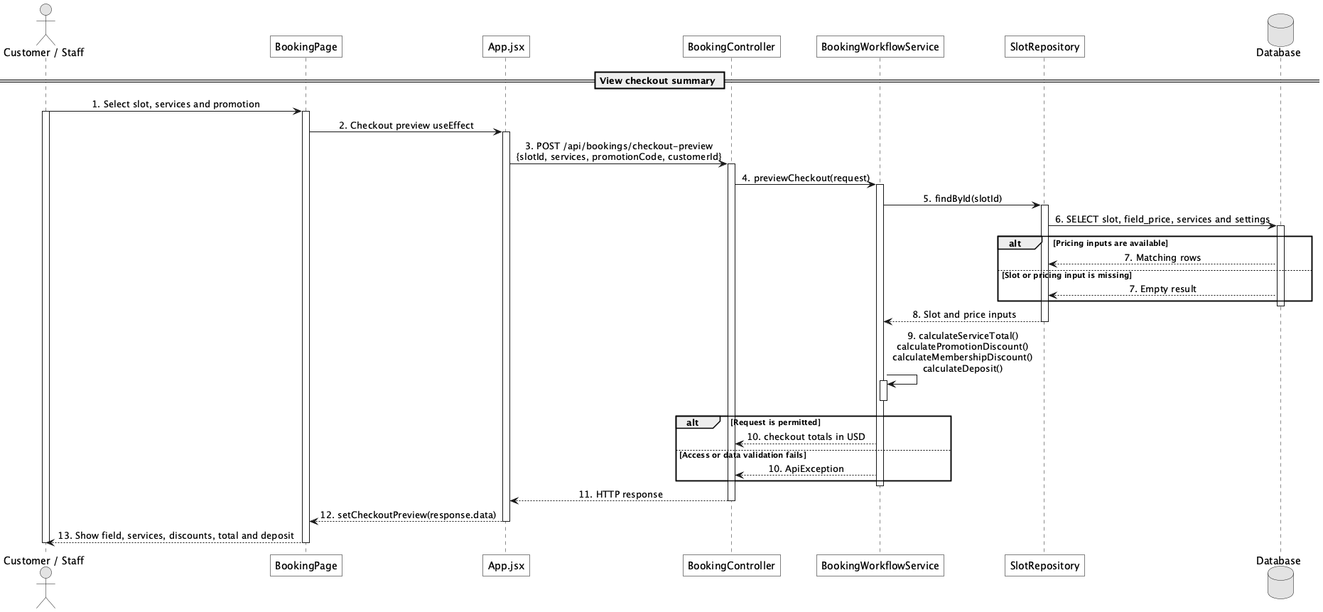

d. Database Queries
== View checkout summary ==

1. Checkout pricing inputs
SELECT s.slot_id, s.slot_date, s.start_time, s.end_time, f.field_id,
fp.price AS field_price, ss.setting_value AS deposit_percent
FROM slot s
JOIN field f ON f.field_id = s.field_id
LEFT JOIN field_price fp ON fp.field_id = f.field_id
AND fp.status = 'active'
AND (fp.day_type = :dayType OR fp.day_type = 'all')
AND s.start_time >= fp.start_time AND s.end_time <= fp.end_time
LEFT JOIN system_setting ss ON ss.setting_key = 'deposit.default_percent'
WHERE s.slot_id = :slotId;

Implementation note: This endpoint is intentionally public for anonymous basket estimation and does not return a supplied customer's profile.

39. Choose payment option

a. Class Diagram
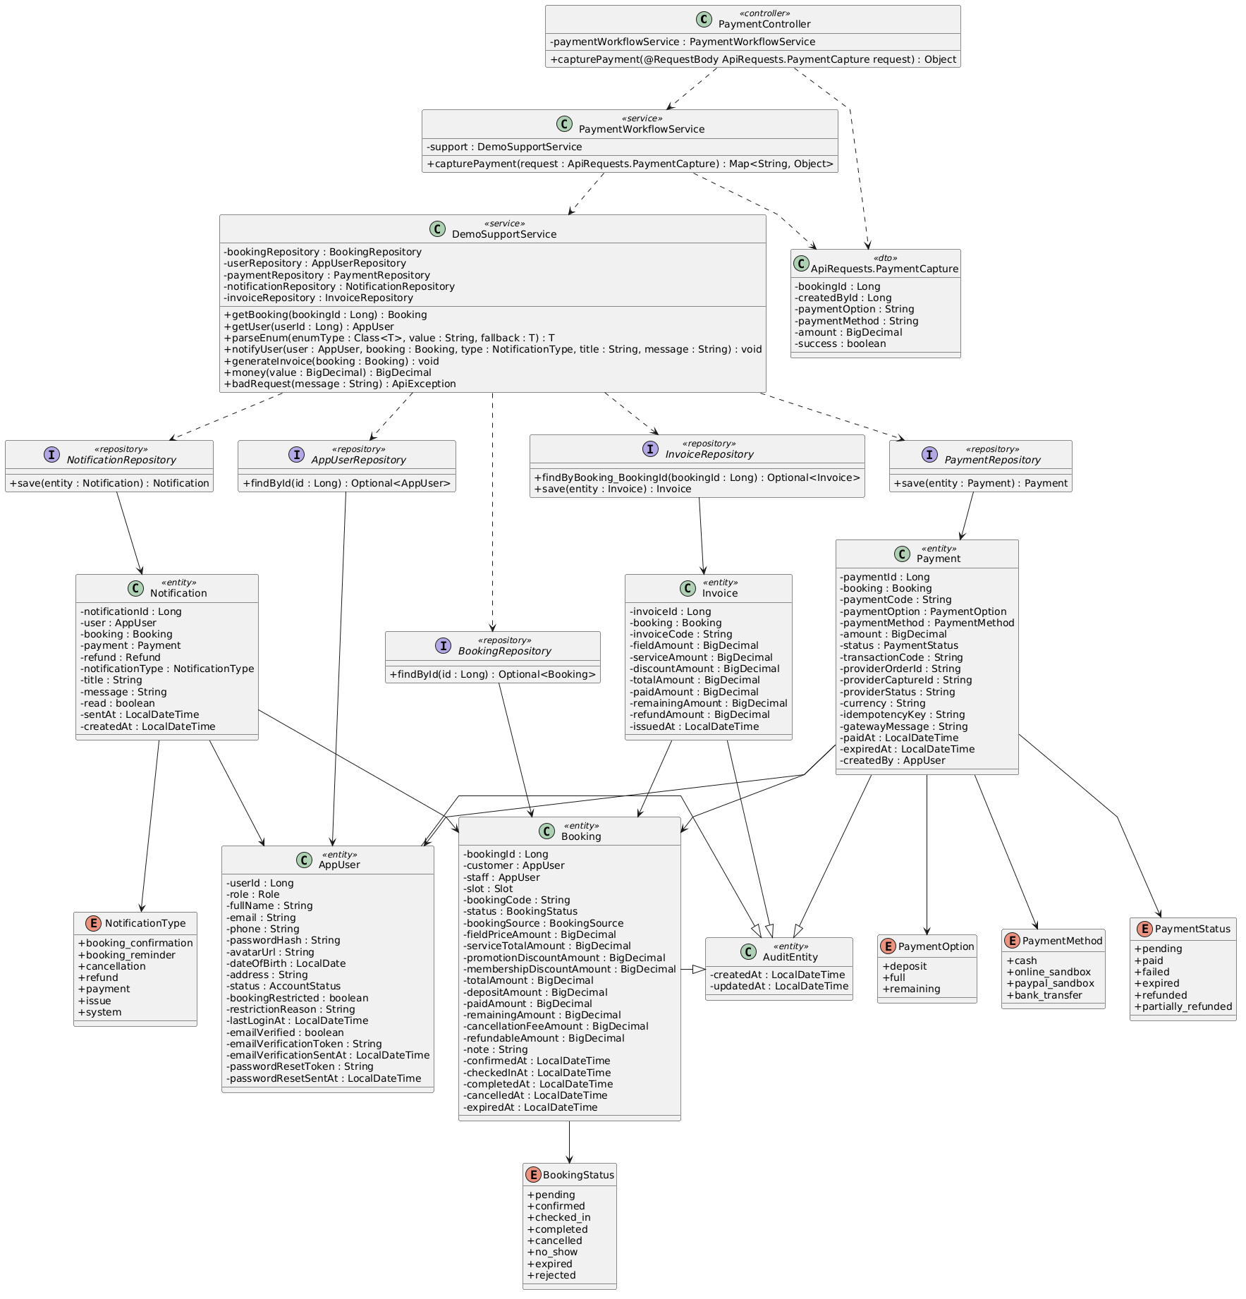

b. Class Specifications
PayPalCheckoutService
No | Method | Description
01 | public Map<String, Object> createOrder(Long bookingId, ApiRequests.PayPalOrderCreate request) | Uses deposit or full to calculate the customer PayPal payable amount.

PaymentWorkflowService
No | Method | Description
01 | public Map<String, Object> capturePayment(ApiRequests.PaymentCapture request) | Accepts deposit, full, or remaining for Staff/Admin counter payment but requires cash.

BookingWorkflowService
No | Method | Description
01 | public Map<String, Object> previewCheckout(ApiRequests.PromotionApply request) | Supplies total, deposit, and remaining values shown before option choice.

c. Sequence Diagram
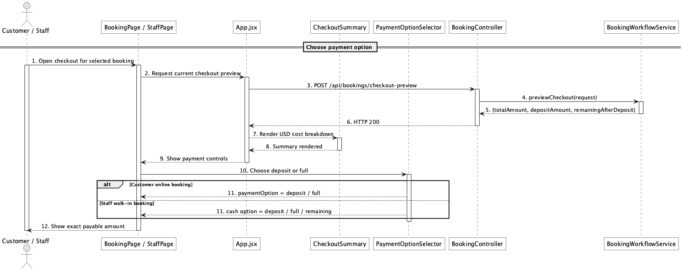

d. Database Queries
== Choose payment option ==

1. Payment option amounts
SELECT booking_id, total_amount, deposit_amount, paid_amount, remaining_amount,
CASE :paymentOption
WHEN 'deposit' THEN GREATEST(deposit_amount - paid_amount, 0)
WHEN 'full' THEN remaining_amount
WHEN 'remaining' THEN remaining_amount
END AS payable_amount
FROM booking
WHERE booking_id = :bookingId;

Implementation note: Customer online checkout supports deposit/full through PayPal; Staff/Admin counter flow records cash and may use remaining.

40. Pay deposit/full amount via online payment sandbox

a. Class Diagram
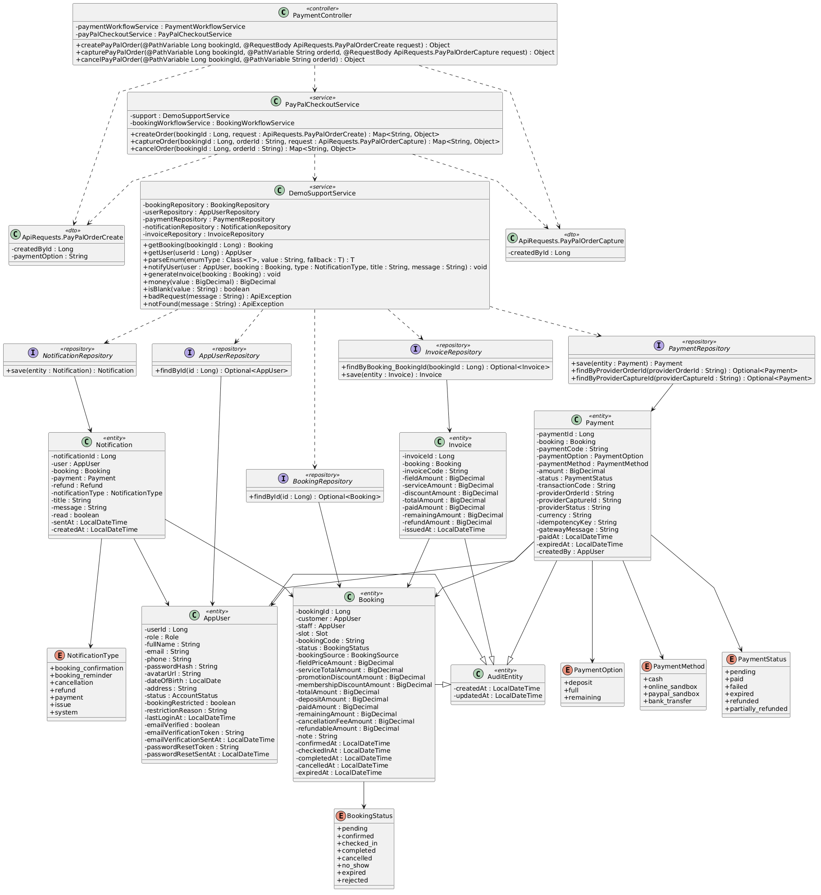

b. Class Specifications
PaymentController
No | Method | Description
01 | public Object payPalConfig() | Returns client-side sandbox configuration without exposing the secret.
02 | public Object createPayPalOrder(Long bookingId, ApiRequests.PayPalOrderCreate request) | Starts a PayPal order for the customer-owned online booking.
03 | public Object capturePayPalOrder(Long bookingId, String orderId, ApiRequests.PayPalOrderCapture request) | Captures the approved order.

PayPalCheckoutService
No | Method | Description
01 | public Map<String, Object> config() | Reports whether configured sandbox checkout is enabled.
02 | public Map<String, Object> createOrder(Long bookingId, ApiRequests.PayPalOrderCreate request) | Creates provider order and pending local payment with idempotency metadata.
03 | public Map<String, Object> captureOrder(Long bookingId, String orderId, ApiRequests.PayPalOrderCapture request) | Calls PayPal Orders v2 capture and validates captured currency/amount.

c. Sequence Diagram
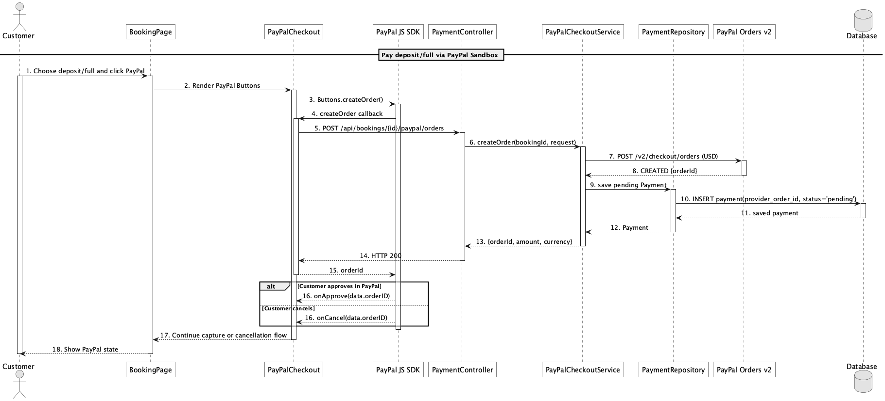

d. Database Queries
== Pay deposit/full amount via online payment sandbox ==

1. Persist pending PayPal order
INSERT INTO payment
(booking_id, payment_code, payment_option, payment_method, amount, status,
provider_order_id, provider_status, currency, idempotency_key, gateway_message,
created_by, created_at, updated_at)
VALUES
(:bookingId, :paymentCode, :paymentOption, 'paypal_sandbox', :amount, 'pending',
:orderId, 'CREATED', 'USD', :idempotencyKey, :gatewayMessage,
:customerId, CURRENT_TIMESTAMP, CURRENT_TIMESTAMP);

Implementation note: The product target is PayPal Sandbox, not live-money certification. Mock mode exists for local automated tests.

41. Capture/confirm online payment

a. Class Diagram
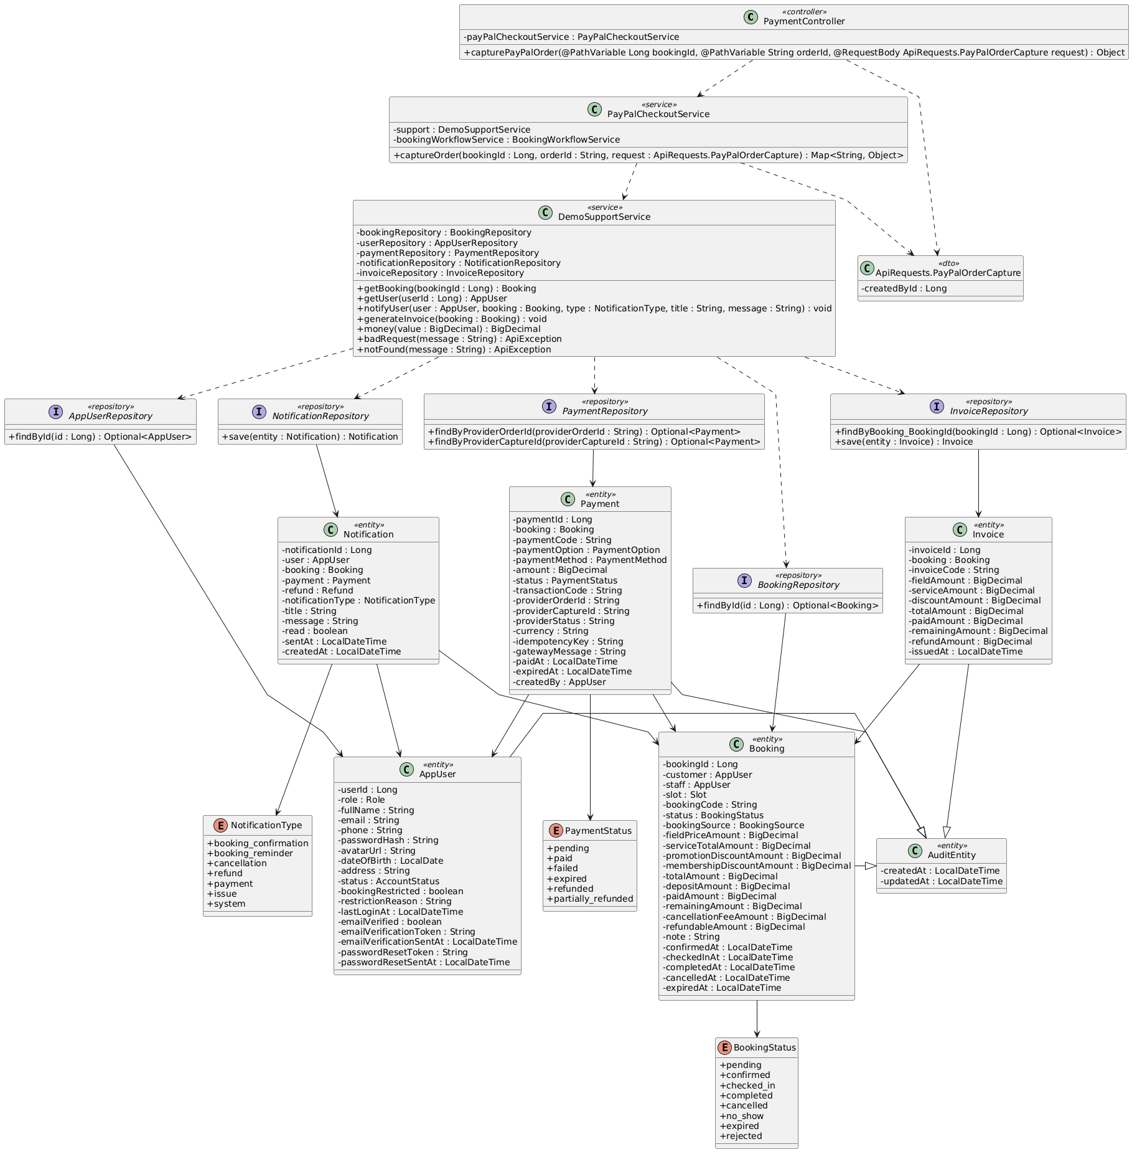

b. Class Specifications
PayPalCheckoutService
No | Method | Description
01 | public Map<String, Object> captureOrder(Long bookingId, String orderId, ApiRequests.PayPalOrderCapture request) | Makes capture idempotent by provider identifiers, stores success/failure, updates booking balance, confirms when deposit threshold is reached, and regenerates invoice.

PaymentRepository
No | Method | Description
01 | Optional<Payment> findByProviderOrderId(String providerOrderId) | Resolves the local pending payment for capture.
02 | Optional<Payment> findByProviderCaptureId(String providerCaptureId) | Prevents a provider capture from being processed twice.

DemoSupportService
No | Method | Description
01 | void generateInvoice(Booking booking) | Synchronizes invoice totals after capture.

c. Sequence Diagram
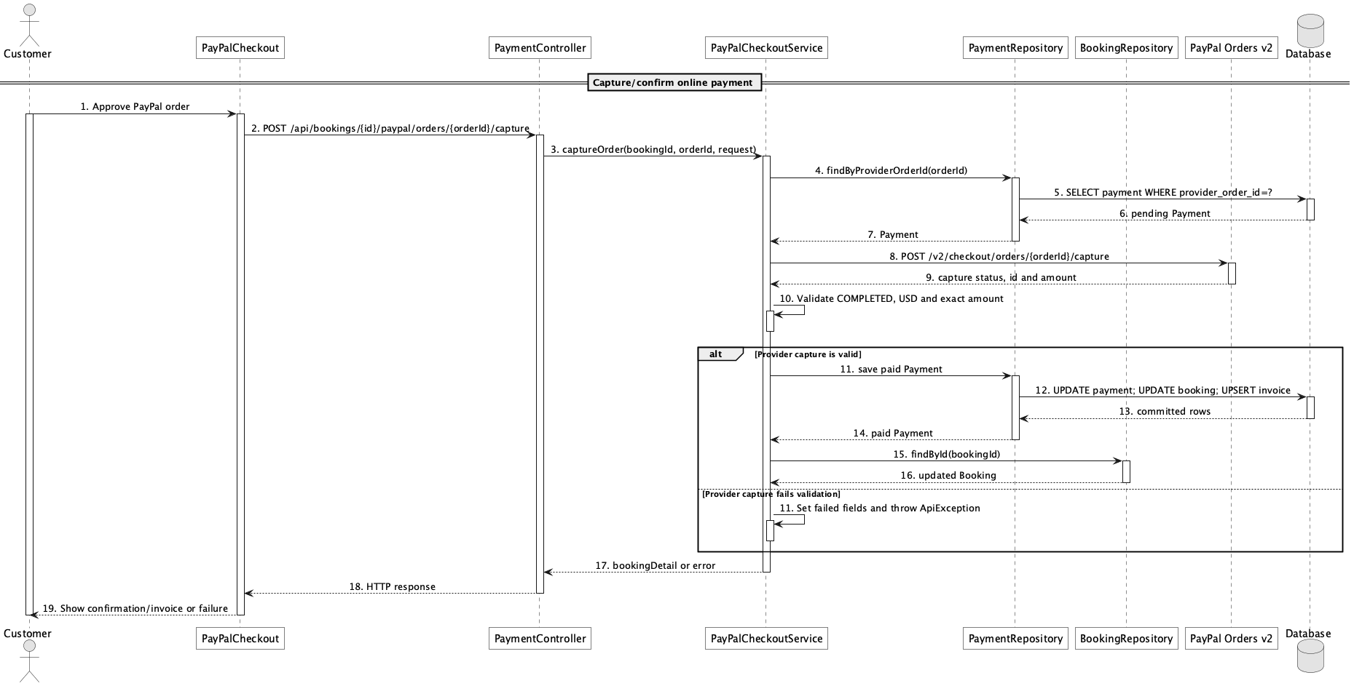

d. Database Queries
== Capture/confirm online payment ==

1. Store successful capture and update balance
UPDATE payment
SET status = 'paid', provider_capture_id = :captureId, provider_status = :providerStatus,
transaction_code = :captureId, gateway_message = :message, paid_at = CURRENT_TIMESTAMP,
updated_at = CURRENT_TIMESTAMP
WHERE provider_order_id = :orderId AND status = 'pending';

UPDATE booking
SET paid_amount = paid_amount + :capturedAmount,
remaining_amount = GREATEST(total_amount - (paid_amount + :capturedAmount), 0),
status = CASE WHEN status = 'pending' AND paid_amount + :capturedAmount >= deposit_amount
THEN 'confirmed' ELSE status END,
confirmed_at = CASE WHEN status = 'pending' AND paid_amount + :capturedAmount >= deposit_amount
THEN CURRENT_TIMESTAMP ELSE confirmed_at END
WHERE booking_id = :bookingId;

Implementation note: Only provider COMPLETED capture is accepted as paid outside mock mode.

42. Confirm remaining payment

a. Class Diagram


b. Class Specifications
PaymentController
No | Method | Description
01 | public Object capturePayment(ApiRequests.PaymentCapture request) | Exposes Staff/Admin counter capture.

PaymentWorkflowService
No | Method | Description
01 | public Map<String, Object> capturePayment(ApiRequests.PaymentCapture request) | Requires operator and cash, validates exact payable amount, records payment, updates booking balance, and refreshes invoice.

DemoSupportService
No | Method | Description
01 | void generateInvoice(Booking booking) | Updates the invoice after remaining cash capture.

c. Sequence Diagram
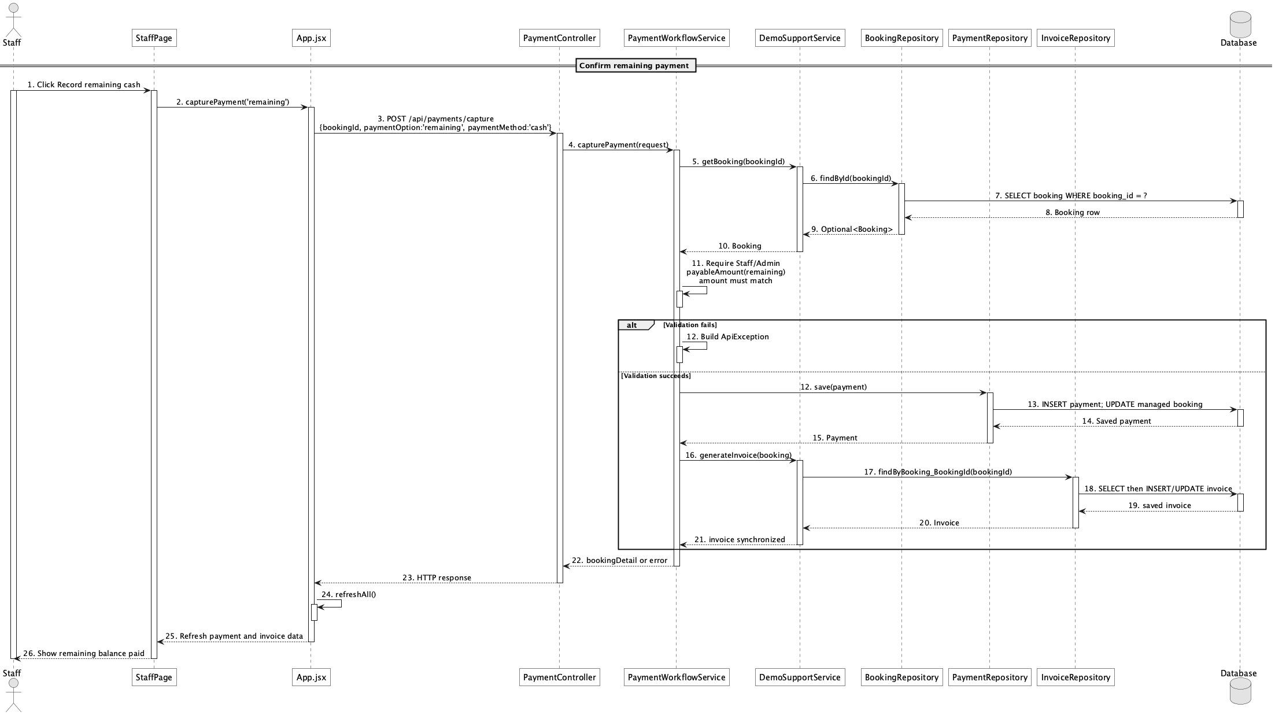

d. Database Queries
== Confirm remaining payment ==

1. Record remaining cash payment
INSERT INTO payment
(booking_id, payment_code, payment_option, payment_method, amount, status,
transaction_code, paid_at, created_by, created_at, updated_at)
VALUES
(:bookingId, :paymentCode, 'remaining', 'cash', :remainingAmount, 'paid',
:transactionCode, CURRENT_TIMESTAMP, :operatorId, CURRENT_TIMESTAMP, CURRENT_TIMESTAMP);

UPDATE booking
SET paid_amount = paid_amount + :remainingAmount, remaining_amount = 0, updated_at = CURRENT_TIMESTAMP
WHERE booking_id = :bookingId;

Implementation note: Counter capture rejects non-cash methods; customer PayPal is handled by the separate provider flow.

43. Handle failed/expired payment

a. Class Diagram
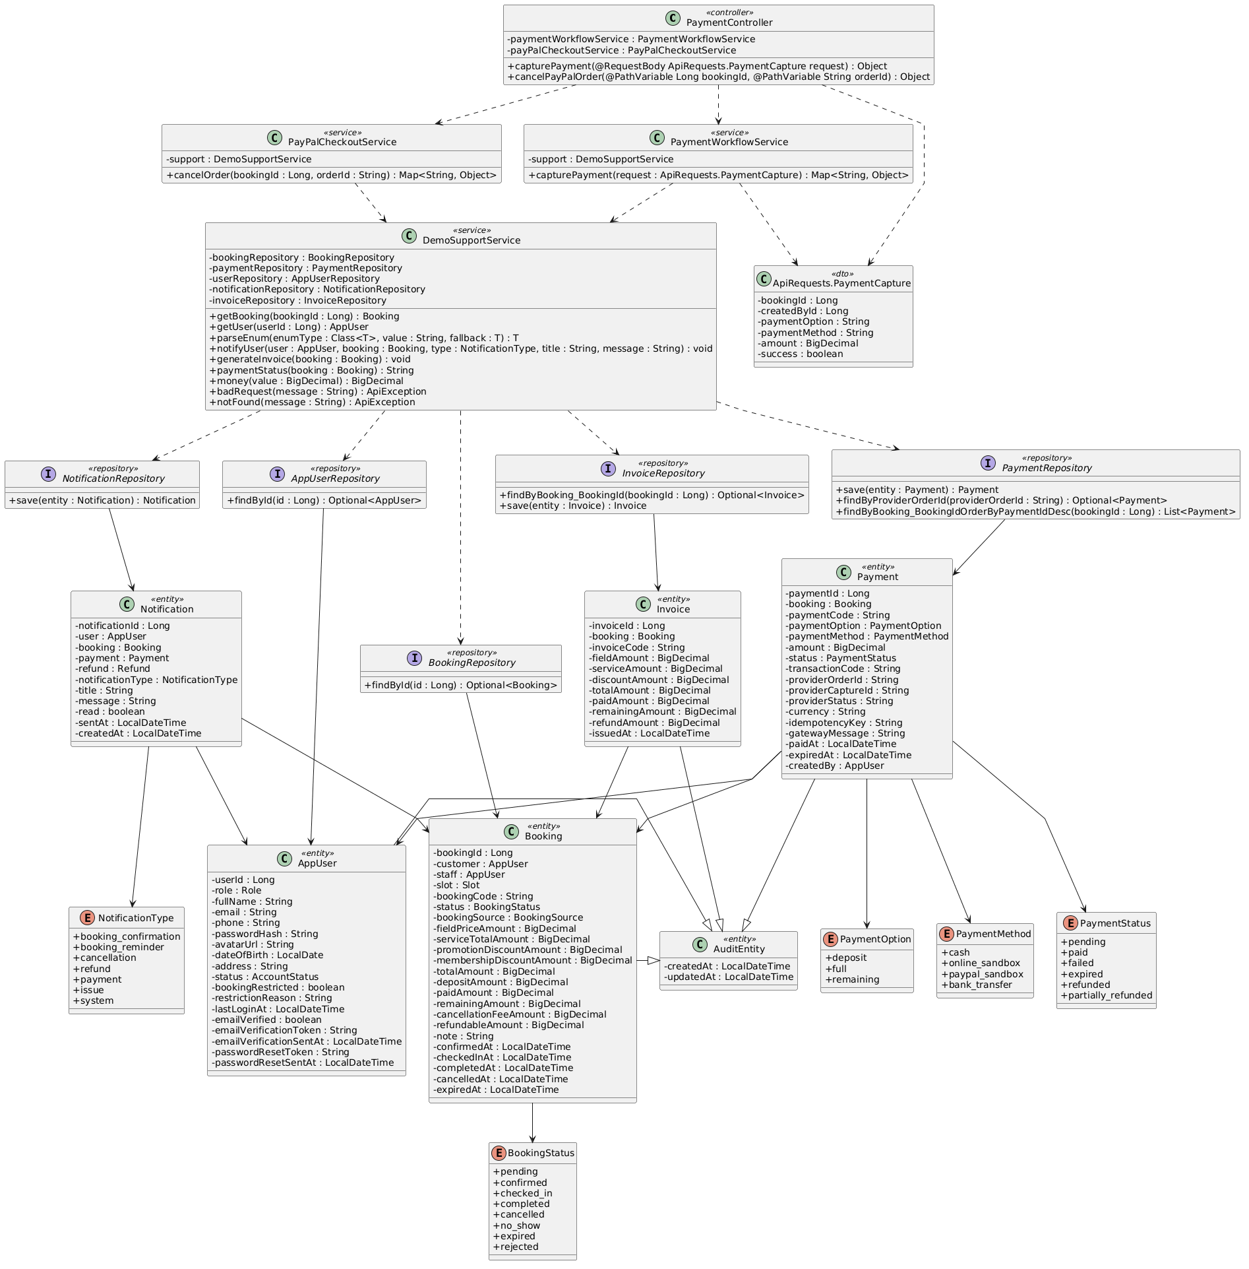

b. Class Specifications
PayPalCheckoutService
No | Method | Description
01 | public Map<String, Object> cancelOrder(Long bookingId, String orderId) | Expires an uncaptured payment and an unpaid pending booking when the customer cancels checkout.

BookingMaintenanceScheduler
No | Method | Description
01 | public void maintainBookings() | Scheduled entry point for payment expiry and reminder maintenance.
02 | public int expireUnpaidPendingBookings() | Expires aged unpaid pending holds using payment.pending_timeout_minutes.

BookingRepository
No | Method | Description
01 | List<Booking> findByStatusIn(Collection<BookingStatus> statuses) | Loads pending expiry candidates.

c. Sequence Diagram
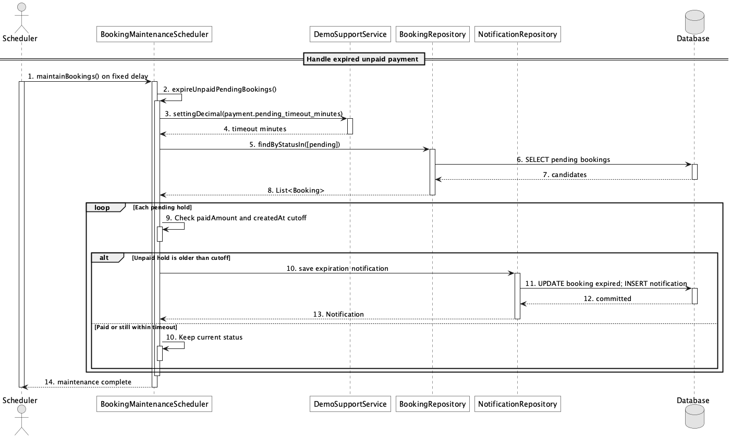

d. Database Queries
== Handle failed/expired payment ==

1. Find expired unpaid holds
SELECT b.booking_id, b.booking_code, b.customer_id, b.created_at
FROM booking b
WHERE b.status = 'pending'
AND b.paid_amount = 0
AND b.created_at < CURRENT_TIMESTAMP - (:timeoutMinutes * INTERVAL '1 minute');

Implementation note: The scheduler now exists; older documentation saying scheduled timeout was missing is stale.

44. View payment history

a. Class Diagram
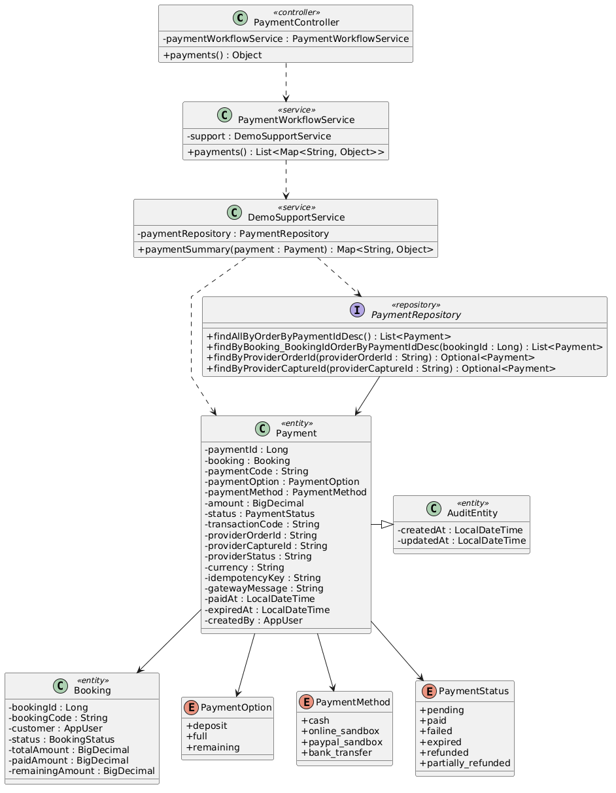

b. Class Specifications
PaymentController
No | Method | Description
01 | public Object payments() | Exposes authenticated GET /api/payments.

PaymentWorkflowService
No | Method | Description
01 | public List<Map<String, Object>> payments() | Returns own payment history for Customer or all payments for operators.

PaymentRepository
No | Method | Description
01 | List<Payment> findByBooking_Customer_UserIdOrderByPaymentIdDesc(Long customerId) | Loads the signed-in customer's transactions.
02 | List<Payment> findAllByOrderByPaymentIdDesc() | Loads the operator-wide history.

c. Sequence Diagram
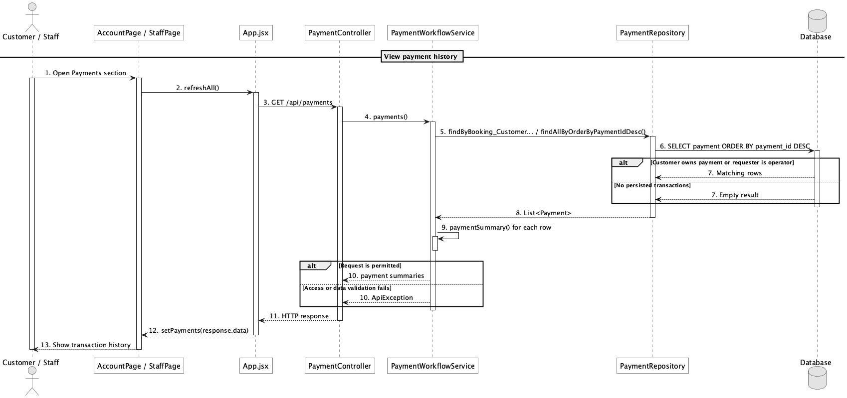

d. Database Queries
== View payment history ==

1. Customer payment history
SELECT p.payment_id, p.payment_code, p.payment_option, p.payment_method,
p.amount, p.status, p.transaction_code, p.gateway_message, p.paid_at, b.booking_code
FROM payment p
JOIN booking b ON b.booking_id = p.booking_id
WHERE b.customer_id = :customerId
ORDER BY p.payment_id DESC;

45. Generate booking invoice

a. Class Diagram
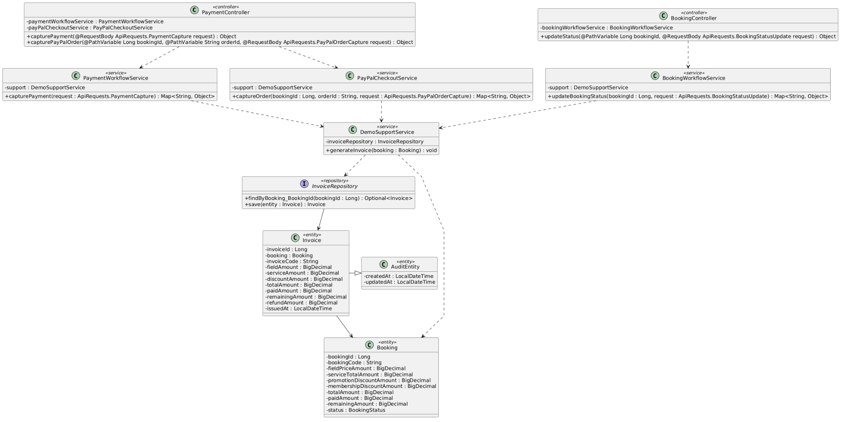

b. Class Specifications
DemoSupportService
No | Method | Description
01 | void generateInvoice(Booking booking) | Upserts one invoice per booking from booking financial snapshots.

InvoiceRepository
No | Method | Description
01 | Optional<Invoice> findByBooking_BookingId(Long bookingId) | Finds the existing invoice before creating or updating it.

PaymentWorkflowService
No | Method | Description
01 | public Map<String, Object> capturePayment(ApiRequests.PaymentCapture request) | Triggers invoice generation after a successful counter payment.

c. Sequence Diagram
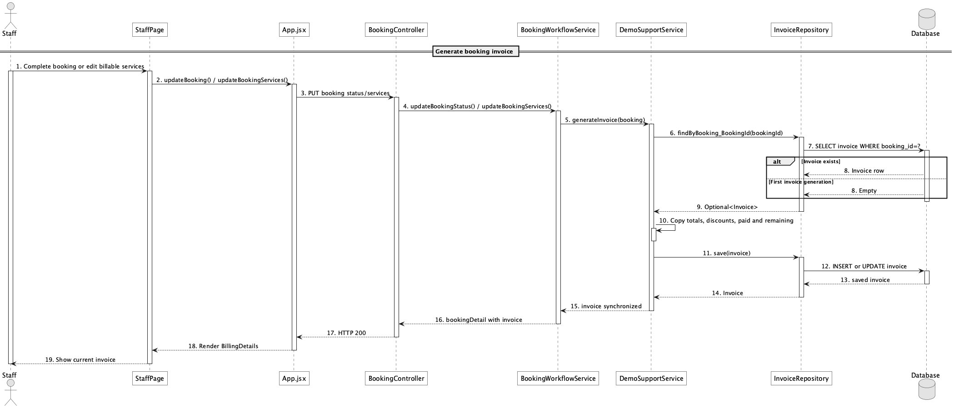

d. Database Queries
== Generate booking invoice ==

1. Invoice upsert
INSERT INTO invoice
(booking_id, invoice_code, field_amount, service_amount, discount_amount,
total_amount, paid_amount, remaining_amount, refund_amount, issued_at, created_at, updated_at)
VALUES
(:bookingId, :invoiceCode, :fieldAmount, :serviceAmount, :discountAmount,
:totalAmount, :paidAmount, :remainingAmount, :refundAmount, CURRENT_TIMESTAMP,
CURRENT_TIMESTAMP, CURRENT_TIMESTAMP)
ON CONFLICT (booking_id) DO UPDATE
SET field_amount = EXCLUDED.field_amount, service_amount = EXCLUDED.service_amount,
discount_amount = EXCLUDED.discount_amount, total_amount = EXCLUDED.total_amount,
paid_amount = EXCLUDED.paid_amount, remaining_amount = EXCLUDED.remaining_amount,
issued_at = EXCLUDED.issued_at, updated_at = CURRENT_TIMESTAMP;

Implementation note: The Java implementation uses find-or-create plus repository save; the SQL expresses equivalent PostgreSQL behavior.

46. View invoice/payment status

a. Class Diagram
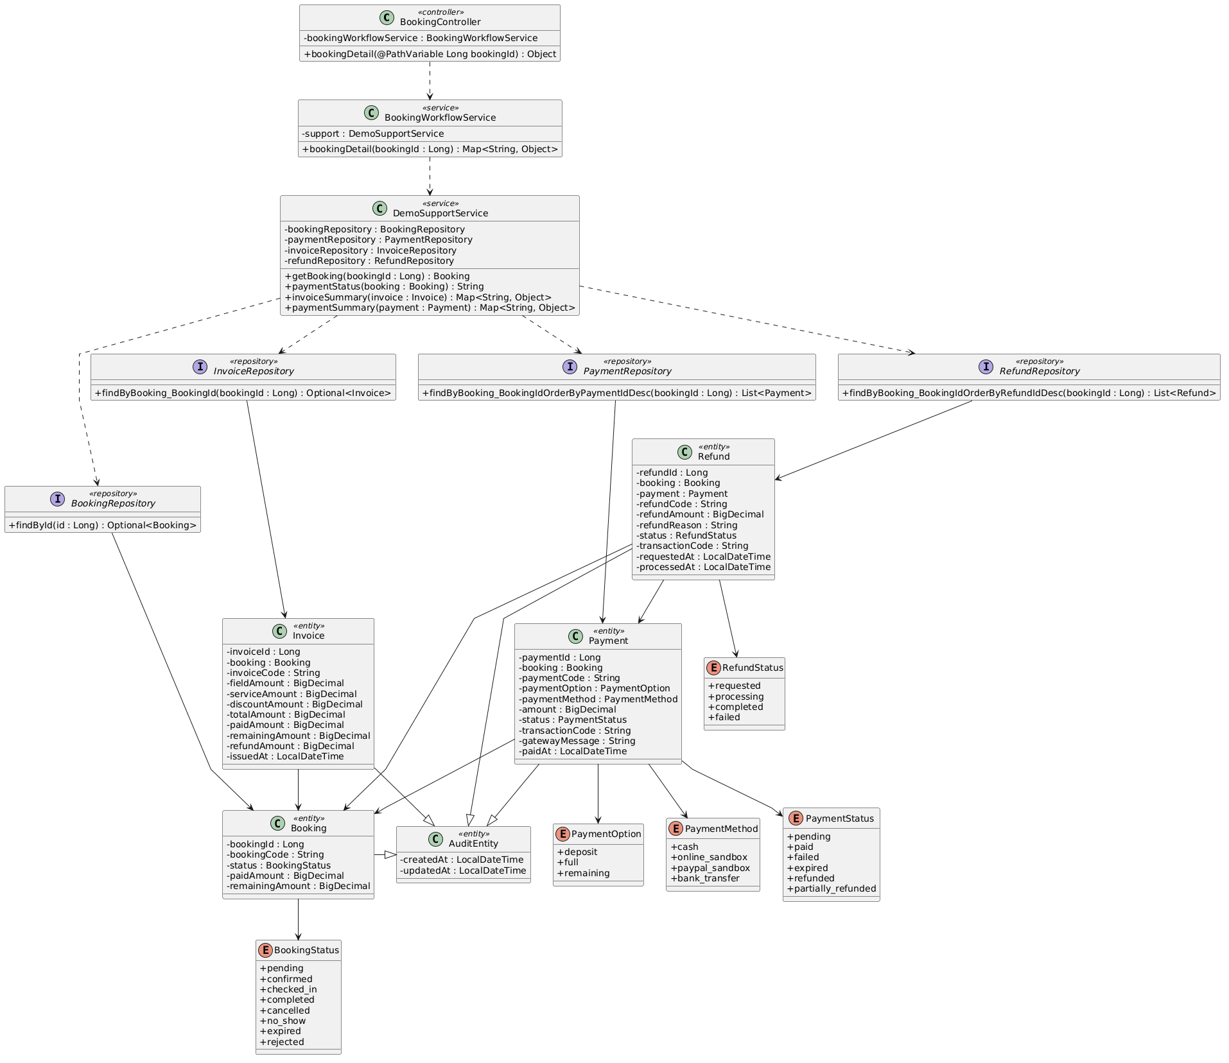

b. Class Specifications
BookingWorkflowService
No | Method | Description
01 | public Map<String, Object> bookingDetail(Long bookingId) | Returns invoice, transaction list, refunds, and derived paymentStatus together.

DemoSupportService
No | Method | Description
01 | String paymentStatus(Booking booking) | Derives unpaid, failed, expired, partially_paid, paid, partially_refunded, or refunded.

RefundRepository
No | Method | Description
01 | List<Refund> findByBooking_BookingIdOrderByRefundIdDesc(Long bookingId) | Provides completed-refund amounts for status derivation.

c. Sequence Diagram
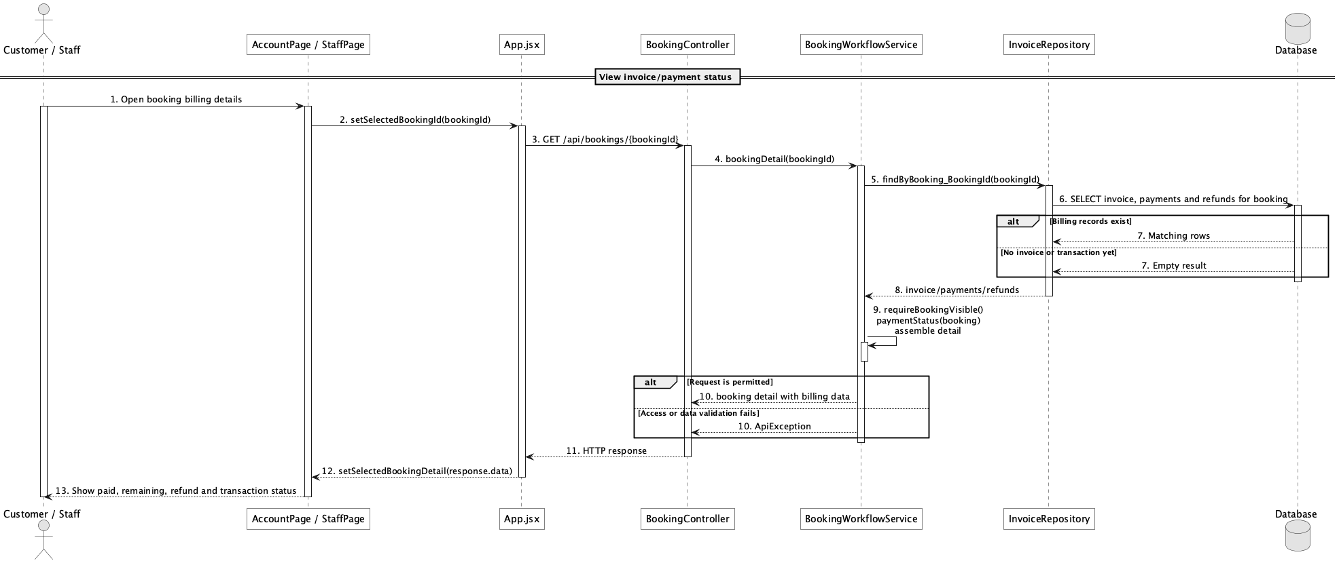

d. Database Queries
== View invoice/payment status ==

1. Invoice and payment status inputs
SELECT b.booking_id, b.booking_code, b.status AS booking_status, b.paid_amount, b.remaining_amount,
i.invoice_code, i.total_amount, i.paid_amount AS invoice_paid,
i.remaining_amount AS invoice_remaining, i.refund_amount,
COALESCE(SUM(CASE WHEN r.status = 'completed' THEN r.refund_amount ELSE 0 END), 0) AS completed_refunds
FROM booking b
LEFT JOIN invoice i ON i.booking_id = b.booking_id
LEFT JOIN refund r ON r.booking_id = b.booking_id
WHERE b.booking_id = :bookingId
GROUP BY b.booking_id, b.booking_code, b.status, b.paid_amount, b.remaining_amount,
i.invoice_code, i.total_amount, i.paid_amount, i.remaining_amount, i.refund_amount;

Implementation note: paymentStatus is derived in Java; it is not a column on invoice or booking.

47. Process online refund

a. Class Diagram
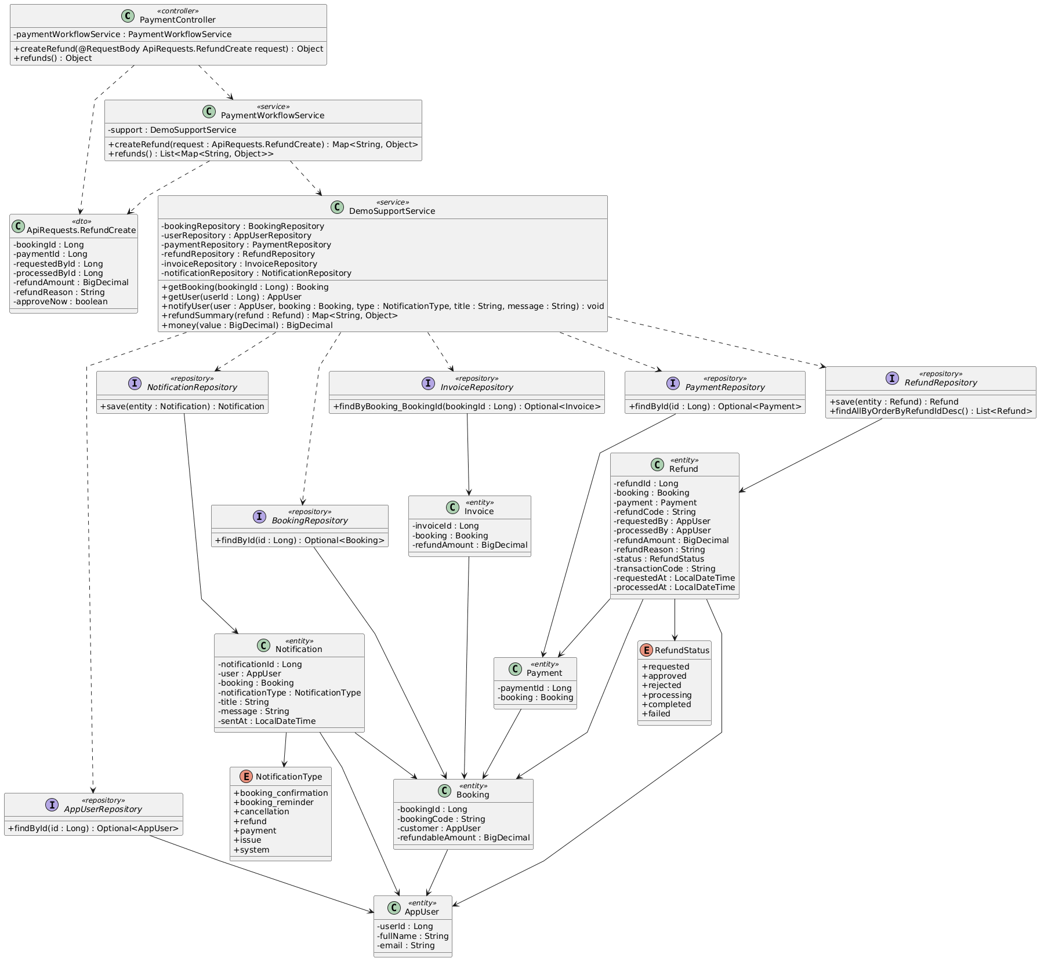

b. Class Specifications
PayPalCheckoutService
No | Method | Description
01 | public RefundResult refundCapture(Payment payment, BigDecimal refundAmount, String requestId, String existingRefundId) | Calls PayPal Payments v2 by capture id, reuses stable request id, and polls an existing refund when present.

PaymentWorkflowService
No | Method | Description
01 | public Map<String, Object> updateRefundStatus(Long refundId, ApiRequests.RefundStatusUpdate request) | Drives approval/processing, maps provider COMPLETED only to completed, and keeps retryable state visible.

PaymentRepository
No | Method | Description
01 | Optional<Payment> findByProviderCaptureId(String providerCaptureId) | Represents provider capture reconciliation data held on payment.

c. Sequence Diagram
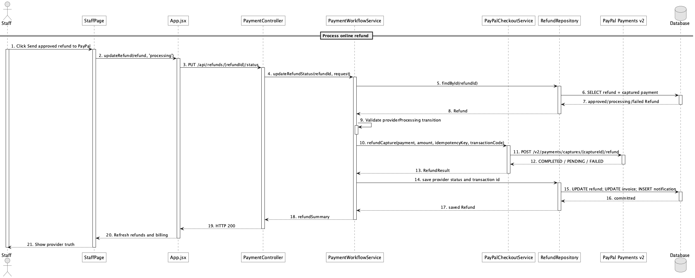

d. Database Queries
== Process online refund ==

1. Provider refund work item
SELECT r.refund_id, r.refund_code, r.refund_amount, r.status,
r.transaction_code AS provider_refund_id, r.provider_status, r.idempotency_key,
p.payment_id, p.provider_capture_id, p.payment_method, p.status AS payment_status
FROM refund r
JOIN payment p ON p.payment_id = r.payment_id
WHERE r.refund_id = :refundId;

Implementation note: Only PayPal provider COMPLETED becomes completed. Real buyer/refund confirmation remains an external sandbox smoke check, not live-money certification.

48. Manage refund requests

a. Class Diagram
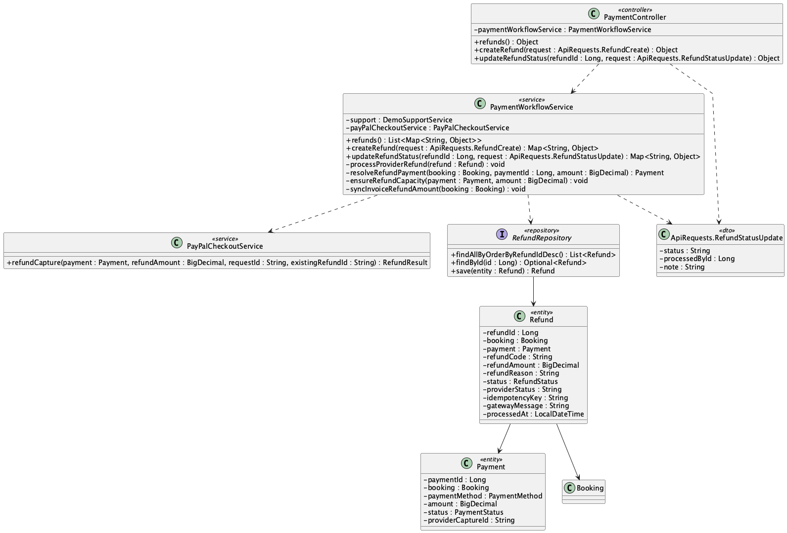

b. Class Specifications
PaymentController
No | Method | Description
01 | public Object refunds() | Lists the operator refund queue.
02 | public Object createRefund(ApiRequests.RefundCreate request) | Creates a customer/operator refund request.
03 | public Object updateRefundStatus(Long refundId, ApiRequests.RefundStatusUpdate request) | Applies an operator status transition.

PaymentWorkflowService
No | Method | Description
01 | public Map<String, Object> createRefund(ApiRequests.RefundCreate request) | Validates ownership, refundable capacity, and selected captured payment.
02 | public Map<String, Object> updateRefundStatus(Long refundId, ApiRequests.RefundStatusUpdate request) | Validates transitions and handles PayPal or explicit manual cash completion.
03 | public List<Map<String, Object>> refunds() | Returns newest-first requests.

RefundRepository
No | Method | Description
01 | List<Refund> findAllByOrderByRefundIdDesc() | Loads the refund queue.

c. Sequence Diagram
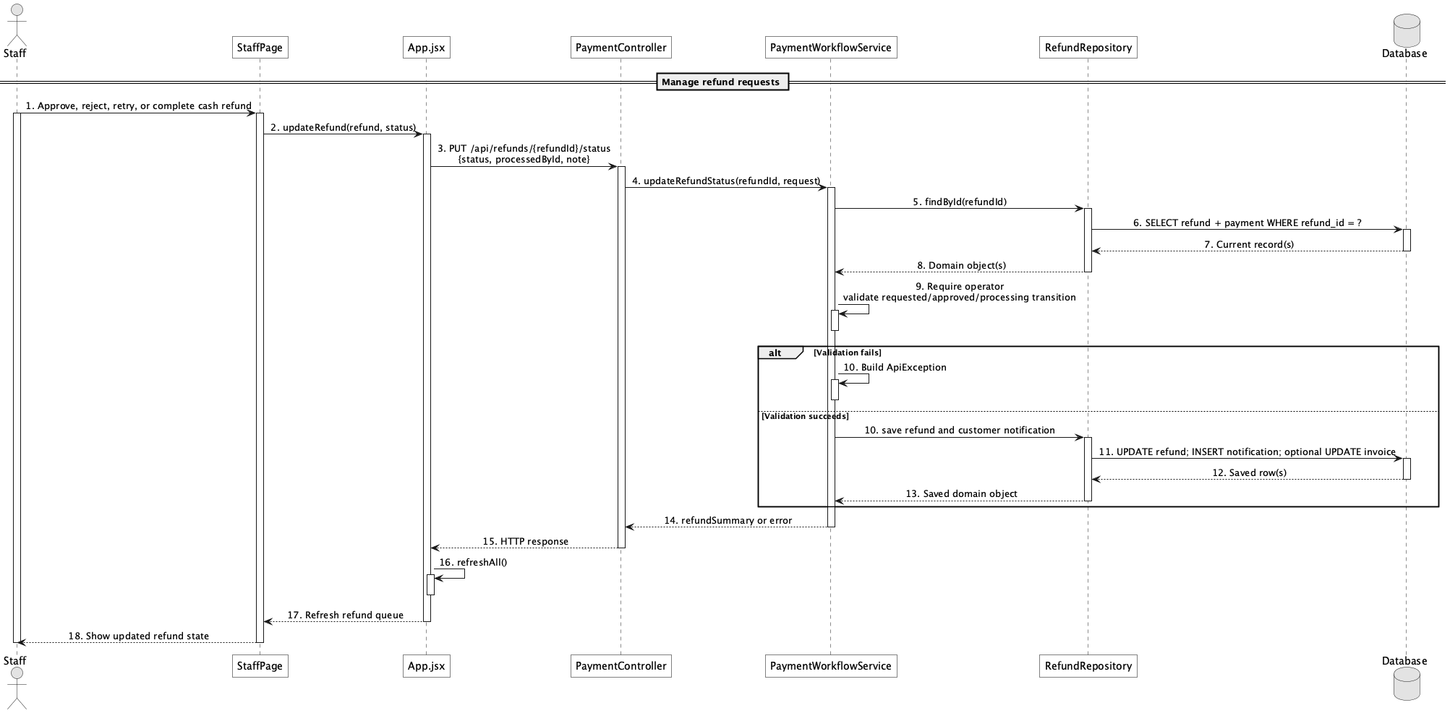

d. Database Queries
== Manage refund requests ==

1. Refund management queue
SELECT r.refund_id, r.refund_code, r.refund_amount, r.refund_reason, r.status,
r.provider_status, r.gateway_message, r.requested_at, r.processed_at,
b.booking_code, p.payment_method, p.provider_capture_id
FROM refund r
JOIN booking b ON b.booking_id = r.booking_id
LEFT JOIN payment p ON p.payment_id = r.payment_id
ORDER BY r.refund_id DESC;

Implementation note: Cash refund completion is an explicit venue operation and is marked MANUAL_CASH_REFUND.

49. Configure deposit rules

a. Class Diagram
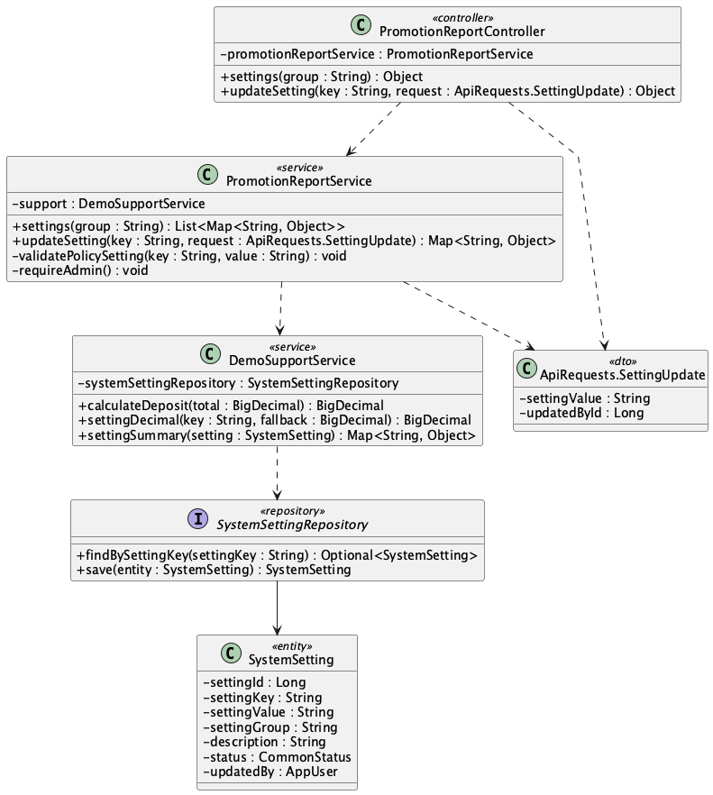

b. Class Specifications
PromotionReportController
No | Method | Description
01 | public Object settings(String group) | Lists policy settings.
02 | public Object updateSetting(String key, ApiRequests.SettingUpdate request) | Exposes Admin policy update.

PromotionReportService
No | Method | Description
01 | public Map<String, Object> updateSetting(String key, ApiRequests.SettingUpdate request) | Validates percentage range and updates deposit.default_percent.

DemoSupportService
No | Method | Description
01 | BigDecimal calculateDeposit(BigDecimal total) | Reads deposit.default_percent and computes the booking deposit.

SystemSettingRepository
No | Method | Description
01 | Optional<SystemSetting> findBySettingKey(String settingKey) | Loads the deposit setting by stable key.

c. Sequence Diagram
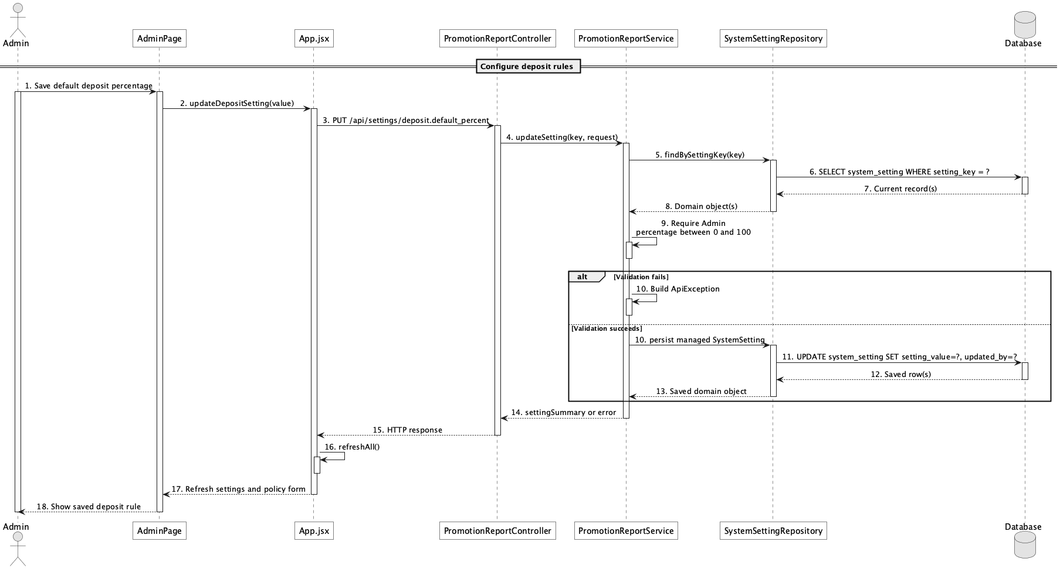

d. Database Queries
== Configure deposit rules ==

1. Update deposit percentage
UPDATE system_setting
SET setting_value = :percent, updated_by = :adminId, updated_at = CURRENT_TIMESTAMP
WHERE setting_key = 'deposit.default_percent'
AND CAST(:percent AS numeric) BETWEEN 0 AND 100;

Implementation note: The implemented rule is a single default percentage, not a tiered deposit-rule DSL.

50. Configure cancellation/refund policy

a. Class Diagram
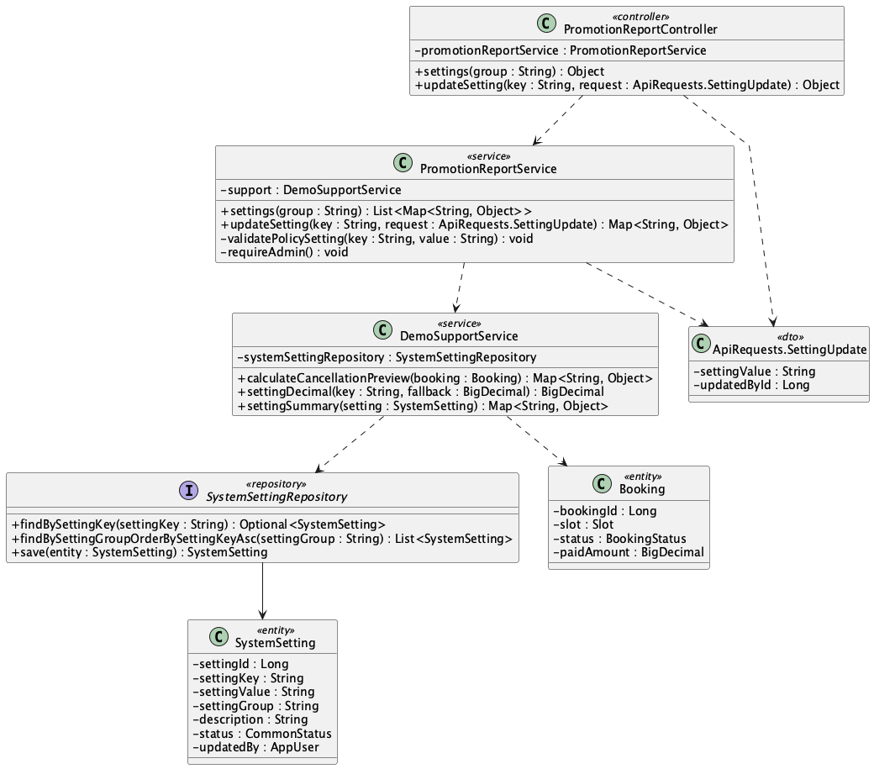

b. Class Specifications
PromotionReportService
No | Method | Description
01 | public List<Map<String, Object>> settings(String group) | Reads all or group-filtered system settings.
02 | public Map<String, Object> updateSetting(String key, ApiRequests.SettingUpdate request) | Validates and updates refund percentage settings.

DemoSupportService
No | Method | Description
01 | Map<String, Object> calculateCancellationPreview(Booking booking) | Applies refund.before_24h_percent and refund.same_day_percent.
02 | BigDecimal settingDecimal(String key, BigDecimal fallback) | Reads numeric policy values with code defaults.

SystemSettingRepository
No | Method | Description
01 | List<SystemSetting> findBySettingGroupOrderBySettingKeyAsc(String settingGroup) | Loads the refund policy group for Admin.

c. Sequence Diagram
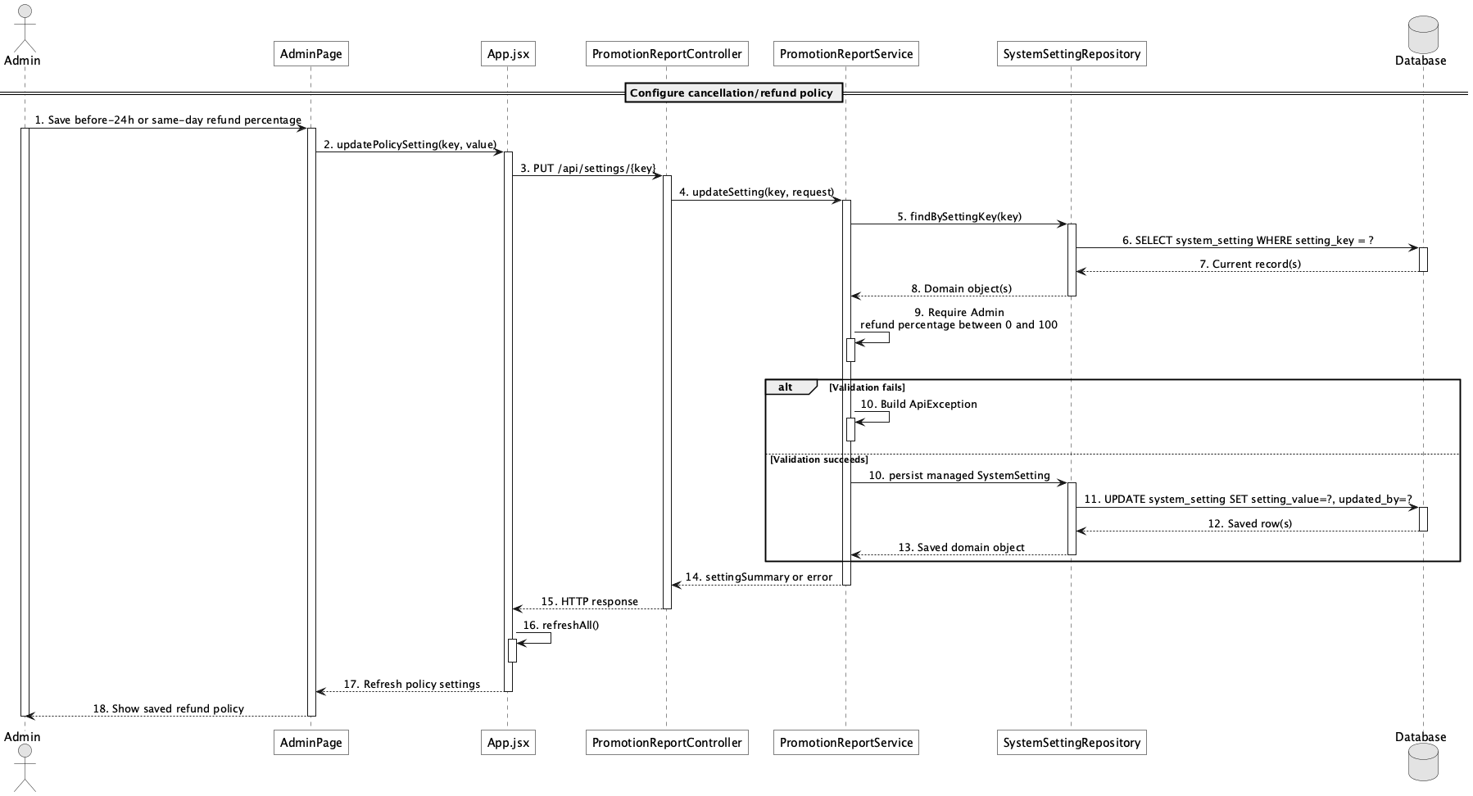

d. Database Queries
== Configure cancellation/refund policy ==

1. Refund policy settings
SELECT setting_key, setting_value, description, updated_by, updated_at
FROM system_setting
WHERE setting_group = 'refund'
ORDER BY setting_key;

Implementation note: Current cancellation logic has two configured percentage bands: at least 24 hours and same-day before start; after start is zero refund.

51. View active promotions

a. Class Diagram
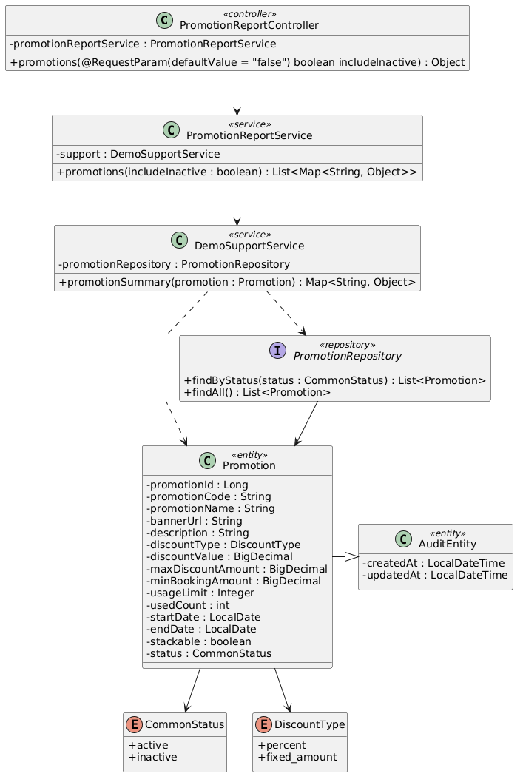

b. Class Specifications
PromotionReportController
No | Method | Description
01 | public Object promotions(boolean includeInactive) | Exposes GET /api/promotions; public callers normally use includeInactive=false.

PromotionReportService
No | Method | Description
01 | public List<Map<String, Object>> promotions(boolean includeInactive) | Returns active promotions or the full admin catalogue.

PromotionRepository
No | Method | Description
01 | List<Promotion> findByStatus(CommonStatus status) | Loads active promotion campaigns.

c. Sequence Diagram
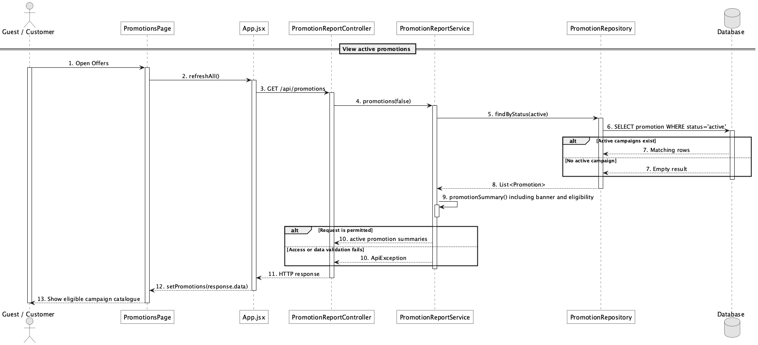

d. Database Queries
== View active promotions ==

1. Active promotion catalogue
SELECT promotion_id, promotion_code, promotion_name, banner_url, description,
discount_type, discount_value, max_discount_amount, min_booking_amount,
start_date, end_date, usage_limit, used_count
FROM promotion
WHERE status = 'active'
ORDER BY promotion_id;

Implementation note: The repository status filter does not itself filter dates; eligibility date validation occurs when applying a code.

52. Manage promotion campaigns

a. Class Diagram
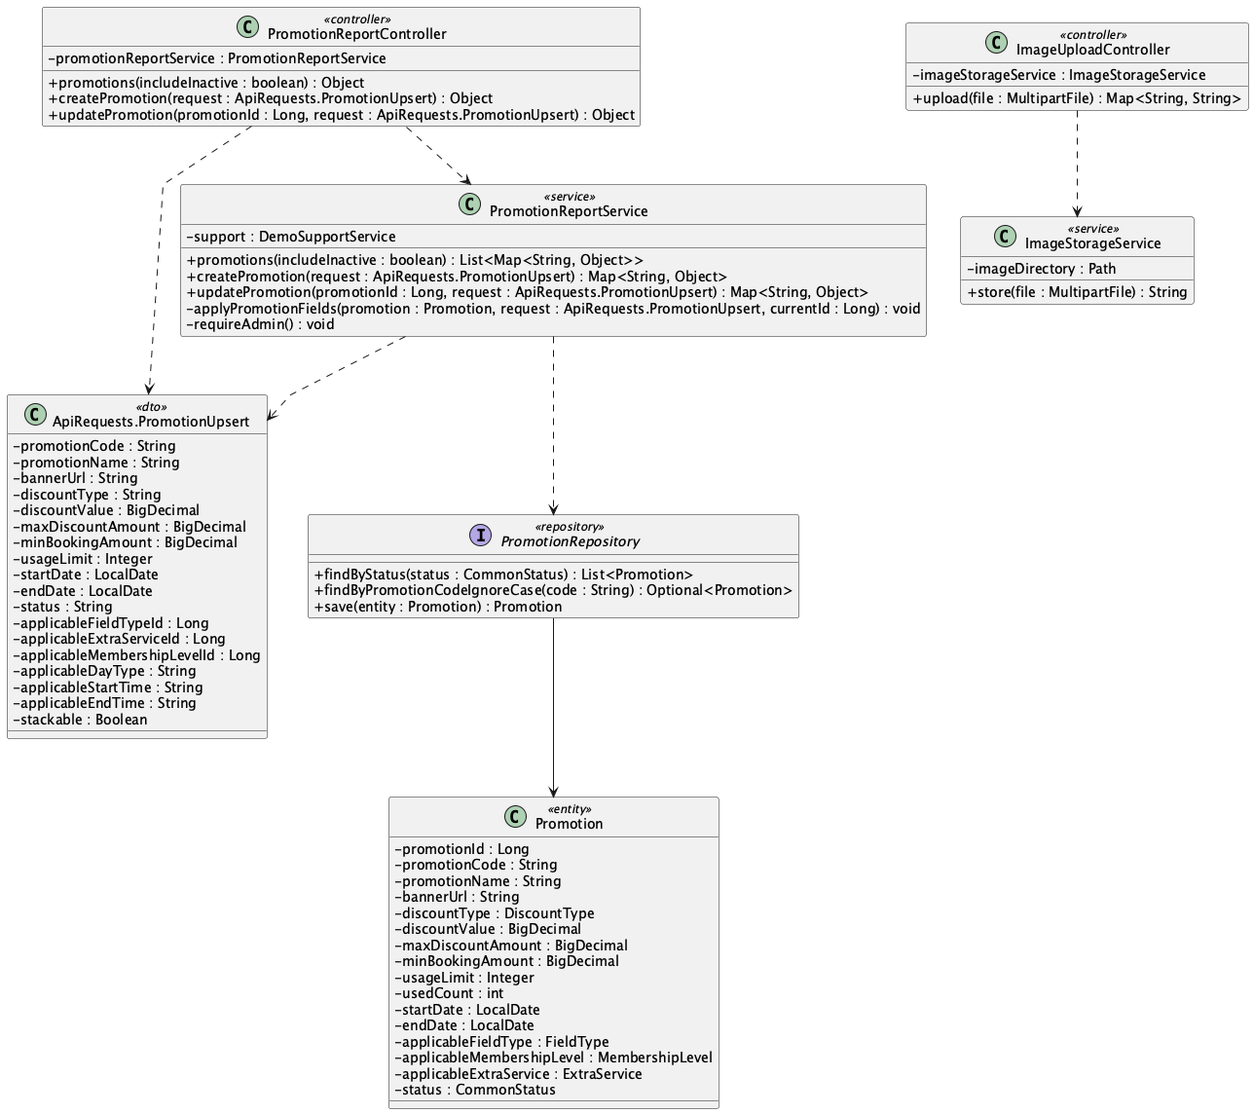

b. Class Specifications
PromotionReportController
No | Method | Description
01 | public Object createPromotion(ApiRequests.PromotionUpsert request) | Creates an Admin campaign.
02 | public Object updatePromotion(Long promotionId, ApiRequests.PromotionUpsert request) | Updates a campaign and active/inactive state.

PromotionReportService
No | Method | Description
01 | public Map<String, Object> createPromotion(ApiRequests.PromotionUpsert request) | Validates campaign fields and initializes used_count to zero.
02 | public Map<String, Object> updatePromotion(Long promotionId, ApiRequests.PromotionUpsert request) | Updates campaign applicability, dates, discount, banner, limits, and status.

PromotionRepository
No | Method | Description
01 | Optional<Promotion> findByPromotionCodeIgnoreCase(String promotionCode) | Enforces case-insensitive code uniqueness in service validation.

c. Sequence Diagram
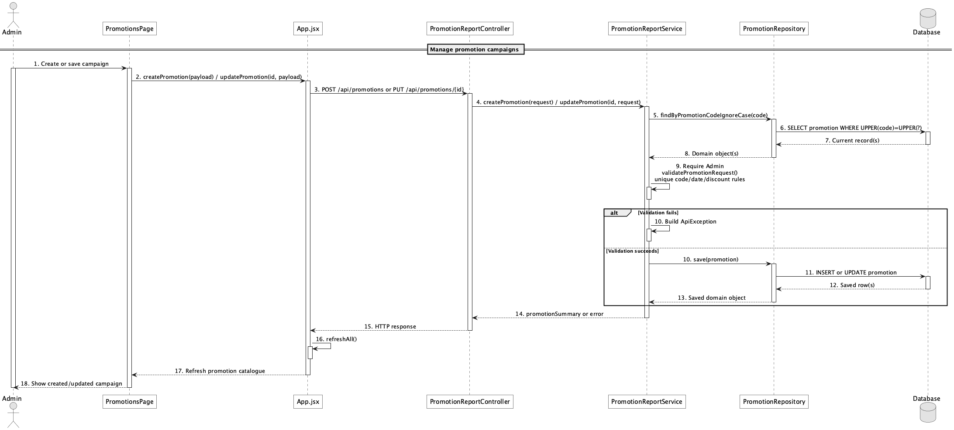

d. Database Queries
== Manage promotion campaigns ==

1. Create promotion campaign
INSERT INTO promotion
(promotion_code, promotion_name, banner_url, description, discount_type, discount_value,
max_discount_amount, min_booking_amount, usage_limit, used_count, start_date, end_date,
applicable_field_type_id, applicable_membership_level_id, applicable_extra_service_id,
applicable_day_type, applicable_start_time, applicable_end_time, stackable, status, created_at, updated_at)
VALUES
(:code, :name, :bannerUrl, :description, :discountType, :discountValue,
:maxDiscount, :minBookingAmount, :usageLimit, 0, :startDate, :endDate,
:fieldTypeId, :membershipLevelId, :extraServiceId, :dayType, :startTime, :endTime,
false, :status, CURRENT_TIMESTAMP, CURRENT_TIMESTAMP);

Implementation note: SecurityConfig restricts promotion mutations to Admin. The scope supports one applied code per booking; stacking is out of scope even though the schema retains stackable.

53. Apply promotion to booking

a. Class Diagram
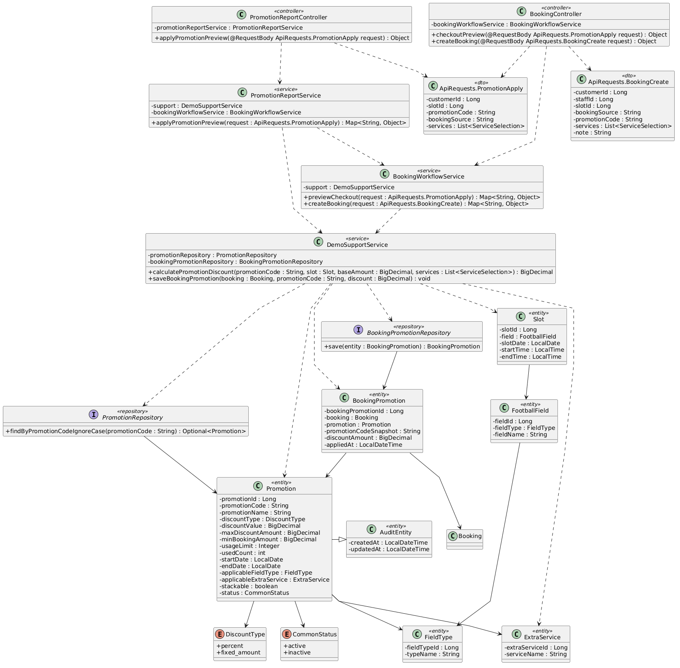

b. Class Specifications
PromotionReportService
No | Method | Description
01 | public Map<String, Object> applyPromotionPreview(ApiRequests.PromotionApply request) | Delegates promotion preview to checkout pricing.

DemoSupportService
No | Method | Description
01 | BigDecimal calculatePromotionDiscount(String promotionCode, Slot slot, BigDecimal baseAmount, List<ApiRequests.ServiceSelection> services, AppUser customer) | Validates status, dates, usage, minimum, field type, required service, membership, day, and time before calculating discount.
02 | void saveBookingPromotion(Booking booking, String promotionCode, BigDecimal promotionDiscount) | Snapshots the code/discount and increments used_count.

PromotionRepository
No | Method | Description
01 | Optional<Promotion> findByPromotionCodeIgnoreCase(String promotionCode) | Resolves the entered code.

c. Sequence Diagram
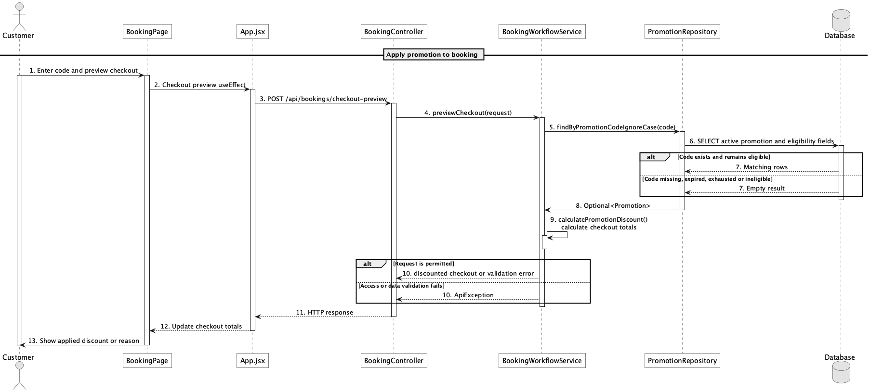

d. Database Queries
== Apply promotion to booking ==

1. Promotion eligibility record
SELECT p.promotion_id, p.promotion_code, p.discount_type, p.discount_value,
p.max_discount_amount, p.min_booking_amount, p.usage_limit, p.used_count,
p.start_date, p.end_date, p.applicable_field_type_id,
p.applicable_membership_level_id, p.applicable_extra_service_id,
p.applicable_day_type, p.applicable_start_time, p.applicable_end_time
FROM promotion p
WHERE UPPER(p.promotion_code) = UPPER(:promotionCode)
AND p.status = 'active';

Implementation note: booking_promotion is the applied snapshot table; multi-code stacking is intentionally out of scope.

54. View membership progress

a. Class Diagram
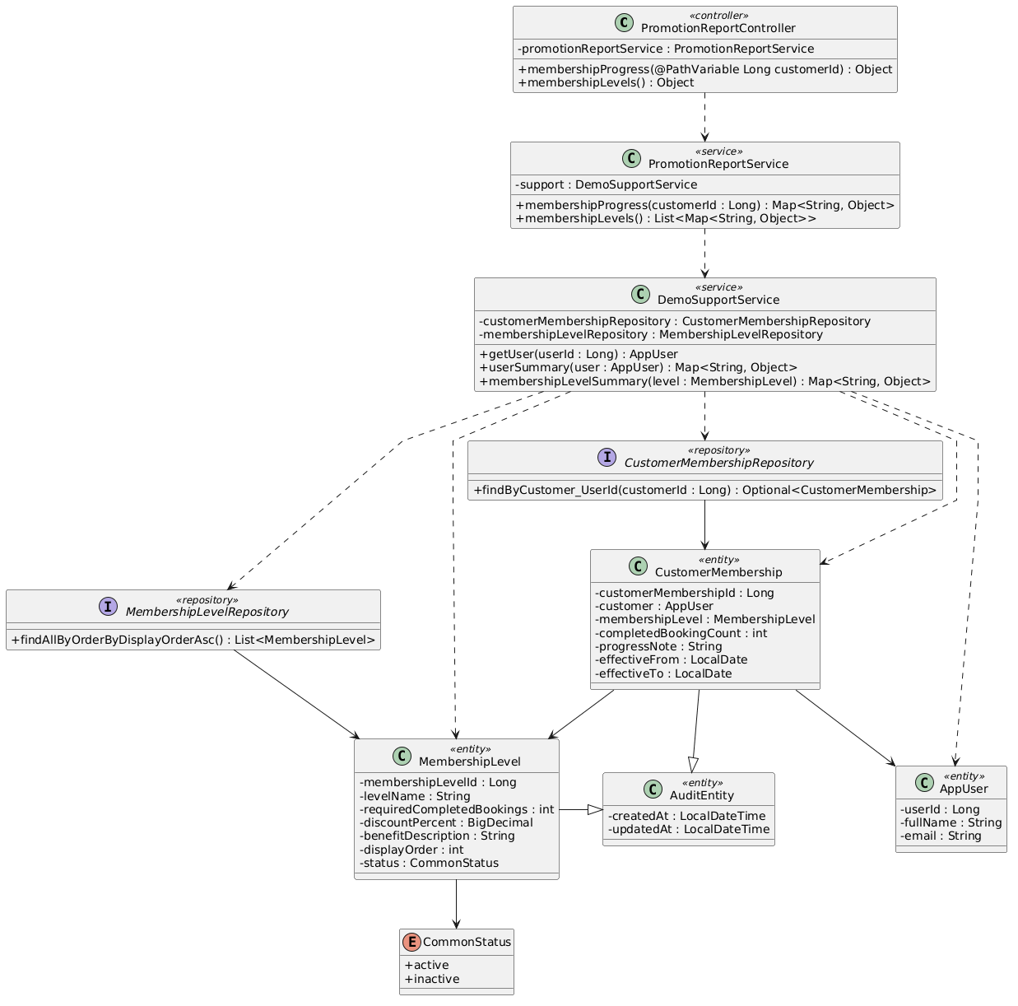

b. Class Specifications
PromotionReportController
No | Method | Description
01 | public Object membershipProgress(Long customerId) | Exposes GET /api/membership/{customerId}/progress.

PromotionReportService
No | Method | Description
01 | public Map<String, Object> membershipProgress(Long customerId) | Returns current level, lifetime audit count, period-aware next-level progress, target, and remaining value.

CustomerMembershipRepository
No | Method | Description
01 | Optional<CustomerMembership> findByCustomer_UserId(Long customerId) | Loads the customer's single membership progress row.

c. Sequence Diagram
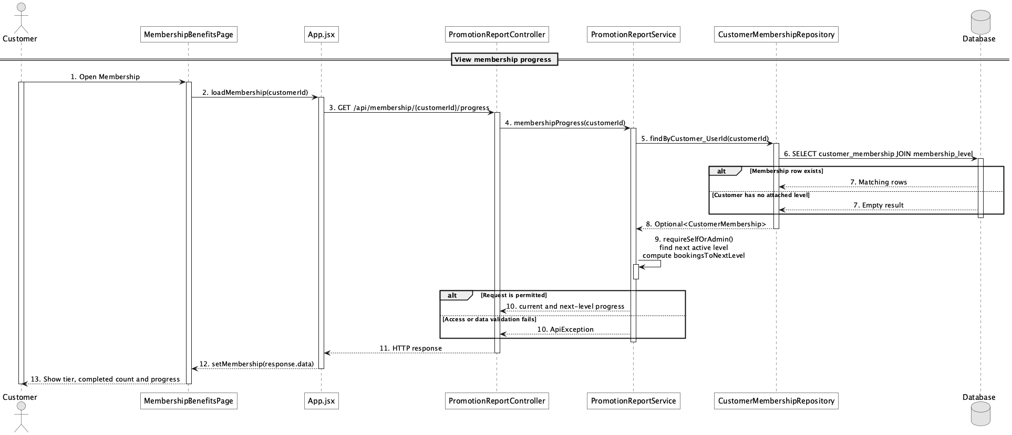

d. Database Queries
== View membership progress ==

1. Membership progress and next thresholds
SELECT cm.customer_id, cm.completed_booking_count, ml.membership_level_id,
ml.level_name, ml.discount_percent, ml.required_completed_bookings,
ml.qualification_period, ml.required_consecutive_periods, ml.benefit_description
FROM customer_membership cm
JOIN membership_level ml ON ml.membership_level_id = cm.membership_level_id
WHERE cm.customer_id = :customerId;

Implementation note: Eligibility/progress is computed from completed bookings using each next level's lifetime, current-month, or consecutive-week rule.

55. Manage membership rules

a. Class Diagram
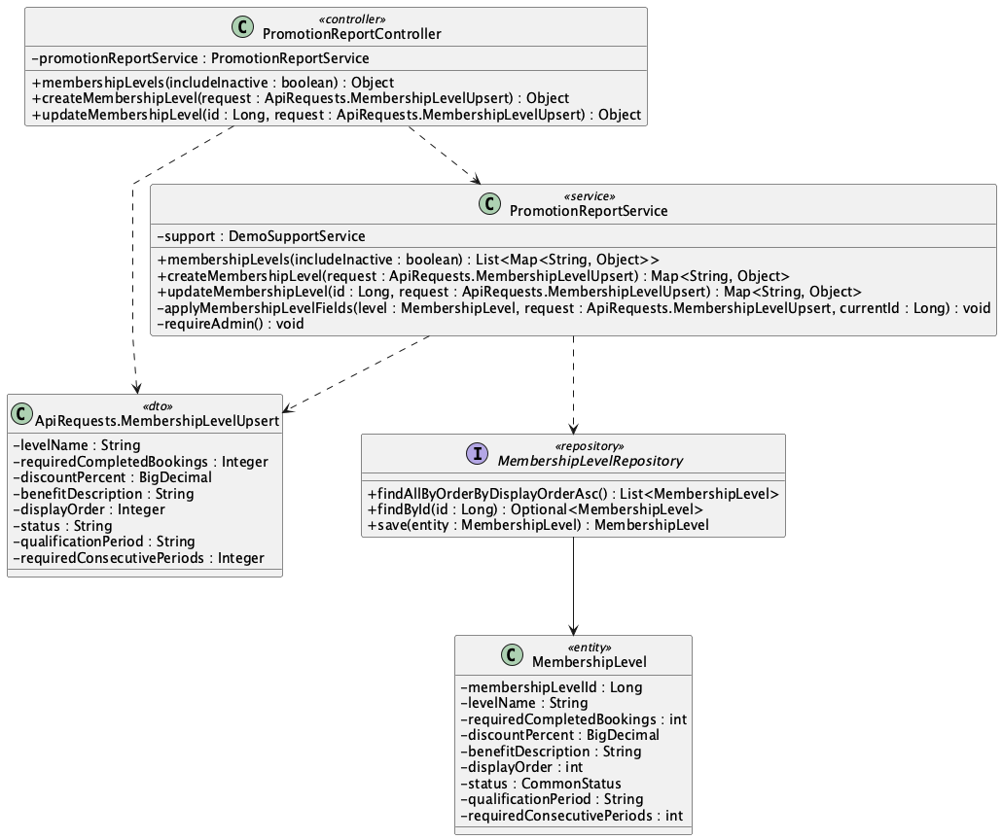

b. Class Specifications
PromotionReportController
No | Method | Description
01 | public Object createMembershipLevel(ApiRequests.MembershipLevelUpsert request) | Creates a membership level.
02 | public Object updateMembershipLevel(Long id, ApiRequests.MembershipLevelUpsert request) | Updates a level's threshold, discount, benefit, order, and status.

PromotionReportService
No | Method | Description
01 | public Map<String, Object> createMembershipLevel(ApiRequests.MembershipLevelUpsert request) | Validates and persists a new level.
02 | public Map<String, Object> updateMembershipLevel(Long id, ApiRequests.MembershipLevelUpsert request) | Validates and persists an existing level.

MembershipLevelRepository
No | Method | Description
01 | List<MembershipLevel> findAllByOrderByDisplayOrderAsc() | Provides deterministic progression order.

c. Sequence Diagram
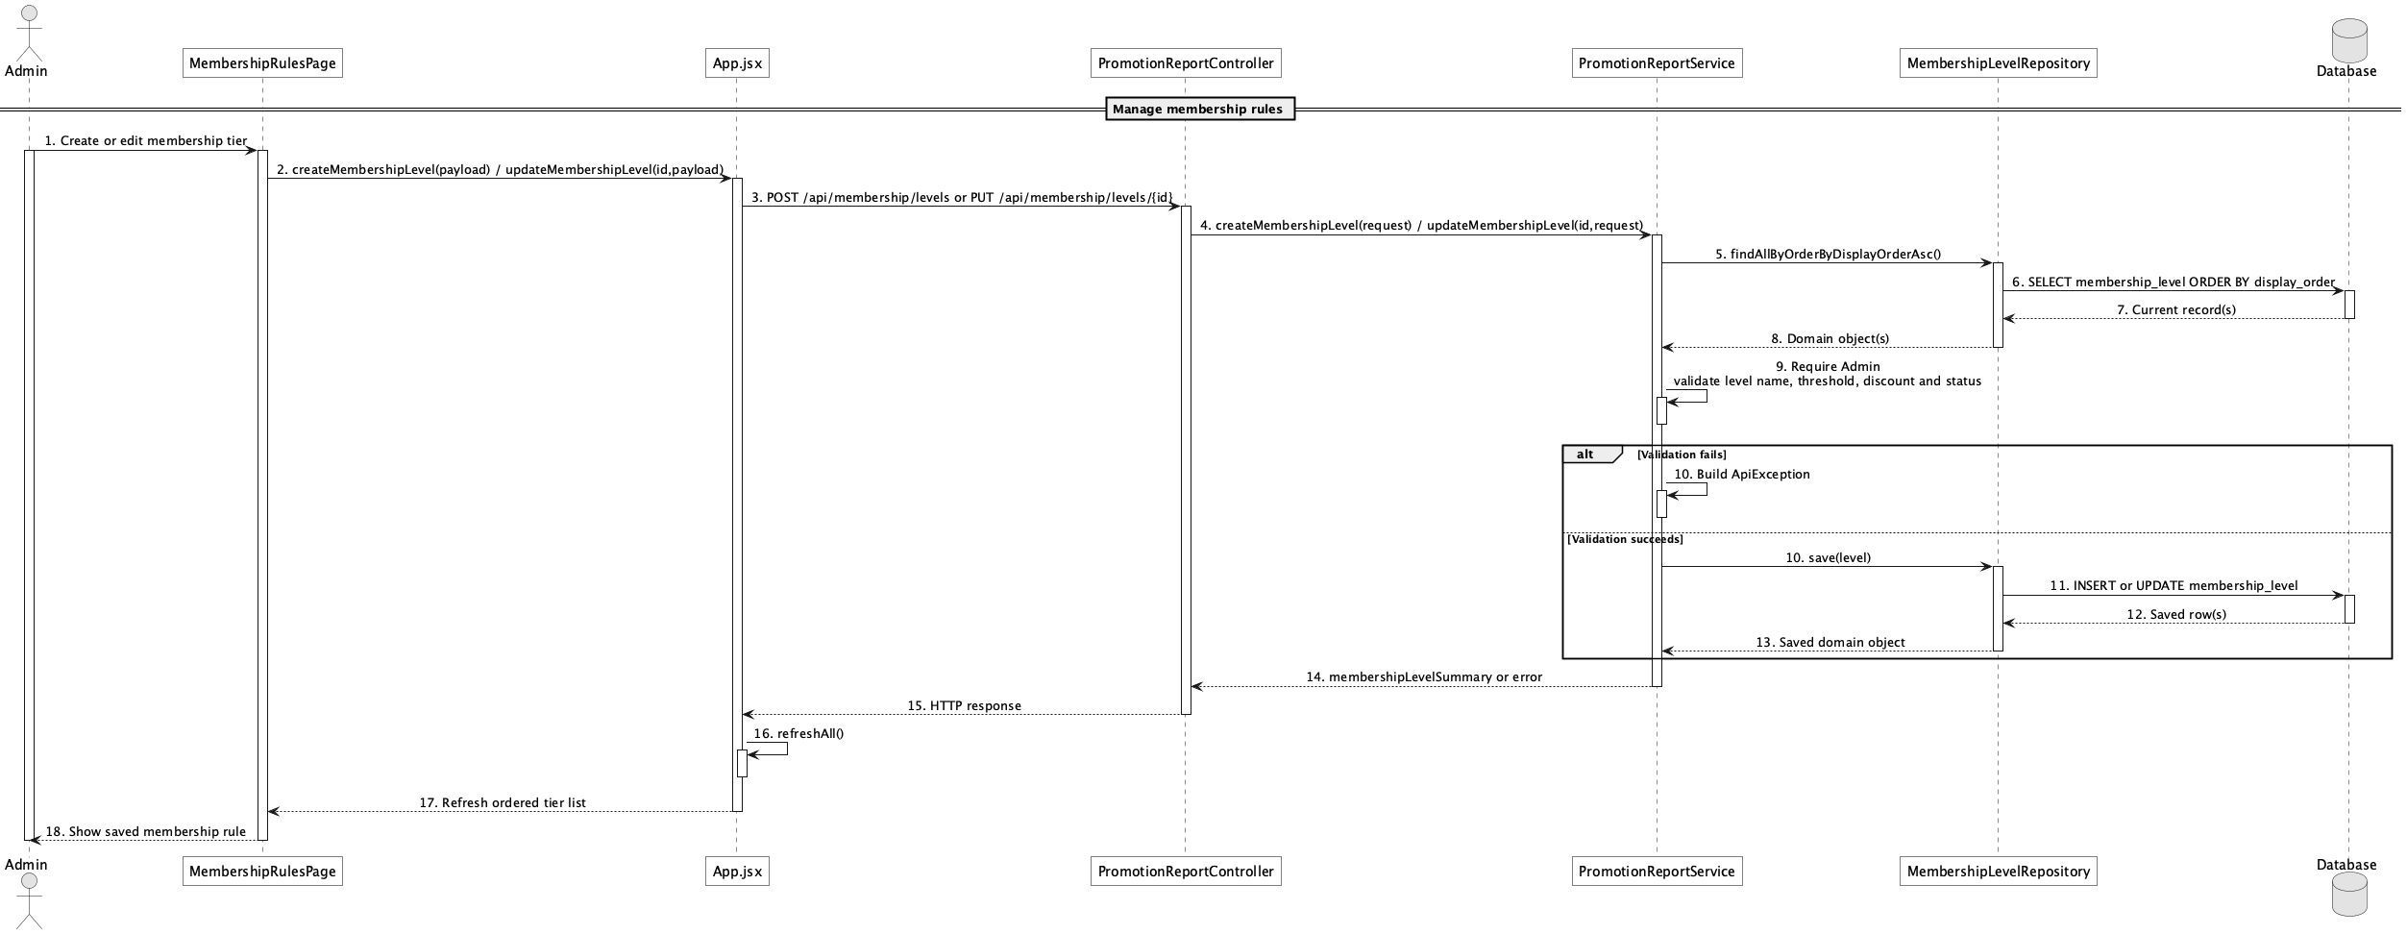

d. Database Queries
== Manage membership rules ==

1. Membership rule catalogue
SELECT membership_level_id, level_name, required_completed_bookings,
qualification_period, required_consecutive_periods,
discount_percent, benefit_description, display_order, status
FROM membership_level
ORDER BY display_order ASC;

Implementation note: Qualification period is lifetime, monthly, or weekly; weekly rules require a configurable consecutive qualifying-week streak.

56. View membership benefits

a. Class Diagram
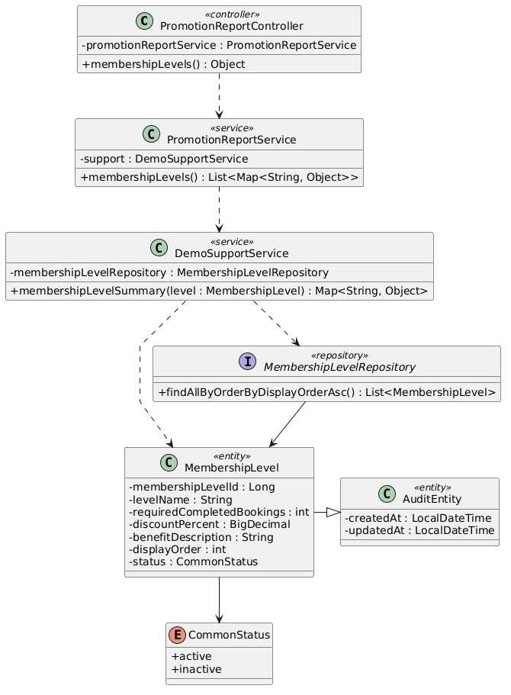

b. Class Specifications
PromotionReportController
No | Method | Description
01 | public Object membershipLevels(boolean includeInactive) | Exposes public GET /api/membership/levels.

PromotionReportService
No | Method | Description
01 | public List<Map<String, Object>> membershipLevels(boolean includeInactive) | Returns ordered level names, thresholds, discounts, and benefit descriptions.

MembershipLevelRepository
No | Method | Description
01 | List<MembershipLevel> findAllByOrderByDisplayOrderAsc() | Loads the benefit catalogue in display order.

c. Sequence Diagram
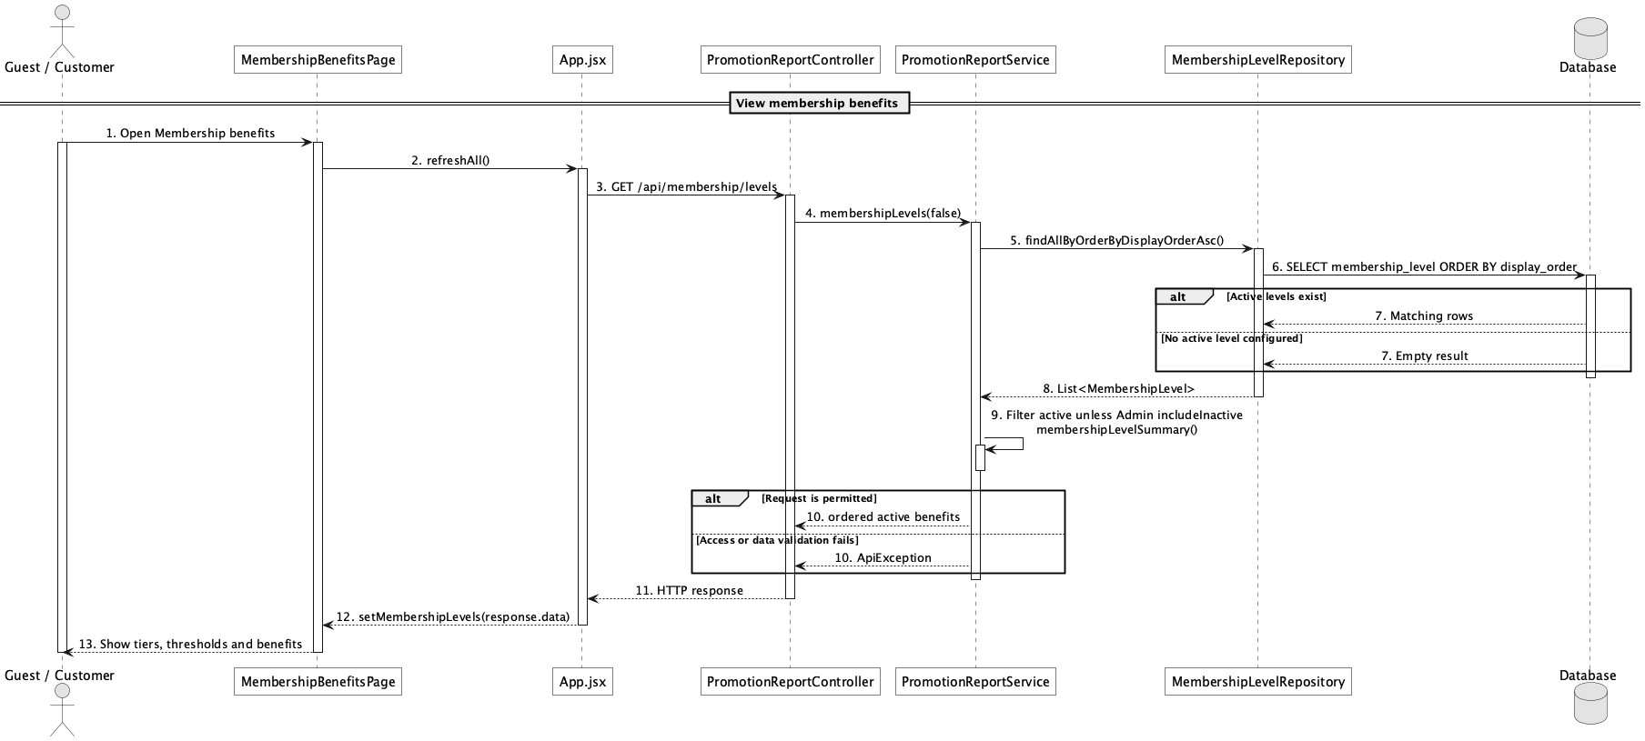

d. Database Queries
== View membership benefits ==

1. Membership benefits
SELECT membership_level_id, level_name, required_completed_bookings,
qualification_period, required_consecutive_periods,
discount_percent, benefit_description, display_order, status
FROM membership_level
WHERE status = 'active'
ORDER BY display_order;

Implementation note: Public calls exclude inactive levels; only Admin may request includeInactive=true.

57. Send booking confirmation notification

a. Class Diagram
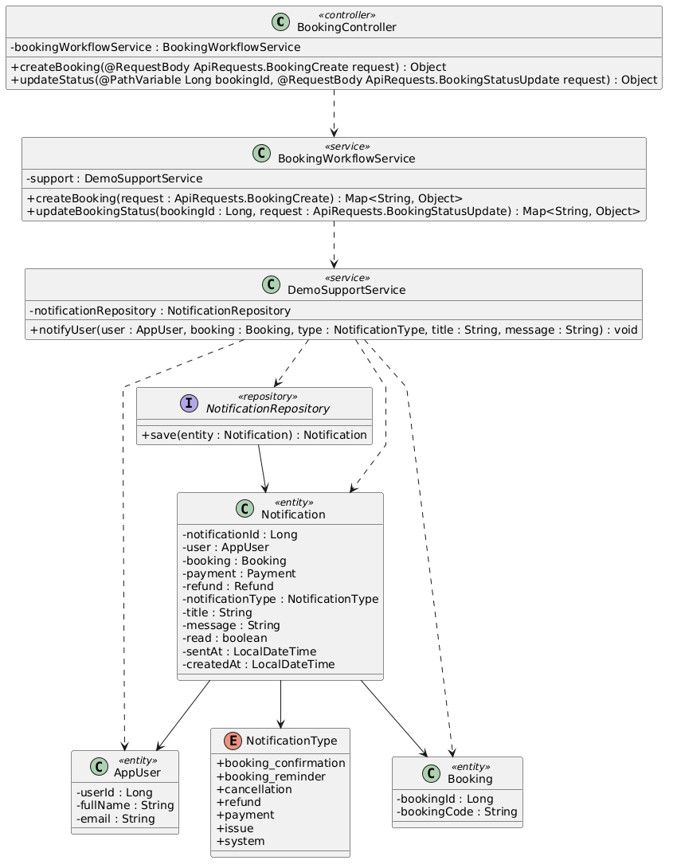

b. Class Specifications
BookingWorkflowService
No | Method | Description
01 | public Map<String, Object> createBooking(ApiRequests.BookingCreate request) | Creates a booking-created notification.
02 | public Map<String, Object> updateBookingStatus(Long bookingId, ApiRequests.BookingStatusUpdate request) | Creates confirmed/rejected lifecycle notifications.

DemoSupportService
No | Method | Description
01 | void notifyUser(AppUser user, Booking booking, NotificationType type, String title, String message) | Persists the in-app notification.

c. Sequence Diagram
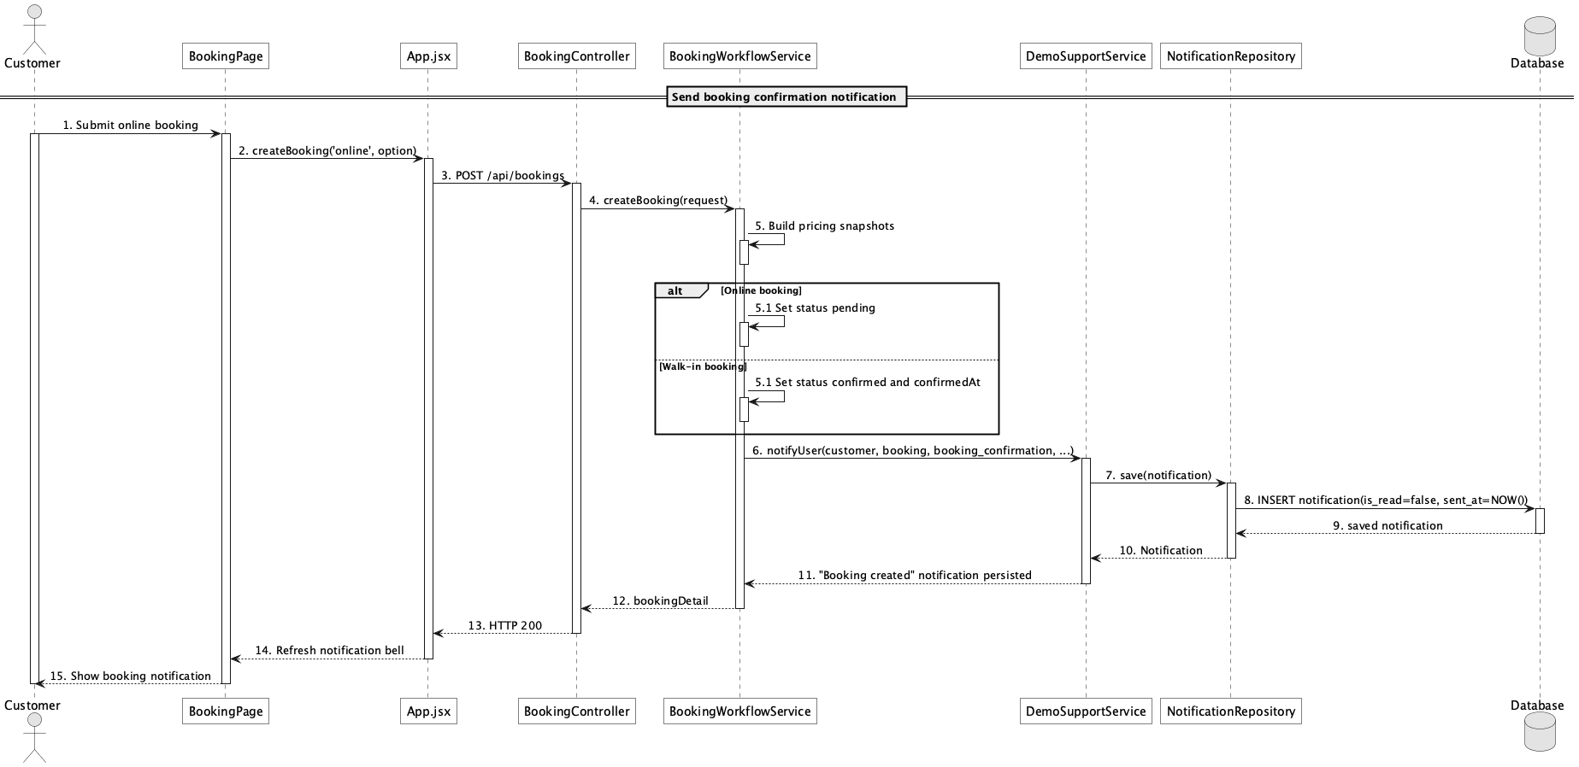

d. Database Queries
== Send booking confirmation notification ==

1. Booking confirmation notification
INSERT INTO notification
(user_id, booking_id, notification_type, title, message, is_read, sent_at, created_at)
VALUES
(:customerId, :bookingId, 'booking_confirmation', :title, :message, false,
CURRENT_TIMESTAMP, CURRENT_TIMESTAMP);

Implementation note: This use case is implemented as in-app persistence; it is not an SMTP booking-confirmation email workflow.

58. Send booking reminder notification

a. Class Diagram
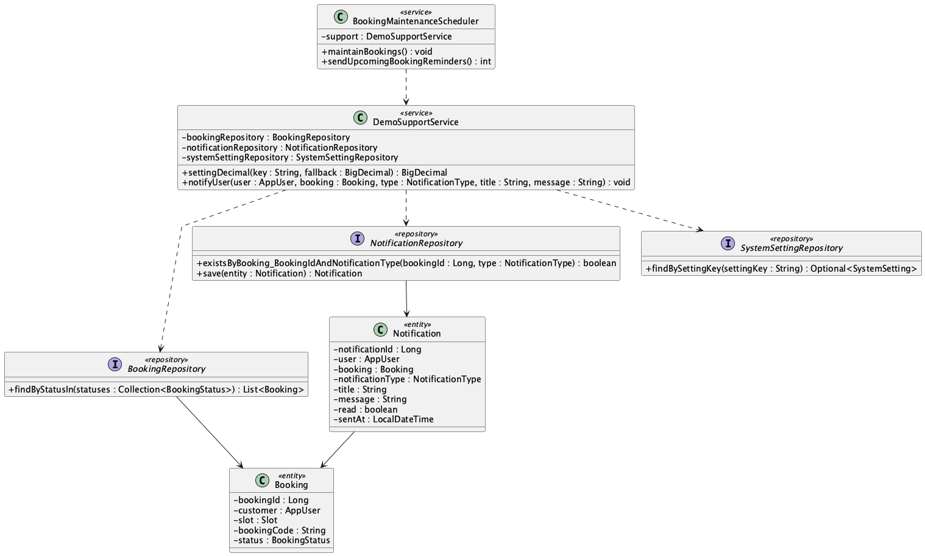

b. Class Specifications
BookingMaintenanceScheduler
No | Method | Description
01 | public void maintainBookings() | Runs reminder maintenance on the configured fixed delay.
02 | public int sendUpcomingBookingReminders() | Creates one reminder for pending/confirmed bookings within the configured window.

NotificationRepository
No | Method | Description
01 | boolean existsByBooking_BookingIdAndNotificationType(Long bookingId, NotificationType notificationType) | Prevents duplicate booking_reminder rows.

BookingRepository
No | Method | Description
01 | List<Booking> findByStatusIn(Collection<BookingStatus> statuses) | Loads pending and confirmed reminder candidates.

c. Sequence Diagram
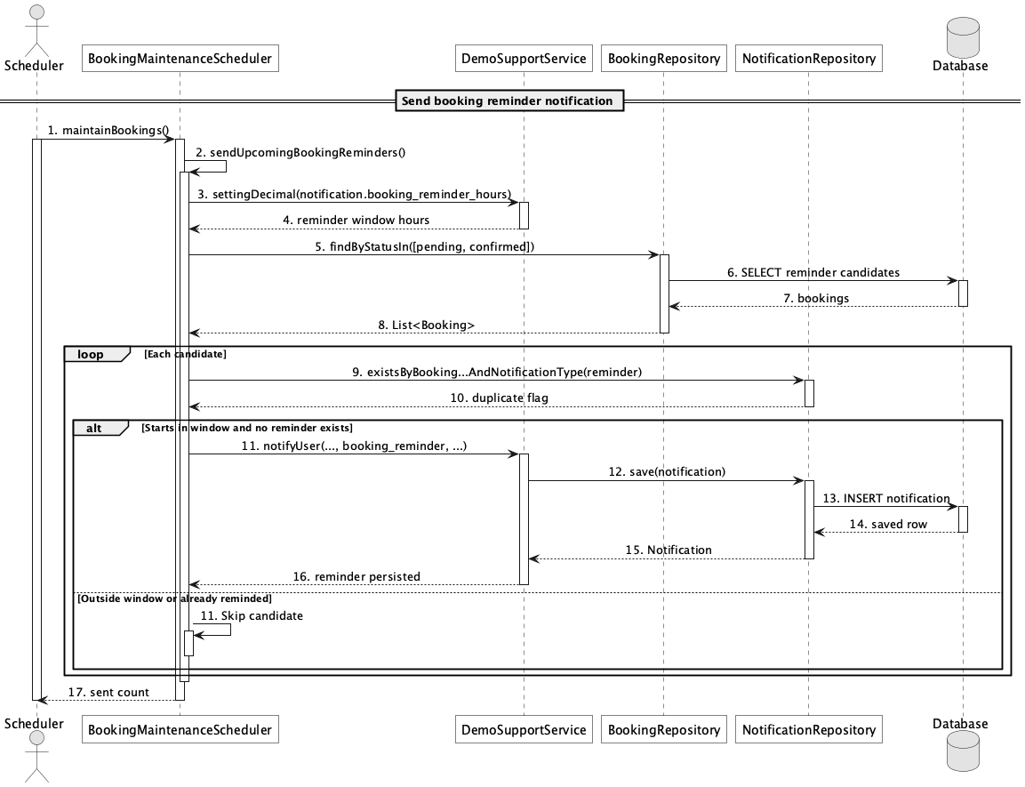

d. Database Queries
== Send booking reminder notification ==

1. Upcoming bookings without a reminder
SELECT b.booking_id, b.booking_code, b.customer_id, s.slot_date, s.start_time
FROM booking b
JOIN slot s ON s.slot_id = b.slot_id
WHERE b.status IN ('pending','confirmed')
AND (s.slot_date + s.start_time) BETWEEN CURRENT_TIMESTAMP
AND CURRENT_TIMESTAMP + (:reminderHours * INTERVAL '1 hour')
AND NOT EXISTS (
SELECT 1 FROM notification n
WHERE n.booking_id = b.booking_id
AND n.notification_type = 'booking_reminder'
);

Implementation note: The reminder is exactly-once at the application-query level for each booking/type; there is no database unique constraint on that pair.

59. Send cancellation/refund notification

a. Class Diagram
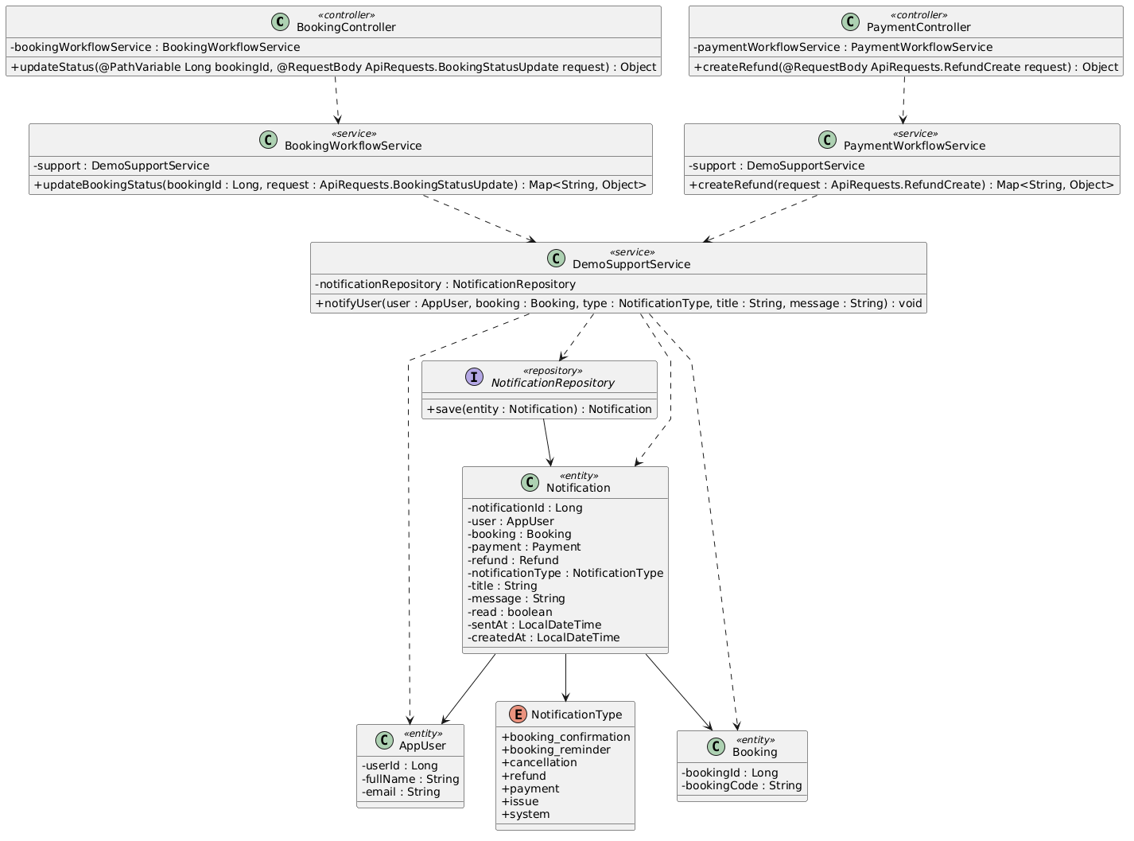

b. Class Specifications
BookingWorkflowService
No | Method | Description
01 | public Map<String, Object> updateBookingStatus(Long bookingId, ApiRequests.BookingStatusUpdate request) | Creates cancellation notification when status becomes cancelled.

PaymentWorkflowService
No | Method | Description
01 | public Map<String, Object> updateRefundStatus(Long refundId, ApiRequests.RefundStatusUpdate request) | Notifies the customer for approved, rejected, processing, completed, and failed refund states.

DemoSupportService
No | Method | Description
01 | void notifyUser(AppUser user, Booking booking, NotificationType type, String title, String message) | Writes cancellation/refund messages to notification.

c. Sequence Diagram
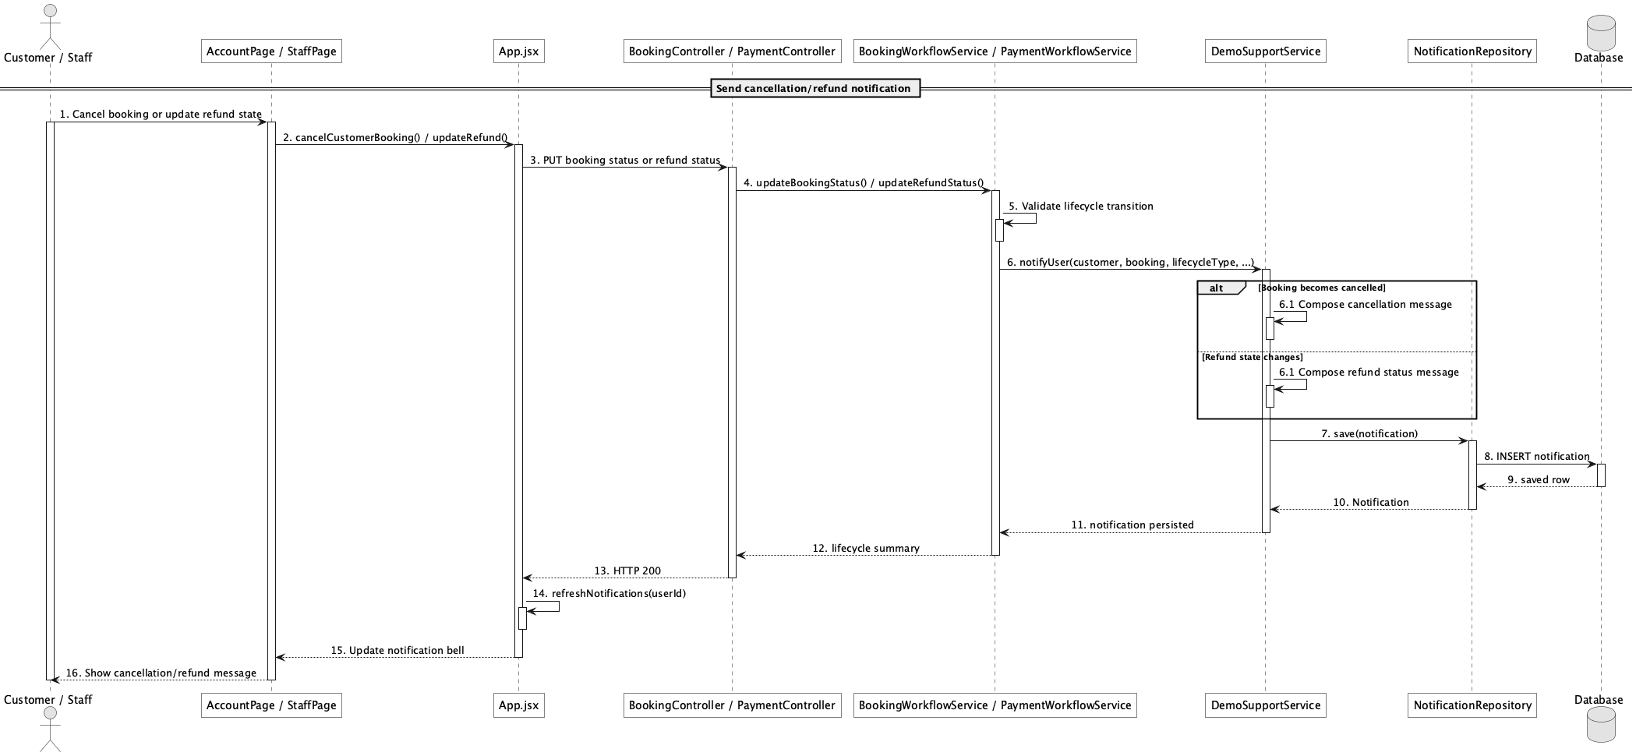

d. Database Queries
== Send cancellation/refund notification ==

1. Cancellation and refund notifications
SELECT notification_id, user_id, booking_id, refund_id, notification_type,
title, message, is_read, sent_at
FROM notification
WHERE user_id = :customerId
AND notification_type IN ('cancellation','refund')
ORDER BY notification_id DESC;

Implementation note: Notification.refund_id exists in the schema/entity, but notifyUser currently accepts only a booking and does not populate payment_id or refund_id.

60. View revenue report

a. Class Diagram
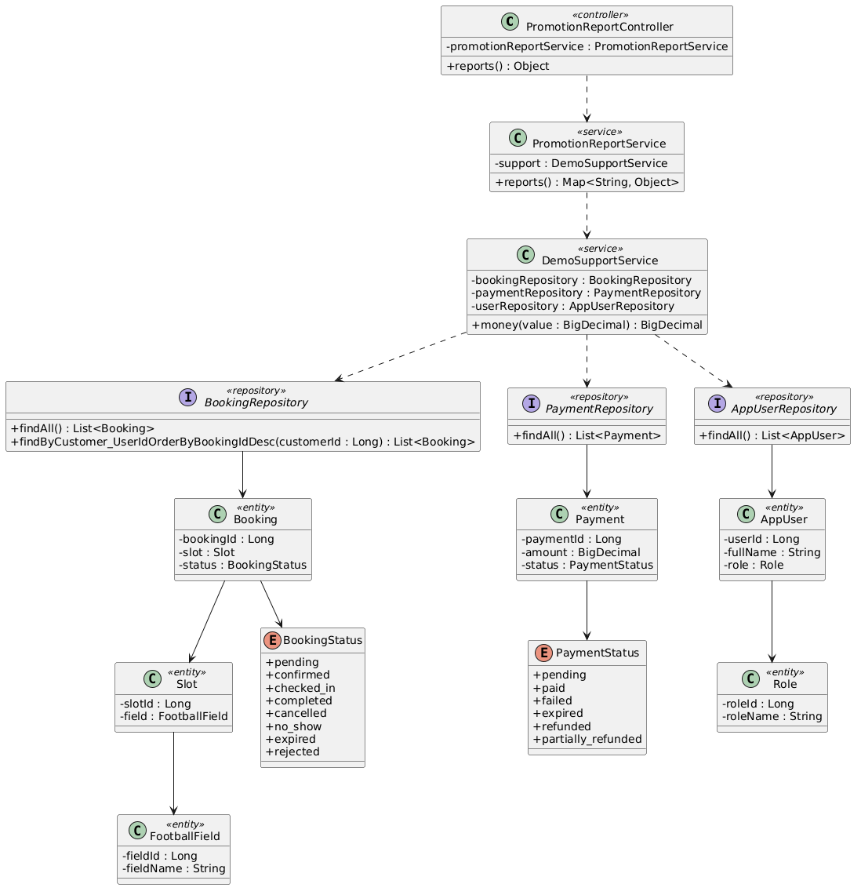

b. Class Specifications
PromotionReportController
No | Method | Description
01 | public Object reports() | Exposes Admin GET /api/reports.

PromotionReportService
No | Method | Description
01 | public Map<String, Object> reports() | Computes gross paid revenue, completed refunds, net revenue, field/service value, and discount totals.

c. Sequence Diagram
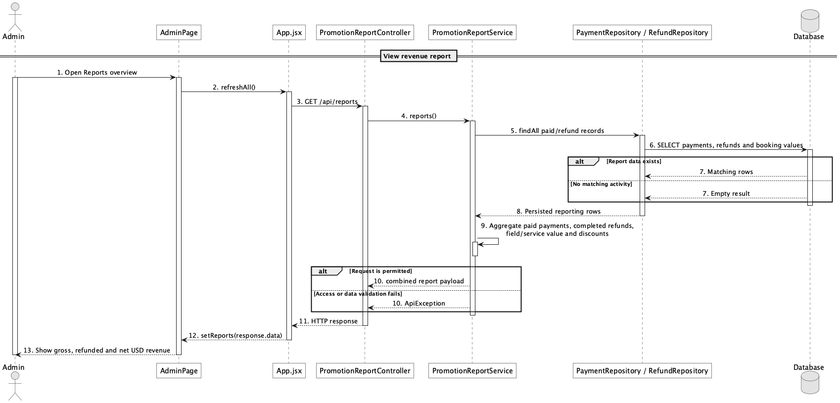

d. Database Queries
== View revenue report ==

1. Revenue totals
SELECT
COALESCE((SELECT SUM(amount) FROM payment WHERE status = 'paid'), 0) AS gross_revenue,
COALESCE((SELECT SUM(refund_amount) FROM refund WHERE status = 'completed'), 0) AS refund_total,
COALESCE((SELECT SUM(amount) FROM payment WHERE status = 'paid'), 0)
- COALESCE((SELECT SUM(refund_amount) FROM refund WHERE status = 'completed'), 0) AS net_revenue,
COALESCE((SELECT SUM(field_price_amount) FROM booking WHERE status NOT IN ('rejected','expired')), 0) AS field_value,
COALESCE((SELECT SUM(service_total_amount) FROM booking WHERE status NOT IN ('rejected','expired')), 0) AS service_value;

Implementation note: The live service currently loads entities with findAll() and aggregates in Java; this is representative equivalent SQL for the SDS.

61. View booking report

a. Class Diagram (similar to 60)
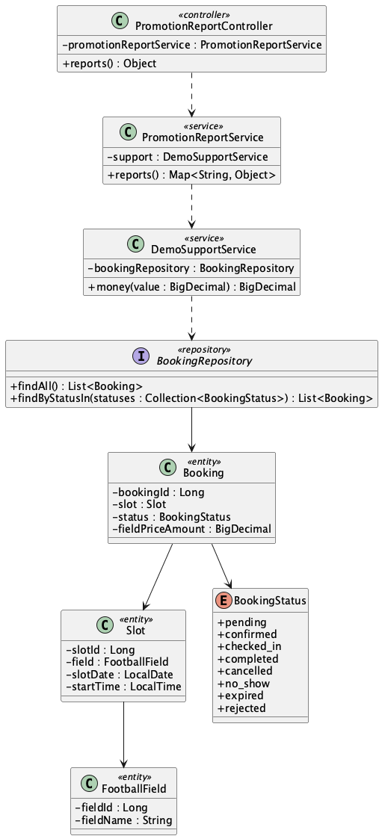

b. Class Specifications
PromotionReportService
No | Method | Description
01 | public Map<String, Object> reports() | Builds booking counts, status counts, field utilization, booked field value, and peak start times.

BookingRepository
No | Method | Description
01 | List<Booking> findByStatusIn(Collection<BookingStatus> statuses) | Custom status lookup used elsewhere; reports currently use inherited findAll().

c. Sequence Diagram
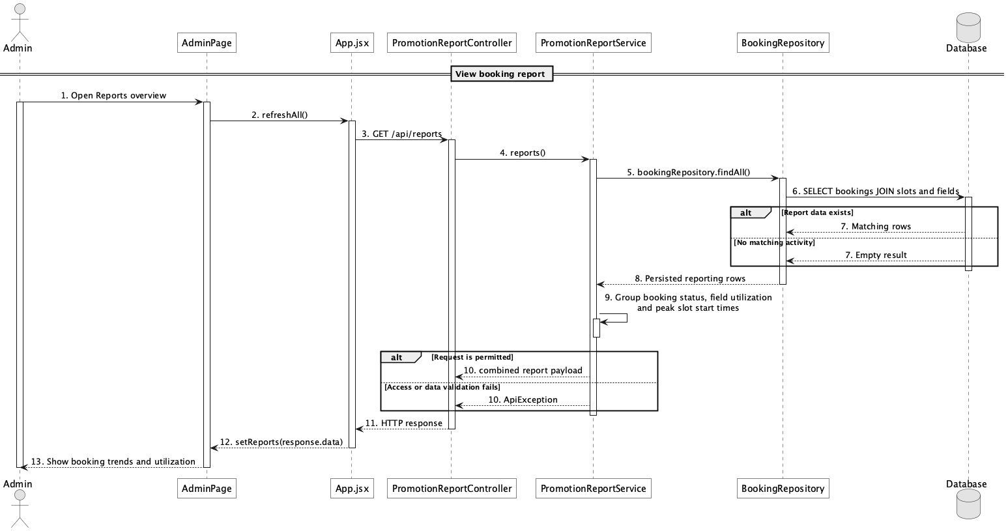

d. Database Queries
== View booking report ==

1. Booking status, utilization, and peak time
SELECT b.status, f.field_name, s.start_time, COUNT(*) AS booking_count,
SUM(CASE WHEN b.status NOT IN ('rejected','expired') THEN b.field_price_amount ELSE 0 END) AS booked_field_value
FROM booking b
JOIN slot s ON s.slot_id = b.slot_id
JOIN field f ON f.field_id = s.field_id
GROUP BY b.status, f.field_name, s.start_time
ORDER BY booking_count DESC;

Implementation note: There is one combined report endpoint rather than separate revenue, booking, and customer report controllers.

62. View customer activity report

a. Class Diagram (similar to 60)
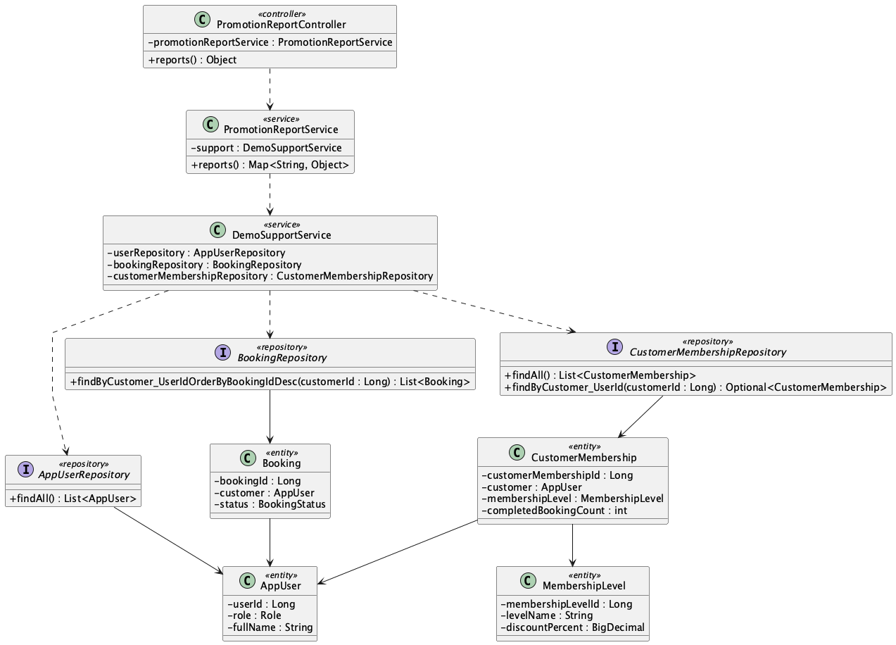

b. Class Specifications
PromotionReportService
No | Method | Description
01 | public Map<String, Object> reports() | Computes top customers, returning-customer count, and membership distribution.

BookingRepository
No | Method | Description
01 | List<Booking> findByCustomer_UserIdOrderByBookingIdDesc(Long customerId) | The current Java report calls this per customer to derive booking count.

CustomerMembershipRepository
No | Method | Description
01 | Optional<CustomerMembership> findByCustomer_UserId(Long customerId) | Represents the customer-to-level relationship; reports currently aggregate inherited findAll() results.

c. Sequence Diagram
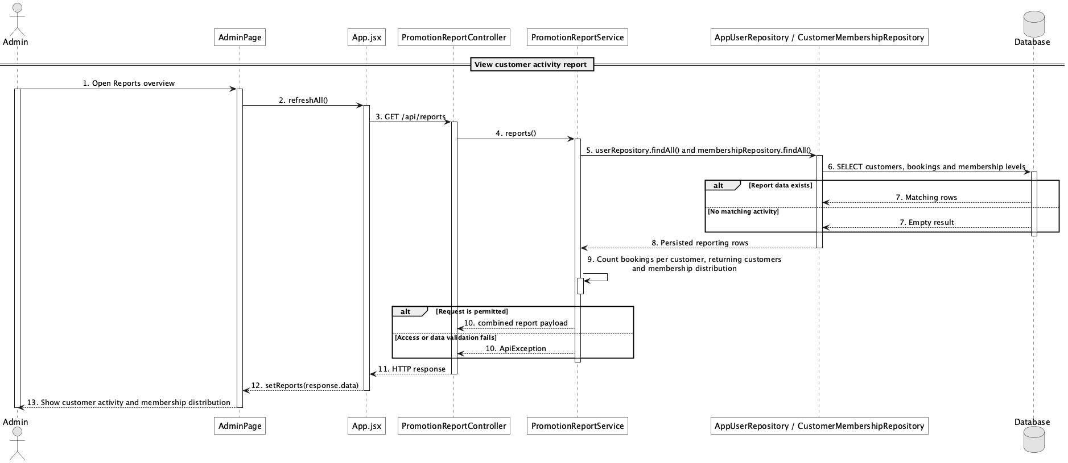

d. Database Queries
== View customer activity report ==

1. Customer activity summary
SELECT u.user_id, u.full_name, COUNT(b.booking_id) AS booking_count,
ml.level_name, cm.completed_booking_count
FROM app_user u
JOIN role r ON r.role_id = u.role_id AND r.role_name = 'Customer'
LEFT JOIN booking b ON b.customer_id = u.user_id
LEFT JOIN customer_membership cm ON cm.customer_id = u.user_id
LEFT JOIN membership_level ml ON ml.membership_level_id = cm.membership_level_id
GROUP BY u.user_id, u.full_name, ml.level_name, cm.completed_booking_count
ORDER BY booking_count DESC;

Implementation note: The current implementation has an N+1 query shape for top-customer booking counts because it loads all users and then calls the per-customer booking repository method.

63. Ask smart assistant for available fields

a. Class Diagram
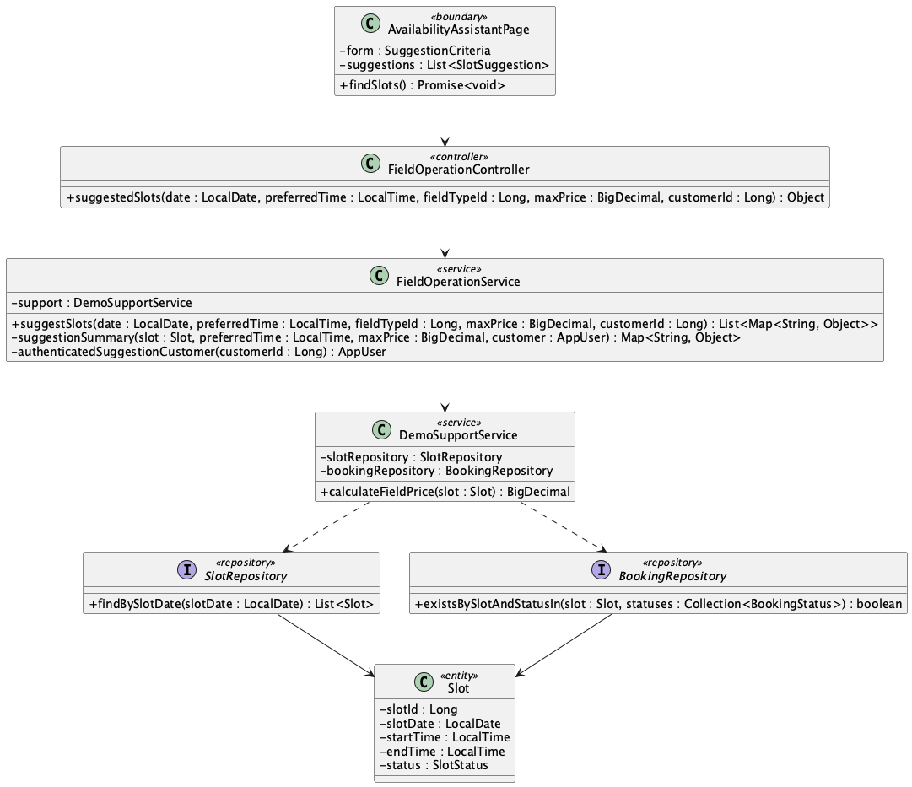

b. Class Specifications
FieldOperationController
No | Method | Description
01 | public Object suggestedSlots(LocalDate date, LocalTime preferredTime, Long fieldTypeId, BigDecimal maxPrice, Long customerId) | Exposes GET /api/slots/suggestions.

FieldOperationService
No | Method | Description
01 | public List<Map<String, Object>> suggestSlots(LocalDate date, LocalTime preferredTime, Long fieldTypeId, BigDecimal maxPrice, Long customerId) | Validates criteria, filters live availability, ranks results, and returns explainable reasons.

SlotRepository
No | Method | Description
01 | List<Slot> findBySlotDate(LocalDate slotDate) | Loads date candidates.

BookingRepository
No | Method | Description
01 | boolean existsBySlotAndStatusIn(Slot slot, Collection<BookingStatus> statuses) | Excludes active reservations.

c. Sequence Diagram
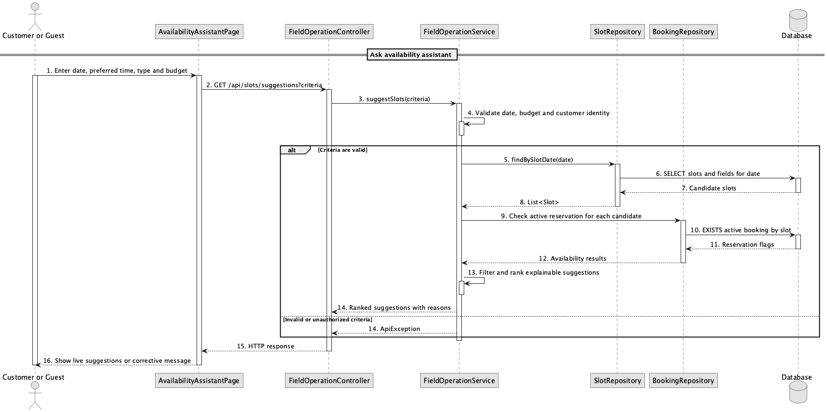

d. Database Queries
== Ask smart assistant for available fields ==

1. Live suggestion candidates
SELECT s.slot_id, s.slot_date, s.start_time, s.end_time, f.field_id, f.field_name,
ft.type_name
FROM slot s
JOIN field f ON f.field_id = s.field_id AND f.status = 'active'
JOIN field_type ft ON ft.field_type_id = f.field_type_id
WHERE s.slot_date = :date AND s.status = 'available'
AND NOT EXISTS (SELECT 1 FROM booking b WHERE b.slot_id = s.slot_id
AND b.status IN ('pending','confirmed','checked_in'));

Implementation note: Ranking and promotion eligibility are calculated in Java; no chatbot/RAG table is required.

64. Get suggested available slots

a. Class Diagram
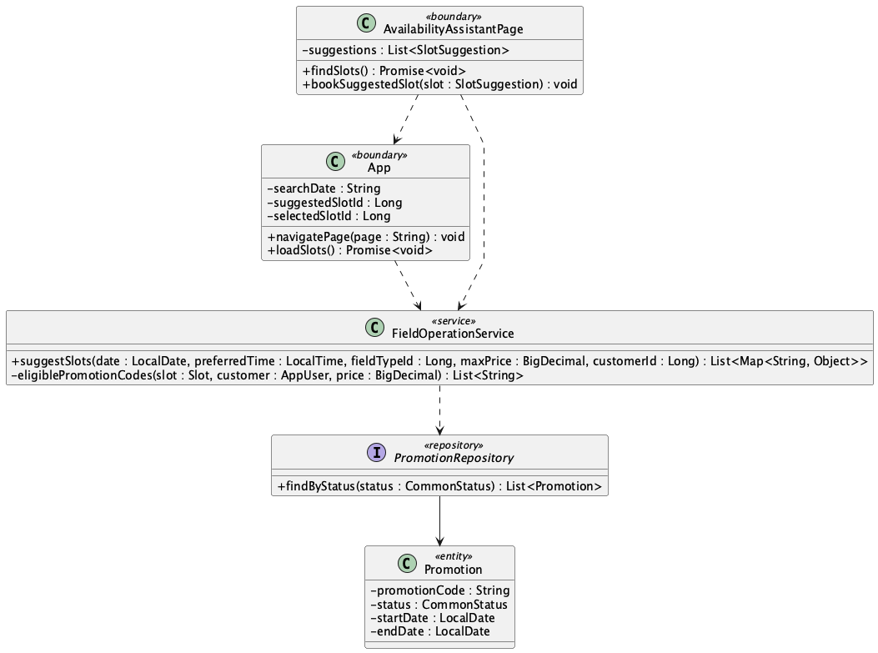

b. Class Specifications
AvailabilityAssistantPage
No | Method | Description
01 | findSlots() | Requests and displays ranked live suggestions.
02 | bookSuggestedSlot(slot) | Stores slot id/date and navigates to booking.

App
No | Method | Description
01 | loadSlots() | Reloads the suggested date and selects the exact slot only while available.

c. Sequence Diagram
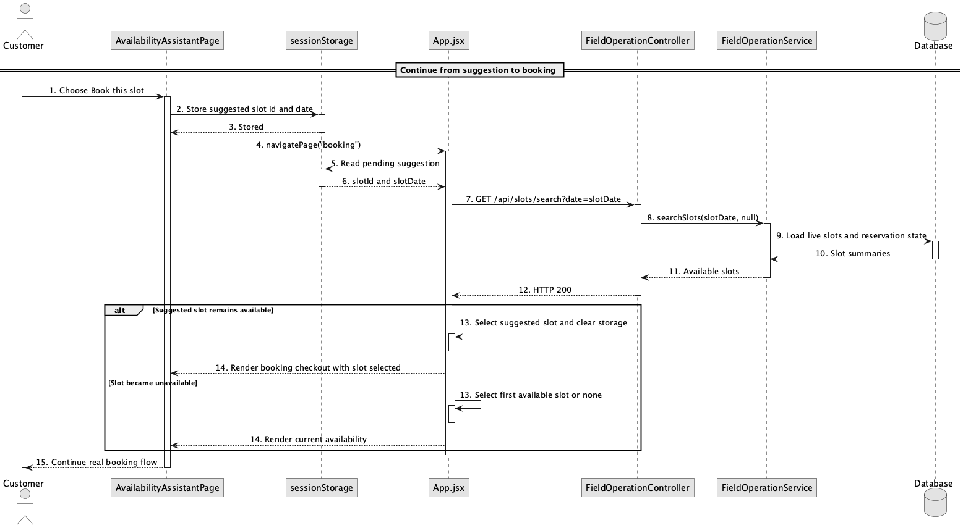

d. Database Queries
== Get suggested available slots ==

1. Revalidate suggested slot
SELECT s.slot_id, s.status
FROM slot s
WHERE s.slot_id = :suggestedSlotId AND s.slot_date = :suggestedDate
AND s.status = 'available'
AND NOT EXISTS (SELECT 1 FROM booking b WHERE b.slot_id = s.slot_id
AND b.status IN ('pending','confirmed','checked_in'));

Implementation note: sessionStorage is only a UI handoff; the booking API remains authoritative and revalidates availability.

